******Fishermans Bend Planning Review Panel

Wirraway Precinct – Report No. 5

19 July 2018

*Planning and Environment Act 1987*

Report pursuant to section 151 of the Act

Fishermans Bend Planning Review Panel

Wirraway Precinct – Report No. 5

19 July 2018

 

Kathy Mitchell, Chair Lester Townsend, Deputy Chair

 

Sarah Carlisle, Member Rodger Eade, Member



Peter Edwards, Member

Contents

Page

1 Strategic Overview 1

1.1 Precinct context 1

1.2 Existing Planning Controls 1

1.3 Planning permit application history 3

1.4 Hearing process 3

2 Vision and Framework 4

2.1 Wirraway Vision 4

2.2 Proposed urban structure 4

2.3 Proposed built form 5

2.4 Key issues 6

3 Urban structure and built form 7

3.1 Context 7

3.2 General urban structure 10

3.3 Achieving a varied building typology 10

3.4 Proposed density 12

3.5 Core and subprecinct boundaries 13

3.6 Building heights and setbacks 14

3.7 Primary and secondary active frontages 17

3.8 Recommendations 19

4 Location of open space 20

4.1 Context 20

4.2 Submissions and evidence 20

4.3 Discussion 22

4.4 Findings 23

5 Location of hubs 24

5.1 Context 24

5.2 Submissions and evidence 24

5.3 Discussion 25

5.4 Findings 26

6 Site specific issues 27

6.1 Rocklea Drive overpass (S19) 27

6.2 9a/339 Williamstown Road (S58) 28

6.3 112 Salmon Street (S68) 28

6.4 8/339 Williamstown Road (S76) 29

6.5 339-343 Williamstown Road (S100) 29

6.6 332 Plummer Street and 21 Smith Street (S131) 29

6.7 128 Salmon Street (S145) 29

6.8 Various properties in Salmon and Plummer Streets (S149) 30

6.9 541 Graham Street (S150) 30

6.10 19 Salmon Street (S167) 30

6.11 359 Plummer Street (S208) 31

6.12 320 Plummer Street, 365-391 Plummer Street and 17 Rocklea Drive (S217) 32

6.13 299 Williamstown Road and 11 Salmon Street (S222) 32

6.14 351 Plummer Street (S238) 32

Appendix A Document list

List of Tables

Page

Table 1: Interim built form controls 2

Table 2: Current Permits 3

Table 3: Permit applications 3

Table 4: Building height submissions – Wirraway precinct 15

List of Figures

Page

Figure 1: The subject land 1

Figure 2: Design and Development Overlay, Schedule 30 2

Figure 3: Proposed urban structure in Wirraway 5

Figure 4: Proposed building heights in Wirraway 7

Figure 5: Port Phillip preferred built form typologies 11

Figure 6: Wirraway core and subprecinct boundaries 14

Figure 7: Proposed community hub investigation areas 24

Figure 9: Rocklea Drive overpass – conflicting bridge locations 27

Figure 8: Location of proposed east-west road 31

**List of Abbreviations – as per Report No. 1, Volume 1**

Executive summary

#### Summary

This is Report No. 5 of the Review Panel which relates to the Wirraway Precinct within Fishermans Bend.

Wirraway is located in the City of Port Phillip and covers an area of 94 hectares. Wirraway will be an inner city neighbourhood known for its leafy green streets, local cafes and shops and thriving cultural hub. It will provide walking and cycling access to Westgate Park and Sandridge Beach. It is proposed to have a larger proportion of two and three bedroom dwellings than the other precincts, and will have a greater emphasis on accommodating households with children.

Submissions raised a wide range of issues including:

* height and setback controls
* urban structure issues including boundaries, building typologies and active frontages
* location of open space
* location of community hubs
* road and transport infrastructure
* particular site matters
* the complexity of the controls.

This report should be read in conjunction with Report No. 1, which provides the overview of the context and process of the Review Panel, and addresses common issues raised in submissions (such as the method of acquiring land for public purposes, funding infrastructure in Fishermans Bend, Floor Area Ratio, Floor Area Uplift, affordable housing, governance and other matters).

#### Findings

In relation to Wirraway Precinct key issues, the Review Panel concludes:

* The proposed built form controls for the core are generally appropriate.
* The proposed built form controls for the non-core are likely to lead to underdevelopment.
* Significantly more development can occur without compromising the Precinct character.
* Minor changes to core and subprecinct boundaries proposed are supported.
* Densities of 370 dwellings per hectare in the core and 348 dwellings per hectare in the non-core are supported.
* Maximum proposed building heights of six storeys in the non-core are likely to be nonviable and an increase to eight storeys as the preferred height is proposed.
* The location and quantum of open space is satisfactory.
* The community hub investigation areas are supported and it is regarded as premature to nominate particular sites for community facilities at this stage.

In addition, the Review Panel has responded to a range of site specific issues raised in submissions and has recommended further changes where appropriate.

#### Recommendations

Based on the reasons set out in this Report, the Review Panel recommends that the Minister for Planning progress draft Amendment GC81, subject to the following changes:

1. Amend Map 2, Building Heights, in the Design and Development Overlay for Wirraway to change building heights in the non-core area which were proposed as six storeys discretionary to be eight storeys discretionary.

# Strategic Overview

## Precinct context

The Wirraway Precinct is located in Port Phillip and is 94 hectares in size, with a net developable area of 58 hectares.

It is bound by the West Gate Freeway to the north, Graham Street to the east, Williamstown Road to the south and Todd Road to the west (refer to Figure 1). Wirraway contains two large public open spaces, the JL Murphy Reserve and Howe Reserve. It has reasonable access to West Gate Park, further to the west in the Employment precinct.

Figure 1: The subject land

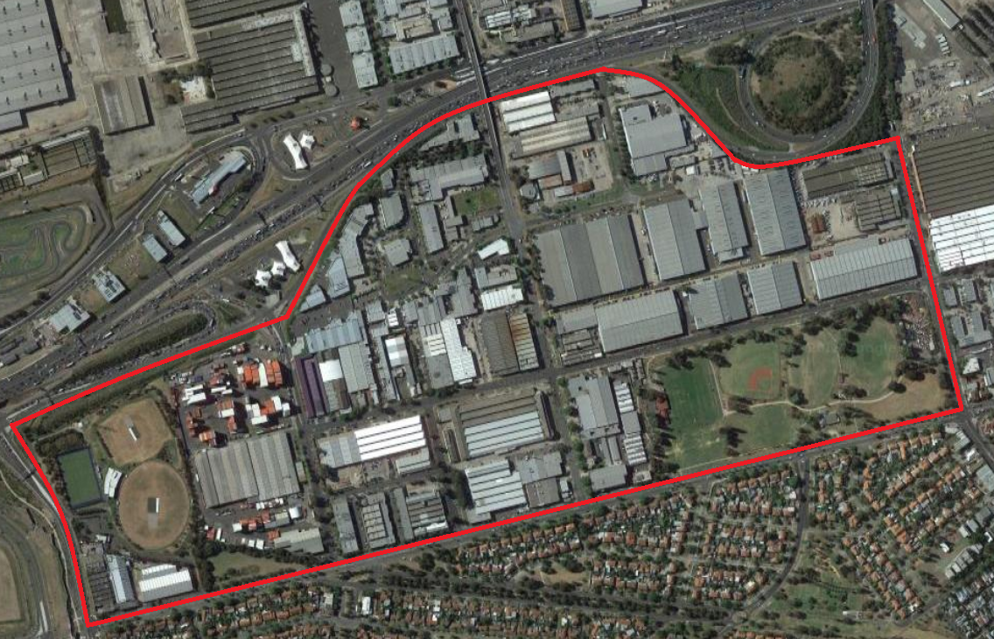

Source: Google Maps

## Existing Planning Controls

The Capital City Zone, Schedule 1 and Design and Development Overlay (DDO), Schedule 30 currently apply to the Wirraway Precinct. DDO30 applies as illustrated in Figure 2.

Figure 2: Design and Development Overlay, Schedule 30

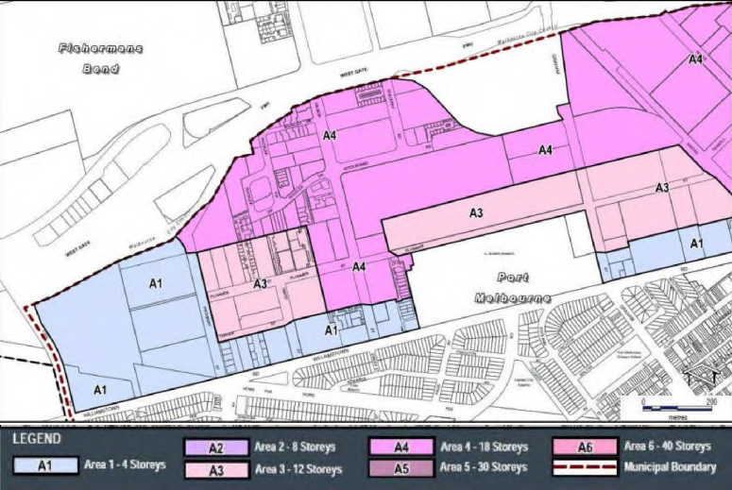

Under DDO30, Wirraway is split into three areas (A1, A3 and A4) with varied maximum building heights. Much of north Wirraway and parts of central Wirraway are designated A4, which allows for 18 storey limits. Land to the north of JL Murphy Reserve is designated A3, which provides for 12 storeys. Land to the south and west of the precinct is predominantly A1, which allows for heights of 1-4 storeys. Most of the current permits and permit applications are for buildings between 12 and 18 storeys which are generally consistent with DDO30.

The interim built form controls currently applying are shown in Table 1.

Table 1: Interim built form controls

|  |  |
| --- | --- |
| Built Form Element | Requirement |
| Building height | Mandatory maximum:  A1 - 4 Storeys  A3 - 12 Storeys  A4 - 18 Storeys |
| Street wall height | Mandatory maximum 5 storeys or 20 metres, whichever is lesser |
| Tower setback | Mandatory minimum 10 metres to the street edge  Mandatory minimum 10 metres to all other boundaries  Setback can be taken from centre of laneway (if applicable) |
| Tower separation | Mandatory minimum 20 metres |

## Planning permit application history

There are currently five approved permits and five live permit applications. Of those permit applications, all five have been called in. Current permits are in Table 2 and permit applications are in Table 3.

Table 2: Current Permits

| Address | Submitter | Permit | Proposed FAR |
| --- | --- | --- | --- |
| 320 Plummer St | 217 | 12 &and 15 storeys | 4.1:1 (core)  2.1:1 (non-core) |
| S2, 19 Salmon St | 167 | 4 storeys | 4.1:1 (core) |
| 101 Salmon St | N/A | 12 storeys | 2.1:1 (non-core) |
| 9, 339 Williamstown Rd | 58 | 10 storeys | 4.1:1 (core) |
| 10-12/339 Williamstown Rd | N/A | 13 storeys | 4.1:1 (core) |

Table 3: Permit applications

| Address | Submitter | Permit application | Proposed FAR |
| --- | --- | --- | --- |
| 365 – 391 Plummer St | 217 | 12-18 storeys (called in) | 4.1:1 (core) |
| 17 Rocklea Dr | 217 | 18 storeys (called in) | 2.1:1 (non-core) |
| 541 Graham St | 150 | 18 storeys (called in) | 2.1:1 (non-core) |
| 18 – 22 Salmon St | 203 | 13 storeys (called in) | 4.1:1 (core) |
| 112 Salmon St | 68 | 12-18 storeys (called in) | N/A |

## Hearing process

The Wirraway Hearing was held over six days, between 8 and 17 May 2018, with some other submitters being heard during other parts of the Hearing due to their unavailability during the scheduled times.

There were in the order of 20 written submissions in relation to sites in Wirraway, of which 13 submitters presented in support of their submission at the Hearing, with a number calling evidence.

The findings and recommendations of the Review Panel for Lorimer are based on the Minister’s Part C version of the planning controls.

# Vision and Framework

## Wirraway Vision

The Vision for Wirraway is, in summary, is a family friendly inner city neighbourhood close to the Bay and West Gate Park. It will provide an array of housing options, including small to medium scale apartment buildings, linked by leafy streets lined with different types of shops and cafes.

JL Murphy Reserve provides a major green space and will provide a focus for recreation, sports and leisure activities. It will incorporate best practice stormwater management in line with sustainability goals.

Wirraway will be known for its thriving arts scene, with galleries and cultural facilities drawing visitors from Melbourne and afar. It will host a wide array of workers, from service industries to research and development, built off connections to the Employment Precinct.

Regular tram services will run down Plummer Street Boulevard ensuring that Wirraway is well connected to the city and beyond. Popular cycle and walking routes will provide access to Sandridge Beach, Westgate Park and back through to the city. The transport network will support a higher density local centre, with slender commercial buildings interspersed among the primarily lower rise skyline.[1]

The Precinct Directions are: [2]

* establish a local centre with a mix of uses at the corner of Plummer and Salmon streets
* provide green links between new and existing public spaces
* support arts and cultural activity to drive creativity and innovation throughout the area
* connect to surrounding precincts and destinations including Sandridge, the Employment Precinct, Garden City and the Beach
* encourage diverse building types and scales including low and medium scale apartment buildings.

The target population is for 17,600 residents in 6,822 households, and 4,000 jobs by 2050.[3]

## Proposed urban structure

The proposed urban structure for the Wirraway Precinct is set out in Figure 3 and is proposed by the Minister to be included as Map 4 in the Capital City Zone Schedule.

Figure 3: Proposed urban structure in Wirraway

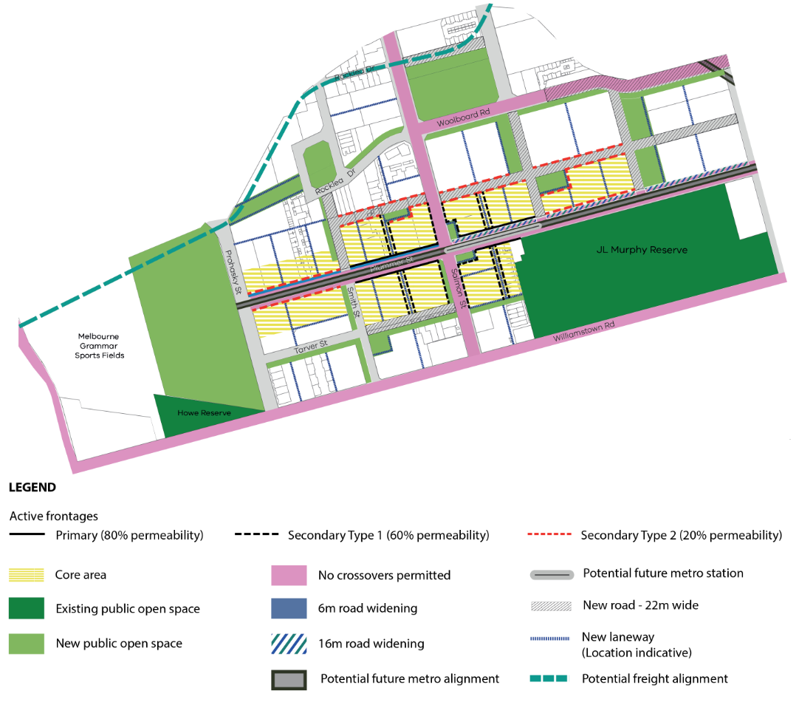

Source: Minister Part C Control maps (D317), map 1c

The Plummer Street and Salmon Street intersection is proposed to be the focus of activity within the Precinct, with Plummer Street Boulevard providing a high quality pedestrian environment.

Active recreation and organised sports are focused on JL Murphy Reserve. Further open space is proposed in Wirraway North and East which are to be linked by green walkways, combined with new laneways and streets, creating a walkable neighbourhood.

Arts and culture, education and community, sports and recreation, and health and well-being hubs will be located centrally within the Precinct.

## Proposed built form

The *Urban Design Strategy* defines the preferred building typology in Wirraway as follows:

The primary focus of Wirraway is to support family friendly housing. The residential density targets here are lower than the other three precincts. Within the new activity core, taller buildings are supported to define this centre, however these should ensure that the southern side of Plummer Street is not overshadowed. Generally six storey height limit in the non-core areas is proposed, reducing to four storeys at the interface to low-scale neighbourhoods to the south.[4]

The tallest built form is anticipated in central Wirraway. Tower form is not supported in the non-core areas of Wirraway.[5]

The proposed DDO schedule provides for maximum building heights of 12-24 storeys (42.2 metres to 80.6 metres) in the Wirraway core with small areas with discretionary maximum heights of:

* 10 storeys (36 metres) at the south eastern corner of the corner of Plummer and Prohasky Streets and on the western edge of the JL Murphy Reserve north of the proposed laneway
* 6 storeys (23 metres) on the northern side of Plummer Street opposite the JL Murphy Reserve.

In the non-core area, the predominant height provided for in the DDO is 6 storeys (23 metres) with:

* 4 storeys (15.4 metres) north of Williamstown Road west of the JL Murphy Reserve, to provide a transition to the built form south of Williamtown Road
* 6 storeys (23 metres) mandatory between those area and the boundary of the core to the north.

## Key issues

The Review Panel supports many aspects of the planning framework and proposed controls for Wirraway. These are not repeated in this report or expanded upon.

During the course of the Wirraway Hearing, the key issues raised related to:

* urban structure and built form
* location of open space
* location of community hubs
* other site specific issues.

The Review Panel notes that not unexpectedly, most issues raised were of a site specific nature but did have a number of common themes. For this reason the focus is on issues with reference to particular submissions and or sites where relevant.

# Urban structure and built form

## Context

Wirraway is proposed to be a precinct which is significantly different in character to other parts of Fishermans Bend. It is proposed to be more appropriate for households with children, with a lower built form in the non-core and a greater proportion of larger dwellings appropriate to the needs of the proposed household mix.

#### Building heights

Building heights in the core are proposed to vary between 12 and 24 storeys and in the non-core are predominantly 6 storeys, with 4 storeys north of Williamstown road to provide a transition to the lower built form south of Williamstown Road. Proposed heights are set out in Figure 4.

Figure 4: Proposed building heights in Wirraway

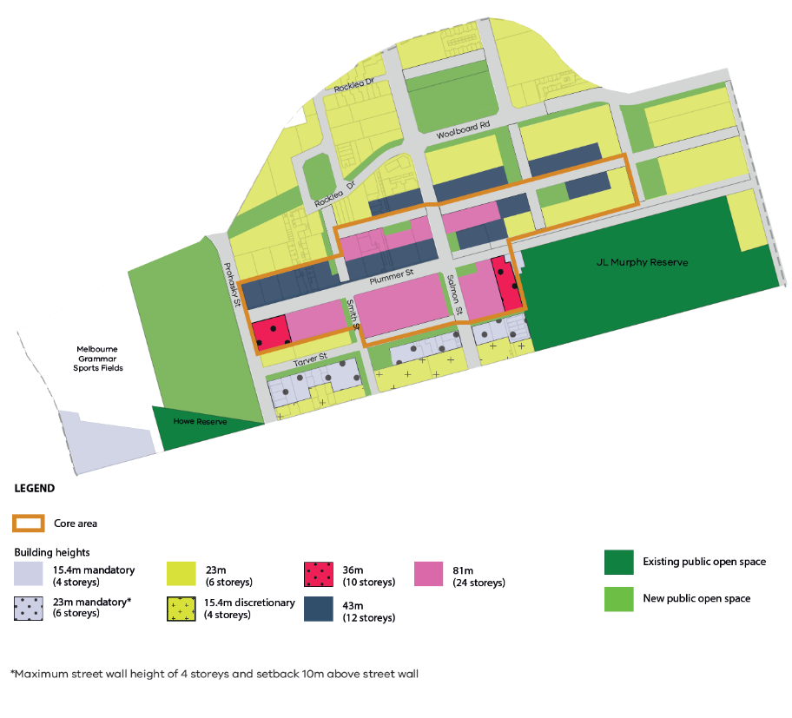

Source: Revised maps Wirraway (DW25), Map 2

#### Street wall heights

Proposed street wall heights are set out in Table 3. In the Wirraway core, lower street wall heights are proposed to maximise the amount of sunlight that will penetrate the built form to reach the southern side of Plummer Street. To the south of the core, a variety of street wall heights between 4 and 8 storeys are proposed, to contribute to architectural diversity within the street and provide opportunities for portions of the street to receive greater levels of sunlight access throughout the day. In the eastern part of the Precinct which abuts Sandridge, street wall heights proposed are consistent with a mid-rise form and allow for visually recessive upper levels.

Table 3: Wirraway street wall height

| Location | Qualification | Preferred street wall height | Maximum street wall height |
| --- | --- | --- | --- |
| on Plummer Streets |  | 6 storeys (23 metres) in height, except where a lower height is necessary to respond to adjoining heritage places |  |
| along Williamstown Road |  | at least 4 storeys (16 metres) | 4 storeys |
| Laneway (street ≤9 m wide) |  |  | 4 storeys along laneways except on corner sites in which case the higher street wall applies and should not extend more than 25 metres along the laneway |
| on a street >9 and ≤22m wide |  |  | 6 storeys |
| On a street >22m wide | where the building height is ≤10 storeys | at least 4 storeys (16 metres) | 8 storeys |
|  | where the building height is >10 storeys | at least 4 storeys (16 metres) | 6 storeys |

#### Setback above street wall

Proposed setbacks above the street wall are set out in Table 4. These generally vary between five and ten metres based on the need to transition to other types of built form, to be visually recessive from the street level and to improve solar access.

Table 4: Wirraway setbacks above the street wall

| Location | Qualification | Preferred Setback | Minimum Setback |
| --- | --- | --- | --- |
| * Where the building has a direct interface with the West Gate Freeway | if the building height is ≤ 8 storeys | 5 metres | 3 metres |
| if the building height is > 8 storeys | 10 metres | 5 metres |
| Williamstown Road |  | As specified for other locations | 10 metres |
| Other locations | if the building height is ≤ 8 storeys | 5 metres | 3 metres |
| if the building height is > 8 storeys and ≤ 20 storeys | 10 metres | 5 metres |
| if the overall building height is > 20 storeys | 10 metres | 10 metres |

#### Side and rear setbacks

The proposed side and rear setbacks, set out in Table 5, will provide equitable development rights, reasonable building separation and in some instances ensure reasonable solar penetration.

Table 5: Wirraway side and rear setbacks

| Part of building | Qualification | Qualification | Preferred setback | Minimum setback |
| --- | --- | --- | --- | --- |
| Below the street wall | If not within 300 mm of a side or rear boundary | Within core areas | 6 metres | 6 metres |
| Within non-core | 9 metres | 6 metres |
| Above the street wall height | Building height ≤ 20 storeys |  | 10 metres | 5 metres |
| Building height > 20 storeys |  | 10 metres | 10 metres |

#### Building separation within a site

Proposed building separation within a site are set out in Table 6.

Table 6: Wirraway

| Part of building | Qualification | Preferred building separation | | Minimum building separation |
| --- | --- | --- | --- | --- |
| Below the street wall |  | 12 metres. | 6 metres. | |
| Above the street wall | A new building up to 20 storeys in height | 20 metres | 10 metres | |
| A new building over 20 storeys in height | 20 metres | 20 metres | |

## General urban structure

#### Submissions and evidence

There was considerable debate about an appropriate urban form for the core and non-core areas of Wirraway. The Minister submitted that the built form controls were aimed at creating a preferred character broadly summarised as follows:

* generally mid-rise developments with potential for commercial uses in the non-core areas
* slender towers on Plummer Street located to minimise overshadowing impacts
* low-rise to mid-rise west of the core with opportunity for visually recessive upper levels which do not result in tower-podium forms
* generally mid-rise development south of the core with an opportunity for visually recessive upper levels.[6]

The definition and interpretation of the term ‘mid-rise’ was the subject of submissions and evidence. Under cross examination by Mr Montebello, Mr Sheppard stated that in his view mid-rise was 5 to 12 storeys, sometimes up to 15 storeys. Port Phillip submitted that a lower built form was appropriate for the Wirraway core, to give it a character which distinguishes it from the other precincts.

Port Phillip submitted that a ‘tooth and gap’ approach to the urban form of the north side of the core in particular was appropriate. The Minister supported a diverse building form and submitted that the proposed FAR would facilitate this. The Minister did not did not specifically oppose the tooth and gap approach.

#### Discussion

The Review Panel generally supports the urban structure proposed by the Minister and believes that a preferred character can be achieved for Wirraway without unnecessarily restricting height in the core, which will be well supported by public transport infrastructure. The different character in Wirraway will be partly achieved by the lower rise forms in the non-core. The Review Panel is supportive of limited use of the tower-podium form in the core.

The Review Panel supports Port Phillip’s tooth and gap approach as appropriate and supports changes to the DDO to facilitate implementation of this. This should apply to both sides of Plummer Street in the Wirraway core with the eastern extent being the lower built form on the north side commencing opposite the western end of the JL Murphy Reserve.

## Achieving a varied building typology

#### Submissions and evidence

Port Phillip proposed adding indicative building typologies to the Building typologies map in the DDO. Port Phillip’s preferred representation is indicated in Figure 4. Port Phillip further proposed that more descriptions of preferred building typologies were required in Table 1 of the DDO to ensure that an appropriately distinct character is created in Wirraway. The Minister did not accept this.

Figure 5: Port Phillip preferred built form typologies

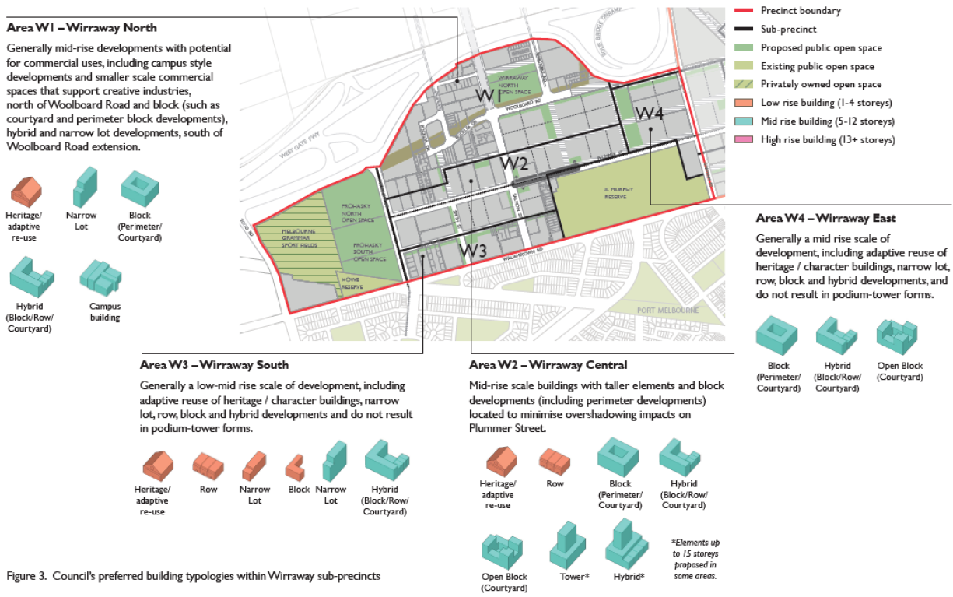

Source: City of Port Phillip Wirraway submission (W4), Figure 3

Port Phillip’s overarching *Urban Design Report,* at Recommendation 8 stated in part:

Reduce the scale of high-rise and encourage a diversity in building typologies such as hybrids in Wirraway core.[7]

In describing mid-rise development it further stated that as part of a mid-rise benchmarking exercise, the characteristics of mid-rise included FARs which ranged from 3.1 to 7.8 with buildings of 3-15 storeys.

#### Discussion

The Review Panel is broadly supportive of more detail being provided in the character statements. The Review Panel believes that the preferred character statements as proposed by Port Phillip will better facilitate the preferred character for Wirraway outlined in the Vision, and are supported. However the Review Panel does not support the inclusion of the indicative built form types in the maps in the DDO, as it does not consider these appropriate for inclusion in a planning scheme control. They are more appropriate for a guidance note or similar, which sits outside the planning scheme.

## Proposed density

#### Proposed FAR

The proposed Floor Area Ratio (FAR) controls for the Wirraway core area is 4.1:1 with a minimum commercial FAR of 1.9:1. The Wirraway non-core FAR controls is proposed at 2.1:1.

In his general evidence, Mr Sheppard pointed out that the *Urban Design Strategy* indicates that the housing typologies proposed for the Wirraway non-core are consistent with a FAR of 4:1, that is significantly higher than the 2.1:1 proposed. On this basis he argued that the proposed FAR is too low and would represent an underdevelopment of the Precinct.

For reasons outlined in the Overview Report, the Review Panel does not support the FARs, and recommends that they be replaced with a dwelling density control. Chapter 7.8 of the Overview Report explains the starting point for the Review Panel’s recommended dwelling densities in each precinct. They are based on the FARs, translated to dwelling densities. The starting point for Wirraway is a dwelling density of 139 dwellings per hectare in the core and 131 dwellings per hectare in the non-core (see Table 16 in Chapter 7.8(ii) of the Overview Report).

#### Is this the right density?

The Review Panel has found that:

* the target population of 80,000 for Fishermans Bend is too low, given its status as a State significant urban renewal area and its potential to provide a greater contribution to help cater for Melbourne’s growth
* planning for Fishermans Bend should proceed on the basis of a target population in the range of 80,000 to 120,000 by 2050
* all of the preferred typologies can deliver residential densities of at least 4:1
* there is scope to increase the densities without compromising the building typologies and preferred characters, with the possible exception of Lorimer, Montague core and Sandridge core (where the proposed densities are already higher than 4:1).

These findings are discussed in detail in Chapters 6 and 7 of the Overview Report.

This raises the question of by how much the densities for each precinct should be increased.

For Wirraway, the Review Panel considers that a dwelling density of 370 dwellings per hectare is appropriate in the core and 348 dwellings per hectare in the non-core. The numbers presented here are more than double the original because as discussed in Chapter 7.8 of the Overview Report, the base densities initially proposed by the Minister have been factored up to provide for a full buildout of the Precinct. This is consistent with the approach taken to calculating the initially proposed FARs in the *Urban Design Strategy*.

The dwelling densities proposed for Wirraway have been increased significantly more than in the other Precincts based on the Review Panel’s assessments as follows:

* It appears that population forecasts for Wirraway were ‘held back’ to keep the overall population forecast for Fishermans Bend at 80,000, possibly on the basis that Wirraway was considered by the Minister to be the last of the Precincts to develop.
* The Review Panel believes that based on current market pressures and development interest, development in Fishermans Bend will progress on two fronts, south from the CBD and Southbank, and north from Port Melbourne and the Bay (into Wirraway). Currently approved developments set out in Table 2 are evidence of this.
* There is significant looseness of fit between the densities represented by the initially proposed FARs and maximum permitted building height. There is therefore adequate scope to accommodate the increased density.
* The proposed densities will not compromise the urban form outcomes for Wirraway nor the Vision for Wirraway as an area that can accommodate households with children. This is because all of the lower rise typologies envisaged for the Wirraway non-core area can, according to Mr Sheppard’s evidence, accommodate densities of up to 4:1.

The Review Panel therefore recommends that the dwelling density for Wirraway be set at 370 dwellings per hectare in the core and 348 dwellings per hectare in the non-core. This is an effective doubling of the proposed density.

## Core and subprecinct boundaries

#### Submissions and evidence

Core and subprecinct boundaries as proposed by the Minister are set out in Figure 6.

Mr Sheppard recommended that the boundary of the core, which bisects property boundaries at 359-391 Plummer Street, between the Smith Street extension and Salmon Street, be moved north to align with property boundaries. The Minister accepted Mr Sheppard’s recommendation and submitted:

The Minister supports revisions to the boundary of the core area to clarify conditions where there are adjoining proposed roads and to incorporate the land required for the road into a core to support higher density over the balance of the land available for development.

Port Phillip submitted that the boundary of subprecinct W2 be moved to align with the core area of Wirraway.

Figure 6: Wirraway core and subprecinct boundaries



Source: Revised maps Wirraway (DW25), map 1C

#### Discussion

The Review Panel accepts the proposed revisions to the core area proposed by the Minister based on Mr Sheppard’s recommendation. The Panel understands that this may extend to a number of properties with a frontage to Plummer Street between the new extension of Smith Street to the new street in the general location of 451 Plummer Street.

Moving the boundary of subprecinct W2 to align with the boundary of the core and non-core in Wirraway is supported by the Review Panel.

## Building heights and setbacks

#### Submissions and evidence

The Minister proposed that building heights abutting Williamstown Road between Smith Street and the JL Murphy Reserve be revised from four storeys mandatory to four storeys discretionary, and behind that frontage, generally abutting Tarver Street and its proposed extension, heights be revised from four storeys discretionary to six storeys mandatory.

On the northern side of the Plummer Street abuttal, Council proposed an eight storey height limit with 15 storeys behind it. This was based on the characterisation of the area in the Vision as small to medium scale buildings. As discussed in Chapter 3.2, there was considerable debate about the translation of the term mid-rise into building height.

Mr Sheppard supported medium rise development for most of the Precinct. He supported limiting tower-podium development to the Plummer Street spine between Prohasky Street and the JL Murphy Reserve, and excluding these forms from the land to the immediate north to protect its solar access.

Mr Sheppard indicated under cross examination by Mr Montebello that he could not understand Port Phillip’s rationale for wishing to restrict building height to 15 storeys on the south side of Plummer Street.

There were a number of site specific submissions with respect to building height. These related to both the core and non-core areas.

These are summarised in Table 4.

Table 4: Building height submissions – Wirraway precinct

|  |  |  |  |  |
| --- | --- | --- | --- | --- |
| Address | core/  non core | Minister  Proposed  Height | Submitter proposed  height | Submission/ comment |
| 332 Plummer/ 21 Smith Street | Part C/NC | 24 storeys/  6 Storeys | 24 storey | “*Southern half in non-core is perplexing*” |
| 320 PlummerStreet | Part C/NC | 10 storeys/  6 storeys |  | Permit for three towers of 15, 12, 12 storeys |
| 365-391 Plummer Street | Part C/NC | 24 storeys/  12 storeys* |  | Only small proportion is non-core. Called in application for three towers of 12, 18 and 18 storeys |
| 17 Rocklea Drive | NC | 6 storeys |  | Called in application for 18 storey tower |
| 299 Williamstown/ 11 Salmon Street | NC | 4 storey street wall/ 6 storey set back | 4 storey discretionary | Opportunities for increased height |
| 2/19 Salmon Street | C | 24 storeys | 24 storey |  |
| 50 Salmon Street | C | 12 storeys* | 24 storey |  |
| 359 Plummer Street | Part C/NC | 24 storeys/ 12 storeys* | 24 storeys | Two height controls on site is problematic |
| 541 Graham Street | NC | 6 storeys |  | Called in application for four towers of 15 and 18 storeys. Six storeys unreasonably restrictive. |
| 351 Plummer Street | Part C/NC | 12 storeys/  6 storeys | 24 storeys/  12 storeys |  |
| 437-481 Plummer Street |  |  |  | Goodman |
| 14-16 Salmon Street | NC | 6 storeys | 8-12 storeys | *Urban Design Strategy* anticipates low to mid-rise |
| 18-22 Salmon Street |  |  |  |  |
| 291 Williamstown and 1-9 Smith Street | NC | 4 and 6 storeys |  | Four storey discretionary would be more strategically sound |
| 112 Salmon Street |  | Open space |  |  |
| 2 Salmon Street | NC | 4 storey |  | Four storey mandatory opposed and should be discretionary |
| 187-201 Williamstown Road | NC | 4 storey |  | Should be based on existing provisions |

* Mandatory six storey street wall height with taller form set back.

There was little argument about the 24 storey height limit set back from the north of Plummer Street, or abutting the south side of Plummer Street in the core area. A number of submissions argued that the maximum height of 12 storeys on the north side of Plummer Street was not appropriate and that the solar access provision protecting the south side of Plummer Street should be deleted to allow a higher built form.

Mr Barnes supported a maximum preferred height of 24 storeys on both sides of Plummer Street between Smith Street and the JL Murphy Reserve. The Minister did not accept this recommendation.

Mr Barnes gave evidence in respect to the proposed height on other properties as follows:

* 50 Salmon Street – remove the 12 storey height limit
* 2/19 Salmon Street – support a discretionary 24 storeys.

In addition, Mr Barnes supported building heights graduating down to 12 storeys towards Williamstown Road with the possibility of an upper level setback of up to 10 storeys along the north side of Williamstown Road. The Minister rejected Mr Barnes’ recommendations.

Bellamia Nominees submitted that the height limit of four storeys on their site was unreasonably low given the core is immediately to its north and that the step down is too severe. The Minister accepted this and proposed to amend the height between the core area and the four storeys on Williamstown Road to a mandatory six storeys (from four storeys).

Mr Armsby submitted that six storey buildings are not viable because soil conditions are such that expensive piling is required for any building taller than four storeys, and that the costs of piling make anything under eight storeys unlikely to be viable. He was supported on this by evidence from Mr Sheppard, however no geo-technical evidence was called.

While many site specific submissions opposed the proposed building heights, particularly on the north side of Plummer Street and in non-core areas, most of them did not nominate a preferred alternative height.

Port Phillip made submissions in relation to setbacks, conveniently summarised by the Minister as follows:

At least 40% of the building height at the street frontage must be 4-6 storeys in height. The remaining height can be up to the discretionary height limit. For a depth of 20m from the street where sheer buildings only are allowed. No pop-ups are permitted (i.e. no upper level setbacks are allowed within this area).

On laneways, development must not exceed 8 storeys in height for lengths greater than 40m.

This would replace the proposed street wall and upper level setback requirements in DDO30.

On other streets within the Core Area, the proposed 6 storey street wall would apply.[8]

The Minister submitted in response that the drafting to achieve some of this is difficult but would be open to further discussion with Port Phillip.

#### Discussion

With respect to height in the core, the Review Panel accepts the Minister’s proposed heights of between 10 and 24 storeys on the grounds that, regardless of the future heavy rail alignment, this will be an important core area in Fishermans Bend. The desired character of the Precinct can still be achieved, primarily through a lower built form in the balance of the Precinct.

The Review Panel supports the tooth and gap outcome sought by Port Phillip as this will help moderate the built form on Plummer Street.

Based on submissions, the Review Panel is concerned about the viability of six storey development in the Wirraway non-core because of the piling that is likely required as a result of soil conditions. No submitter called specific technical evidence upon which to base a definitive conclusion. Mr Armsby provided a detailed submission on this. The Review Panel is concerned that if the six storey limit is retained, a possible outcome is poorer quality three and four storey development, representing a significant underdevelopment of the Precinct. For this reason the Review Panel proposes that where six storeys is proposed in the Wirraway non-core, this should be increased to a discretionary eight storeys. Other non-core building heights as proposed by the Minister are supported.

The Review Panel is cognisant of the evidence of Dr Eaddy regarding wind impacts and the potential ameliorating effects of appropriately designed taller built forms. Mr Tweedie submitted that taller built forms should be permitted immediately abutting the West Gate Freeway. The Review Panel can understand the advantages of this but believes that these are outweighed by possible overshadowing of the lower built form to the south and more particularly the undesirable impact it would have on the character of Wirraway and the non-core in particular.

The Review Panel supports the Minister’s revised building heights for the areas along Williamstown Road and Tarver Street.

The Review Panel supports the further discussion proposed on the setbacks sought by Port Phillip but if agreement with the Minister cannot be reached, the Minister’s proposal should be the fall-back position.

## Primary and secondary active frontages

#### Submissions and evidence

Primary and secondary active street frontages are shown in Map 3 of the Wirraway DDO. These vary from the exhibited control where extensive areas of active street frontage were shown without any primary and secondary differentiation. The Minister submitted that the distinction between frontage types had been introduced in response to the submission by Port Phillip which stated:

A ‘Core Retail Area’ should be identified on the four blocks fronting the intersection of Plummer Street and Salmon Street, with Primary Active Frontages limited to limited to Plummer and Salmon Streets in this area.[9]

The Minister proposed to distinguish between three types of streets as set out in his closing submission.[10]

Port Phillip further submitted that a Development Plan Overlay (DPO) over this area could ensure key anchor land uses such as a supermarket are protected.

The Minister did not consider a DPO was required, as new laneway locations will support large floorplate uses and a core retail area can be identified in the Precinct Plan.

#### Discussion

The Review Panel supports the identification of a core retail area to ensure that retail activities do not become fragmented, thus possibly weakening the retail centre. Port Phillip’s proposed retail core is more restricted than the primary active frontages proposed by the Minister, which extend further in each direction. The Review Panel notes that this Precinct is projected to support 17,500 square metres of retail space by 2050[11], with a supermarket considered unlikely before 2040. This relatively late delivery of a supermarket and likely pressure for residential development adds weight to the argument to plan now for such a use.

Having said this the Review Panel is of the view that it is likely that the development of Fishermans Bend will proceed on two fronts, one from the CBD moving south and the other in Wirraway moving from the south. This view is based on current market activity and the inherent attraction of Port Melbourne. On this basis a supermarket may be viable well before 2040.

The Review Panel understands that there are multiple property holdings in the vicinity of the Plummer Street and Salmon Street intersection which are probably not large enough to support a supermarket on their own. Given the inherent difficulties in land assembly for such uses, the nature and location of core retail uses such as a supermarket and a mechanism to facilitate delivery in the future should be considered at the precinct planning stage. The Review Panel does not support the application of a DPO at this stage, as it considers that it would be premature.

#### Findings

The Review Panel finds:

* It supports the building typologies proposed for the core and non-core areas of Wirraway, including the range of low to mid-rise typologies proposed for the non-core area
* It supports the tooth and gap approach on both sides of Plummer Street with the eastern extent of it being opposite the western end of the JL Murphy Reserve
* It accepts the revision of the core and subprecinct boundaries as proposed by Port Phillip and agreed by the Minister
* buildings heights in the core as proposed by the Minister are acceptable
* A tooth and gap outcome for Plummer Street as sought by Port Phillip should be provided for in the DDO
* In the non-core area, where a building height of six storeys discretionary is proposed, this should be increased to eight storeys discretionary
* The amended height and setbacks for the north side of Williamstown Road are supported
* Further discussion between the Minister and Port Phillip on setbacks is supported with the Minister’s proposal being the fall-back position if agreement is not reached.
* A core retail area can be defined at the Precinct Planning stage.

## Recommendations

The Review Panel recommends to:

1. Amend Map 2, Building Heights, in the Design and Development Overlay for Wirraway to change building heights in the non-core area which were proposed as six storeys discretionary to be eight storeys discretionary.

# Location of open space

## Context

Wirraway has one existing significant area of active open space, the JL Murphy Reserve. It is proximate to both the existing West Gate Park located in the Employment Precinct and Port Phillip a few hundred metres to the west. Howe Reserve is a further area of passive open space.

Two new parks are proposed within Wirraway:

* Prohasky Park (incorporating the existing Howe Reserve)
* Wirraway North Park (in the vicinity of Salmon Street and Woolboard Road)

In addition there are a series of linear spaces linking existing and proposed parks.

## Submissions and evidence

In his opening submissions, the Minister proposed the following open space for Wirraway.

Existing open space:

* JL Murphy Reserve
* Howe Reserve.

Proposed new parks:

* Prohasky Park
* Wirraway North Park.

Neighbourhood open spaces in the following locations:

* abutting a new east-west street west of Salmon Street
* on the southeast corner of Smith Street and a new east-west street
* on the northeast and southeast corners of the Plummer Street/Salmon Street intersection
* Salmon Street opposite the JL Murphy Reserve
* the southwest corner of Woolboard Road and a new north-south street, extending south to a new east-west street.

New linear open space links predominantly:

* east-west along the south side of Woolboard Road
* east-west along the south side of Tarver Street and extending through to JL Murphy Reserve
* north-south along the west side of Smith Street.

The Minister called open space evidence from Ms Thompson who recommended the following changes to open space provision in Wirraway:

* a new neighbourhood open space north west of northern section of Rocklea Drive
* enlarging the neighbourhood open space located on the south east corner of Salmon and the extension of Tarver Street
* relocating the open space on Plummer Street opposite the JL Murphy Reserve to the north so that it includes an existing large tree, abuts the new east west road existing large tree and enlarging it.

In closing for Wirraway, the Minister submitted:

The Minister has accepted all of Ms Thompson’s recommendations to provide further public open space in Wirraway.

For the Wirraway Precinct, the total open space in the draft Framework is 143,378m². Ms Thompson recommended three changes. The Minister has accepted all of these changes. The changes are:

* Introducing a new public open space on Smith Street in the southwest area of Wirraway.
* Reconfiguring and expanding the proposed public open space in Rocklea Drive.
* Relocating and enlarging the proposed public open space near Plummer Street.

The effect of these recommendations is to increase the total public open space for Wirraway to 149,926m², an additional 6548m².[12]

Port Phillip submitted no changes to the provision of open space in Wirraway as recommended by Ms Thompson.

**128 Salmon Street (S145)**

Ms Robertson for Bowens adopted Ms Collingwood’s submission (discussed in the Overview Report) that the provision of open space within 200 metres safe walking distance for all residents lacked strategic justification. She further submitted that her client is a long term business operator and intends to remain in its current location.

There were submissions requesting that some of the linear spaces connecting parks be deleted. These included Ms Collingwood who submitted that there is no need for the space along the east boundary of the Diamond Salmon site at 19 Salmon Street. This was supported by the evidence of Mr Barnes. The submissions and evidence questioned what connectivity this link provides.

**541 Graham Street (S150)**

Mr Canavan for Sel Reklaw objected to the open space link at the north of his client’s site and to the provision of a local park on the western part of the site.

The Minister proposed two areas of open space on the north east and south east corners of Plummer Street and Salmon Street as part of the core. These would be complemented by a green link on the west side of Salmon Street, south of Plummer Street terminating on the south west corner of Salmon and Plummer Streets. Mr Barnes recommended deleting these open spaces, stating:

… this is a key intersection within the core of the Wirraway Precinct. I would prefer a strong built form to define the corners of this intersection rather than relatively small areas of open space.[13]

The Minister noted that the public spaces shown on the Plummer Street and Salmon Street intersection will serve different functions and are not intended to be traditional, green, open space areas. These are proposed to be plazas and public spaces.

**14- 16 Salmon Street (S136)**

A supplementary submission by Bellamia Nominees raised concerns about the apparent inclusion of the northern portion of their site as open space and an east west green link. They submitted Ms Thompson indicated that 478 square metres of their site is required for open space. The Review Panel notes this confirmed in D138 tabled by the Minister.

## Discussion

The Review Panel accepts that the open space provision proposed by the Minister, including Ms Thompson’s recommended changes, is satisfactory. The Panel notes Ms Robinson’s submission that Bowens are a long term business operator and that their site would need to be acquired for the Wirraway North Park. The Panel further notes that park is proposed in a 20-30 year time frame in the *Open Space Strategy,* and that time frame may well see changes which resolve the issue for Bowens.

With respect to the proposed linear spaces which link the proposed parks both within and beyond the Precinct, as indicated in the Overview Report, the Review Panel strongly supports the proposed linear space network because of the connectivity that it provides. This includes the links raised by both Diamond Salmon and Bellamia. The Review Panel notes that there is an apparent discontinuity in the linear open space on the west side of the extension of Smith Street north of Plummer Street. The Review Panel understands that part of the site where the discontinuity occurs is an electrical substation. It notes the Biosis Heritage Study (2016) undertaken as background to the draft Amendment proposes a further study with a view to including the site in a Heritage Overlay. The Review Panel visited this site but does not comment further on the heritage issue.

The Review Panel considers that this linear open space should be continuous and if there is some reason for the discontinuity in this location as a result of further study, the whole of the link should be deleted as there seems to be no logic to including a link that is not continuous.

Mr Canavan’s concerns appear to the Review Panel to be more focussed on the method of acquisition than the provision as such. This issue is addressed in the Overview report at Chapter 14.

With respect to the proposed open spaces on the northeast and southeast corners of Plummer and Salmon Streets, the Review Panel understands that these are proposed as areas where urban design related features will mark this key intersection. For this reason these should be retained and planning for this location be further detailed in the Precinct Plan.

## Findings

The Review Panel finds:

* the provision of open space as proposed by the Minister and subsequently revised is supported
* where linear spaces are proposed they should be retained only if they can be provided as a continuous link.

# Location of hubs

## Context

Five types of community infrastructure hubs are proposed by the Minister for Wirraway:

* Sport and Recreation Hub
* Arts and Cultural Hub
* Education and Community Hub (primary)
* Education and Community Hub (secondary)
* Health and Wellbeing Hub.

The key issues to be addressed are:

* whether it is appropriate at this stage to nominate investigation areas rather than specific sites
* whether the investigation areas/sites are appropriate.

## Submissions and evidence

The Minister submitted that ‘investigation areas’ for hubs of each of the five types be located as set out in the MSS and reproduced here as Figure 7.

Figure 7: Proposed community hub investigation areas

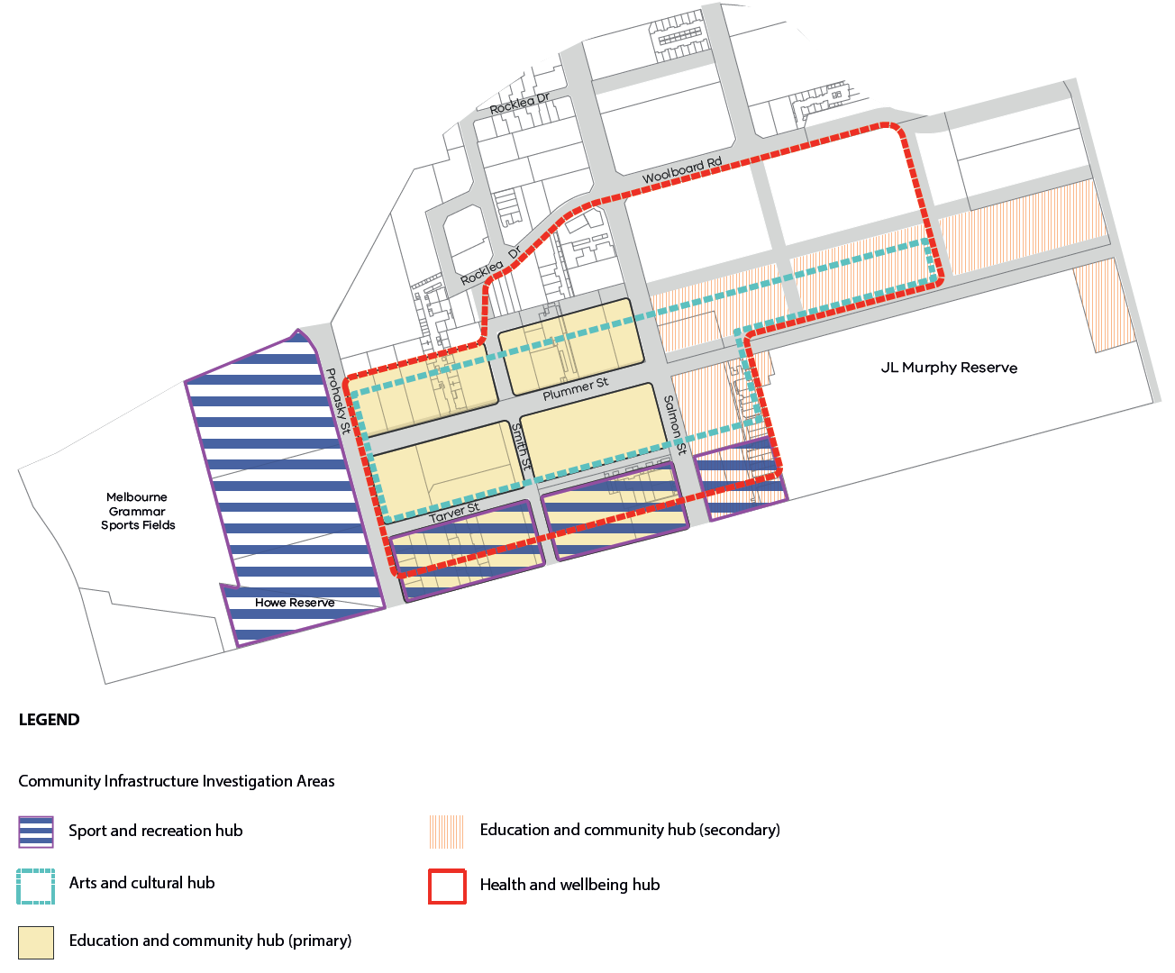

Source: Revised maps Wirraway (DW25), Map 2C

The Minister submitted that the delivery timetable was planned to be as follows:

* Education and Community Hub (secondary school) (2022-2026)
* Education and Community Hub and Health and Wellbeing Hub (2032-2036)
* Arts and Cultural Hub and Sport and Recreation Hub (2036- 2051).

Port Phillip submitted:

* The Health and Wellbeing Hub should be relocated to the core area of Sandridge.
* The Sport and Recreation Hub should be located within the proposed Prohasky Park at the termination of Plummer Street.
* A primary school based Education and Community Hub and the Art and Cultural Hub should be located along Plummer Street within the Goodman owned land.
* A second primary school based Education and Community Hub for Wirraway should be located at the corner of Tarver Street and Smith Street.
* The secondary school based Education and Community Hub should be located on the government owned land on the corner of Plummer Street and Graham Street[14].

Council submitted that its preference for nominating particular sites was based on the need to include the cost of the infrastructure in a DCP (or ICP). This would entail greater detail than the approach proposed by the Minister. Council further submitted that its proposal to locate the Health and Wellbeing Hub in the Sandridge core was based on the need to have it more centrally located for Fishermans Bend. Lorimer is the only other precinct where such a facility is proposed.

In closing, the Minister submitted:

* The Minister does not accept these recommendations at this time.
* The Minister’s Part C controls and policies (see MSS Map 2C – Urban Structure, circulated on 14 May 2018 and updated with this precinct closing submission), retain Areas of Investigation for the Community Hubs. These have been expanded to include all the sites nominated by COPP, except the relocation of the health hub to Sandridge. The final location of the Community Hubs will be determined during the detailed Precinct Planning stage.
* If necessary, the exact location for the various Community Hubs could be fixed in the Precinct Plan or in the ICP if it is used for funding the Community Hubs. In the interim, it is intended that the broader ‘investigation area’ identified in the MSS plan (and the Framework) for Community Hubs should remain.[15]

## Discussion

The Review Panel sympathises with Port Phillip’s wish to be more precise about the location of the various community hubs. It notes that a number of the identified investigation areas are extensive. For example the investigation area for the Health and Wellbeing Hub appears to cover about a half of the entire Precinct.

The Review Panel understands that Port Phillip’s thinking on the location of these hubs is more advanced than that of the Minister and understands the logic associated with a number of the specific locations proposed. The extensive investigation areas cause significant uncertainty for a potentially large group of land owners, particularly any of those who wish to develop their land in the short term.

The Review Panel does not oppose locating the Sport and Recreation Hub in the proposed Prohasky Park but does not agree with the Port Phillip proposal to locate it as a focal point for the western end of Plummer Street. A civic building as a focal point is accepted as an urban design principle but the Review Panel does not believe that a sport and recreation facility is likely to readily fit this function.

The Review Panel notes and supports the Minister’s proposal to extend the investigation area for the Sport and Recreation Hub to include Prohasky Park to facilitate potentially locating the facility within the proposed park.

The Review Panel understands Port Phillip’s logic for locating the Health and Wellbeing Hub in Sandridge. As a matter of principle the boundaries of the Precincts should be regarded as permeable with respect to the location of such facilities and location one side of the boundary or the other may be of little consequence. There appears to be a logic to locating the Health and Wellbeing Hub closer to the centre of Fishermans Bend and locating it in an activity centre that is likely to develop ahead of the Wirraway centre. There are extensive residential areas south of Wirraway which would benefit from such a hub. Its location should be finalised in the Precinct Plan.

If the proposal to develop an ICP is pursued, location of these hubs will need to be finalised before that plan is completed so that accurate costings of land and construction costs are included if it is proposed that they are funded in total or in part through the ICP.

## Findings

The Review Panel finds:

* the precise location of the various hubs needs to be finalised no later than the release of the Precinct Plan
* Precinct boundaries should be regarded as somewhat permeable with respect to the location of key community facilities.

# Site specific issues

A number of the issues raised by submitters in Wirraway are common to all precincts and addressed in the Overview Report. If relevant to Wirraway and have broader implications beyond the particular site, they are addressed in earlier chapters of this report.

Wirraway submissions have in the first instance been identified where the submitter has indicated the submission relates to this precinct. In addition every effort has been made to identify Wirraway related issues raised in other submissions.

## Rocklea Drive overpass (S19)

Mr Pearce made submissions on behalf of Salta Properties who owns 87 Cook Street, an L-shaped site of approximately 2.87 hectares with frontages to Cook Street and Salmon Street. Salta Properties proposed a commercial development for part of the site. Abutting the western boundary is the former GMH site which may ultimately be developed as the University of Melbourne’s new engineering campus.

The draft Framework is confusing as it showed the Rocklea Drive bridge in two different locations. Figure 9 shows the conflicting information on the bridge location north of the West Gate Freeway. The blue bridge appears to land on the internal local road, Gateway Court on the Salta site. This provides access to all commercial units and is critical to the operation of the business park.

Figure 8: Rocklea Drive overpass – conflicting bridge locations

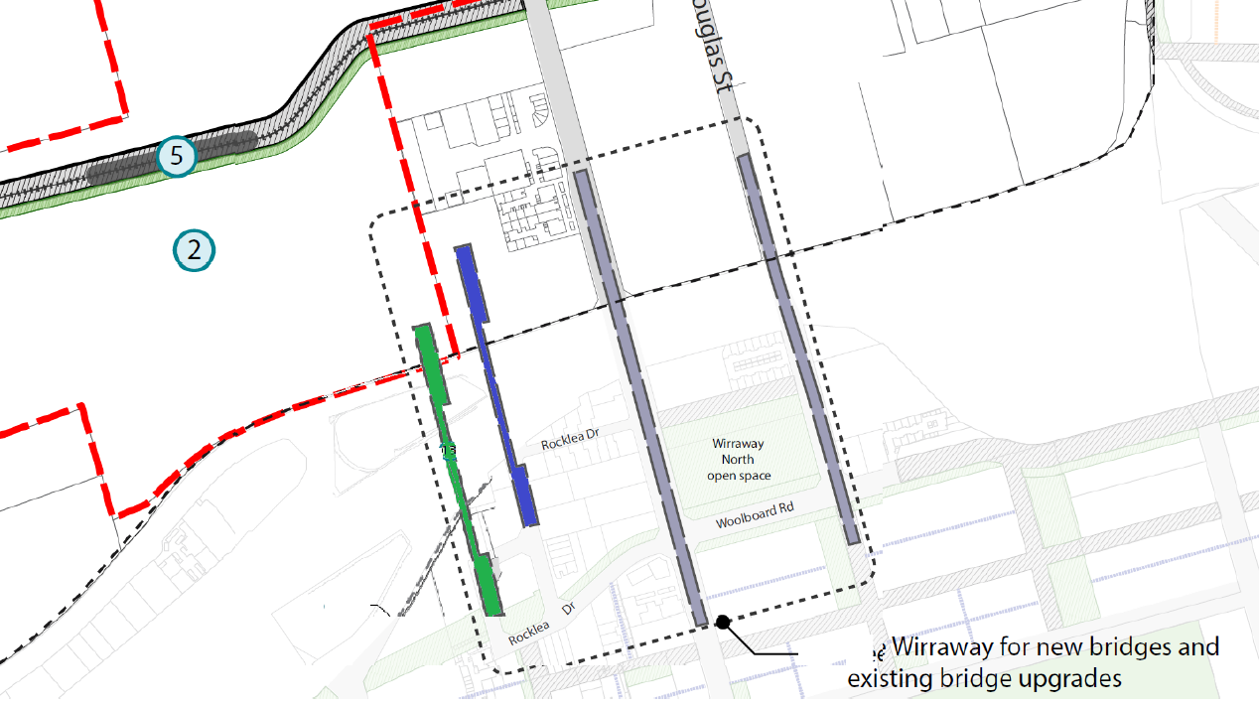

Source: Salta submission to Review Panel (DM20), page 7

Salta questioned the need for three crossings of the freeway within 450 metres of each other and submitted that if the Rocklea Drive bridge was not provided it would require a walk/cycle of approximately 250 metres to utilise Salmon Street overpass. The Review Panel notes this is a strategic cycling corridor.

Salta believed that the bridge should be abandoned or alternatively shifted to the west approximately 50 metres, to land in the former GMH site which is relatively unencumbered (former car parking). This would link into the future University of Melbourne campus.

The Minister acknowledged that the representation of the pedestrian/cycling bridge in the draft Framework is confusing. It is understood that the bridge is intended to be provided at the easternmost location, however it may be possible to deliver a bridge which commences in that location but lands on the former GMH site in the Employment Precinct (which is not part of the current draft Amendment).

The Review Panel accepts that the ‘correct’ location for the Rocklea Drive pedestrian/cycling is the eastern most location as shown in the draft Framework Figure 7 (Cycling infrastructure), and not as displayed elsewhere in the draft Framework.

The Review Panel agrees with Salta that if possible, the northern landing of the bridge should occur in the former GMH site as it is relatively unencumbered. The Minister appeared amenable to exploring this solution. The Review Panel notes that if the ‘western’ alignment was adopted, the bridge would land in the GMH site.

The Review Panel finds:

* the Rocklea Drive pedestrian and bicycle bridge should land on the former GMH site if possible and its final location should be resolved as part of the planning for the Employment Precinct.

## 9a/339 Williamstown Road (S58)

Mr Armsby made detailed submissions including some crucial points about the unintended consequences of using the FAR to control density, which is acknowledged and addressed in the Overview Report.

He submitted that development of the Wirraway Precinct requires a high level of government support to incentivise construction. The Review Panel accepts Mr Armsby’s point about the cost of developing six storey buildings in the Wirraway non-core and have taken this into account in its recommendations with respect to the Wirraway non-core. It is not in a position to comment on other incentives as this is a matter for government.

## 112 Salmon Street (S68)

Aquaino Pty Ltd’s submission raised a number of points which have been addressed in both the Overview Report and elsewhere in this report. Their main concern is the designation of their site as part of the Wirraway North Park. Mr Canavan submitted that the site is not needed for open space because the provision of open space is excessive in this locality, the proximity of the proposed park to the JL Murphy Reserve and the proximity to the future elevated freight alignment. Mechanisms for funding and setting aside land for future open space are discussed in the Overview Report.

As noted in Chapter 5, the Review Panel supports the provision of this park and notes further that it is not proposed to be provided for some years.

Mr Canavan detailed the costs which have been incurred in an attempt to develop the land. The uncertainty and the costs incurred by some landholders is an issue addressed by the Review Panel in dealing with transitional provisions in the Overview Report.

## 8/339 Williamstown Road (S76)

Mr Ninecevic questioned the need for a mid-block open space link from Salmon Street to the JL Murphy Reserve, arguing that there was already good access to that reserve. He submitted that for this reason compulsory acquisition is unnecessary. As indicated in Chapter 5, the Review Panel is broadly supportive of the proposed open space links and given the length of the block in question which is in excess of 200 metres, a mid-block linkage is supported. This issue is raised here as it is another matter for the Owners Corporation to address as it will impact common roadways.

## 339-343 Williamstown Road (S100)

The Owners Corporation submitted the difficulties sites were facing with a range of views amongst owners about the further use and redevelopment of the site.

The Owners Corporation supported master planning of the site with approval its members. Varying views within the Owners Corporation have prevented agreement being reached on this. To overcome this difficulty, they submitted that the draft Framework should be changed to compel the Owners Corporation to create a master plan. They made recommendations about what the proposed DPO needs to provide. The Minister did not respond directly.

The Review Panel is sympathetic to the position in which this and other properties in Fishermans Bend who are members of Owners Corporation find themselves. A planning framework cannot compel an Owners Corporation to act in the way proposed in this submission so this is not an option for solving the dilemma they face.

## 332 Plummer Street and 21 Smith Street (S131)

This is a large site with three street frontages. The northern half will be able to reach 24 storeys and the southern half six storeys before, as Mr Wren put it, “*the heavy hand of the FAR regime further burdens it down*”.[16] The Minister has proposed no changes to the proposed maximum building heights in this location. The Review Panel acknowledges that the change in height is significant but understands the need to transition to lower built forms towards Williamstown Road.

The Review Panel believes that ideally a site should not be split between two controls but because of a number of large sites in Wirraway, this is not always possible. Further, large sites lend themselves to multiple buildings.

## 128 Salmon Street (S145)

Ms Robertson for Bowens submitted that the road proposed to run across the northern part of their site is “*misconceived, inappropriate and unnecessary*.”[17] She argued that the road intersects with Salmon Street where there is an existing overpass and she can’t see how it can connect with Rocklea Drive to the west.

The Minister did not respond directly.

The Review Panel accepts that the proposed street appears likely to be needed to provide access for properties to the north.

The Review Panel acknowledges the point raised by Ms Robertson with respect to the Salmon Street overpass and connectivity to Rocklea Drive. The draft Framework shows a key project for the Wirraway Precinct to be the Salmon Street bridge widening (presumably to accommodate the strategic cycling link). It is anticipated that the current one-way service road operation, each side of Salmon Street overpass, would continue, providing connectivity between Rocklea Drive and the proposed road through the Bowens site.

This can be resolved in the Precinct Plan.

## Various properties in Salmon and Plummer Streets (S149)

Goodman did not appear at the Wirraway Hearing but as indicated in the Overview report they are extensive property holders in the Wirraway Precinct as well as both Lorimer and Sandridge. Of their holding, 26 hectares is contiguous and extends through to the Sandridge to the east. The Review Panel reiterates that it is appropriate to master plan such a large site but considers it premature to apply a DPO to the site until more detail about how Goodman intends to develop its site and what community services might be provided on it.

## 541 Graham Street (S150)

Mr Canavan on behalf of Frank Walker and Sel Reklaw and supported by expert evidence from Dr Eaddy submitted that given the site abuts the West Gate Freeway there is opportunity for appropriately designed taller built forms abutting the freeway. Dr Eaddy gave evidence that these could be beneficial in mitigating the wind impacts on the built form to the south. The Review Panel has indicated in Chapter 4.5 that while this has some advantages, on balance it does not accept this proposal. In Chapter 5 it accepts that the proposed open space on this site is appropriate, as is the proposed street network. Both these will impact the development yield possible on the site.

Mr Canavan made submissions about the alignment for the proposed heavy rail as it potentially impacts the site. The Review Panel reiterates that a decision on the final alignment appears to be some time away and it is inappropriate to comment on the potential impacts of it on a particular site.

## 19 Salmon Street (S167)

Many of the issues raised by One Smart are addressed in the Overview Report. One Smart have a permit for a four storey development in the Wirraway core. Part of their site is proposed for an open space link. As indicated in Chapter 5, the Review Panel is supportive of the open space links.

Ms Collingwood submitted:

There is no strategic justification for mandatory setback controls. Moreover, the overshadowing controls that apply to the south side of Plummer Street are too onerous, given the Site’s core location.

The Minister rejected the proposal to remove mandatory setback controls and submitted that he believed that the correct balance had been struck between mandatory and discretionary controls. The Review Panel supports the mandatory controls.

In its Overview Report the Review Panel supports the overshadowing controls proposed for the south side of Plummer Street and the discretionary equinox controls for the south side of Plummer Street.

While One Smart have a permit, the Review Panel notes that the proposed development is an underdevelopment of the core and in the light of on-going uncertainty, may well constitute an example of developers choosing an option which does not require expensive piling.

## 359 Plummer Street (S208)

Ms Collingwood made submissions on behalf of 359 Plummer Street, Port Melbourne (Mitzmazal Pty Ltd), objecting to the proposed east-west link along their site’s northern boundary. Mr Barnes’ evidence was that the proposed east-west link was unnecessary and unreasonably impacts the site. While he acknowledged it completes the road grid, his evidence was that it is not required as the block is reduced in size by the curved layout of Rocklea Drive along its northern boundary.

In closing, the Minister did not support removal of this road as it is important to provide access and increased permeability on the large blocks in Wirraway.

In response to Mr Barnes’ evidence, Port Phillip noted that this would create a larger block size inconsistent with the endeavours across Fishermans Bend to achieve a permeable grid based series of new precincts supplemented by appropriately spaced laneways.

When considering the broader aspects, in particular urban realm, permeability, and street activation, the Review Panel considers that on balance the proposed east west road should be retained. The Review Panel notes that this is shown as a collector road in the Framework Figure 6 Proposed Road Hierarchy, circled in Figure 8, and as such is an important part of the road network.

Figure 9: Location of proposed east-west road

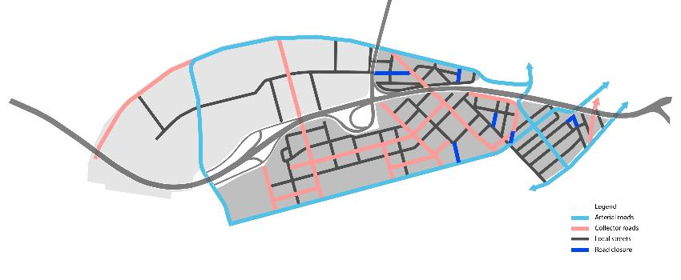

More generally, the road and laneway network can be further refined as part of the precinct planning process to resolve the exact location, width, function and character. The Review Panel supports the Minister and Port Phillip in this regard.

## 320 Plummer Street, 365-391 Plummer Street and 17 Rocklea Drive (S217)

As indicated in Table 2, 320 Plummer Street has a planning permit for three towers of 15, 12 and 12 storeys. The permit has been acted upon and demolition has occurred. The site is partly in the core with a preferred height of 10 storeys and partly in the non-core with a preferred height of 6 storeys. Permits have been lodged for the other two sites and have been called in by the Minister.

Mr Tweedie submitted that the division between core and non-core across 320 Plummer Street is artificial. The site is large at approximately 7,500 square metres and the Review Panel accepts that the boundaries between core and non-core areas cannot necessarily be adjusted to ensure every site is all under one set of controls. Such an outcome may produce other anomalies.

Mr Tweedie submitted that the setback controls are ambiguous, confusing and inconsistently drafted. Mr McGurn appeared mainly concerned about the mandatory nature of the setback controls. He commented on the “*complicated approach*” to setback controls and the assumptions that appear to underpin them. He detailed a number of instances where the proposed mandatory setbacks would unnecessarily limit the development potential of his clients’ sites.

Mr Tweedie submitted that bridge upgrades proposed for Rocklea Drive potentially impacts his client’s property at 17 Rocklea Drive and neighbouring properties. The Review Panel notes that this issue of detail should be resolved in the Precinct Plan.

The Review Panel reaffirms the comments about transitional provisions in the Overview Report.

## 299 Williamstown Road and 11 Salmon Street (S222)

Ms Collingwood made submissions on behalf of Moniton Pty Ltd and relied on evidence from Mr Barnes. He stated that there was an inequity in the burden of the cost of the proposed east-west road which impacts this property. He noted the lack of justification for the mandatory setback controls which is addressed in Chapter 6.10 in respect of 19 Salmon Street.

The Review Panel comments that the equity issue with respect to this and other roads is one that will have to be resolved in the development of the proposed ICP or other mechanism that is used to acquire land to provide this infrastructure. This issue is extensively discussed in Chapters 13 and 14 of the Overview Report.

## 351 Plummer Street (S238)

Kalijo Nominees submitted that their site should be designated as core because it has two street frontages. In the Review Panel’s view this is not adequate justification for including this or any similar property the property in the core.

Kalijo submitted that the heritage designation for the property in not justified in the heritage study. The building referred to is an electrical substation which is recommended in the background Heritage Study for further investigation with a possible view to including it in a proposed Heritage Overlay. The Review Panel offers no further comment on this site.

Appendix A Document list

| No. | Date | Description | Presented by |
| --- | --- | --- | --- |
| W1 | 4/04/18 | City of Port Phillip Urban Design Report for Wirraway | Ms Alvarez, Maddocks |
| W2 | 8/04/18 | Proposed changes to Planning Scheme Maps | Mr Watters |
| W3 | “ | Submission – Minister for Planning | “ |
| W4 | “ | Submission for City of Port Phillip | Mr Montebello |
| W5 | 9/05/18 | Submission of Mr J Armsby and supporting calculations | Mr Armsby |
| W6 | “ | Speaking notes of Mr J Armsby | “ |
| W7 | “ | Presentation by Mr Sheppard | Mr Sheppard |
| W8 | “ | Attachment to Wirraway Report – Revised FAR modelling | “ |
| W9 | “ | Opening submission Jane Group | Mr Wren |
| W10 | “ | Extracts from Hodyl & Co 3d Modelling | Ms Brennan |
| W11 | 10/05/18 | Endorsed Plan 320 Plummer Street | Mr Tweedie |
| W12 | “ | Landscape Plan 320 Plummer Street | “ |
| W13 | “ | Submission on behalf of Third Street | “ |
| W14 | 14/05/18 | Written submission on behalf of Moniton | Ms Collingwood |
| W15 | “ | Map showing Rigby Cooke submitters sites | “ |
| W16 | “ | Cadastral Maps of Rigby Cooke submitter sites | “ |
| W17 | “ | PowerPoint of Mr Barnes presentation | “ |
| W18 | “ | Submission from various landowners represented by Rigby Cooke | “ |
| W19 | 16/05/2018 | Submission from J & D Bowen and Bowen & Pomeroy Pty Ltd | Ms Robertson |
| W20 | 17/05/2018 | Submission from Sel Reklaw Pty Ltd | Mr Canavan |
| W21 | “ | Revised DDO Wirraway Precinct | Mr Watters |
| W22 | “ | Closing submission City of Port Phillip – Wirraway | Mr Montebello |
| W23 | “ | Explanatory table outlining changes to DDO for Wirraway | Mr Watters |
| W24 | “ | Closing submission Minister for Planning | “ |
| W25 | “ | Revised maps accompanying Ministers closing submission | “ |
| W26 |  | Wirraway site information spreadsheet | “ |

1. Fishermans Bend Vision, page 28.
2. Fishermans Bend Framework, page 76.
3. Fishermans Bend Framework, page 76.
4. Hodyl + Co, *Fishermans Bend Urban Design Strategy* (D53), page 88.
5. Hodyl + Co, *Fishermans Bend Urban Design Strategy* (D53), page 69.
6. Port Phillip MSS Review (D66c), pages38-39.
7. City of Port Phillip Urban Design Report (D183), page 45.
8. Minister’s Closing submission for Wirraway (DW24), page7.
9. Submission for CoPP (DW4), [19].
10. Closing submission Minister for Planning (DW24), [9.2].
11. Fishermans Bend Urban Renewal Area Retail Assessment(D196), table 8.3.
12. Minister for Planning Closing submission for Wirraway Precinct (W24), [18]-[19].
13. Expert Evidence of Mr Barnes (D175), [122].
14. Submission for CoPP (DW4), [14]-[18].
15. Closing submission Minister for Planning, [8.1]-[8.3].
16. Opening submission Jane Group (DW9), [9].
17. Submission by J & D Bowen and Bowen and Pomeroy (W19), [14].