

Fishermans Bend Planning Review Panel

Montague Precinct - Report No. 3

19 July 2018

*Planning and Environment Act 1987*

Report pursuant to section 151 of the Act

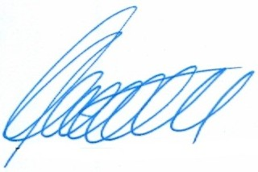 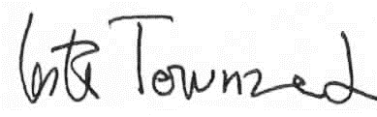

Kathy Mitchell, Chair Lester Townsend, Deputy Chair

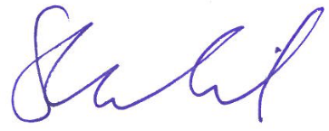 

Sarah Carlisle, Member Rodger Eade, Member



Peter Edwards, Member

Contents

Page

1 Strategic Overview 1

1.1 Precinct context 1

1.2 Existing planning controls 2

1.3 Planning permit application history 3

1.4 Hearing process 4

2 Vision and Framework 6

2.1 Montague Vision 6

2.2 Proposed Urban Structure 6

2.3 Proposed built form 8

2.4 Key issues 8

3 Urban structure and built form 10

3.1 Context 10

3.2 General urban structure 15

3.3 Proposed density 16

3.4 Achieving a varied building typology 17

3.5 Building heights 18

3.6 Street wall heights 19

3.7 Designation of a core retail area and active frontages 20

3.8 Findings 21

4 Location of open space 22

4.1 Context 22

4.2 Submissions and evidence 22

4.3 Discussion 23

4.4 Findings and recommendations 24

5 Location of hubs 26

5.1 Context 26

5.2 Submissions and evidence 26

5.3 Discussion 27

5.4 Findings 28

6 Overshadowing 29

6.1 Context 29

6.2 Submissions and evidence 29

6.3 Discussion 30

6.4 Findings 31

7 Roads and transport infrastructure 32

7.1 187 – 197 Normanby Road ‘no crossovers’ status 32

7.2 Laneways 33

7.3 Other traffic issues 36

8 Site specific issues 37

8.1 Bay Street (S9) 37

8.2 70 – 104 Gladstone Street (S17) 37

8.3 144 Ferrars Street (S57) 37

8.4 6 – 78 Buckhurst Street (S63) 37

8.5 36 – 44 Gladstone Street (S67) 38

8.6 43 - 49, 51 – 65 Buckhurst Street et al (S83) 38

8.7 187 – 197 Normanby Road (S87) and others 38

8.8 2 – 28 Montague Street and 80 Munro Street (S90) and others 39

8.9 171 – 183 Ferrars Street (S93) 40

8.10 156 – 162 Thistlethwaite Street (S115) 40

8.11 176 – 188 Gladstone Street (S123) 40

8.12 245 – 251 Normanby Road (S135), 202-214 Normanby Road (S137) 41

8.13 400 – 430 City Road (S143) 41

8.14 11 – 27, 31 – 41 Buckhurst Street (S146) 41

8.15 37 – 47 Thistlethwaite Street (S156) 42

8.16 189 – 191 Ferrars Street (S164) 42

8.17 253 – 273 Normanby Road (S185) 42

8.18 199 – 201 Normanby Road (S186) 42

8.19 179 – 185 Normanby Road (S200) 43

8.20 168 – 172 Gladstone Street (S201) 43

8.21 272 Normanby Road (S202) 43

8.22 28 Thistlethwaite Street (S237) 43

8.23 121 – 123 Ferrars Street (S244), 111 Ferrars Street (S249) 43

8.24 87 Gladstone Street (S252) 44

8.25 Conclusion of site specific issues 44

Appendix A Document list

List of Tables

Page

Table 1: Interim built form controls (GC50) 2

Table 2: Existing Permits 3

Table 3: Permit Applications 3

List of Figures

Page

Figure 1: The subject land 1

Figure 2: Design and Development Overlay, Schedule 30 2

Figure 3: Proposed building heights in Montague 12

Figure 4: Essential laneways for traffic access and typical restricted access sites 35

**List of Abbreviations (as per Report No. 1)**

Executive summary

#### Summary

This is Report No. 3 of the Review Panel which relates to the Montague Precinct. This report must be read in conjunction with Report No. 1 Volume 1 - Overview, and Volume 2 - Amended planning controls. These reports provide the primary findings and recommendations of the Review Panel, in particular, its position on the key components of the draft Amendment and its recommendations for the planning controls. One recommendation includes a revised Design and Development Overlay for Montague.

In this report, the Review Panel responds to a range of site specific issues raised in submissions and recommends further changes where appropriate.

Montague is a diverse area of Fishermans Bend. Its proximity to the CBD makes it a key Precinct, and it will have the greatest density of built form. Montague North will take the higher levels of built form and this will graduate down to four and six storeys on the southern and western boundaries of Montague South. Much of Montague is likely to be punctuated by taller buildings due to permits already granted, and some applications yet to be considered. If done well, this could add diversity and interest to parts of the Precinct.

#### Findings

In relation to the key issues for the Montague Precinct, the Review Panel finds:

* The built form of Montague will comprise diverse outcomes in the form of high-rise, ‘tooth and gap’ and mid-rise typologies, with taller buildings in the inner core and to its north and north east.
* The key spines of Montague and Buckhurst Streets, and City and Normandy Roads, while being major transit corridors, have the potential to be significant boulevards that cater for pedestrians and cyclists.
* The ‘tooth and gap’ typology for Buckhurst Street is supported, but not the reduced heights sought by Council.
* The gritty urban built form of areas within Montague South should be celebrated as defining features to enhance its overall urban context.
* The discretionary and mandatory building heights for Montague are supported as shown in the revised Map 3 to the Montague Design and Development Overlay.
* The Review Panel supports the deletion of the secondary active frontages designations for Johnson Street and the northern part of Montague Street from Map 3 in the revised Montague Design and Development Overlay.
* The allocation of the public open spaces as shown in DM1A in Montague is generally sound. Open spaces are well spaced and located. Key open spaces include:
  + Montague Park and its extension to the north of the tram line
  + Montague North Park
  + the central spine along the tram line between Woodgate and Gladstone Streets
  + smaller parks north and south along Thistlethwaite Street
  + linear parks along Johnson Street and Ferrars Street
  + the through block park from Gladstone to Buckhurst Street, west of Montague Street.
* The removal of the public open space from 87 Gladstone Street is supported.
* There is merit expanding the major area of public open space in the triangle of the West Gate Freeway, Montague Street and Munro Street, supported by a Precinct wide Sport and Recreation Hub.
* The designation of open space on the Wadhawan Holdings site at 400 – 430 City Road should be retained, but a note added to show that it is in an indicative location only, subject to site design. It should not be required to be handed over as public open space (and therefore should not be counted as public open space), but it should be designed to provide a link from City Road though to the tram stop next to the school in Railway Place.
* There is merit in the Arts and Culture Hub being located on the site of the existing school at Montague Street as per Port Phillip’s proposed urban structure, however no change to the draft Amendment or draft Framework is required.
* The exhibited heights for 400 – 430 City Road are supported, but any future development should be designed to ensure that it does not overshadow the footpaths at the South Melbourne Market.
* Further site access investigations can be undertaken as part of a planning permit application for 187 – 198 Normanby Road.
* The final location of laneways will be resolved and clarified during the Precinct plan and/or permit application stage. Critical laneways, namely at the rear of 562 and 600 City Road, and between Arthur and Alfred Streets should be so designated on Map 1.

#### Recommendations

Based on the reasons set out in this Report, the Review Panel recommends that the Minister for Planning progress draft Amendment GC81, subject to the following changes:

1. Amend Map 2 to the Montague Design and Development Overlay to show the whole of the Montague North site as public open space.

2. Amend Map 2 to the Montague Design and Development Overlay to show the open space designation on the site at 400 – 430 City Road as ‘communal open space – location indicative, subject to site design’.

# Strategic Overview

## Precinct context

The Montague precinct is located in the City of Port Phillip and is 43 hectares in size, with a net developable area of 25 hectares (Refer to Figure 1).

It is bound by the West Gate Freeway to the north, City Road to the east, Boundary Street to the south and Johnson Street to the west. The Precinct is supported by the 109 and 96 trams. Montague has two distinct neighbourhoods (North and South), and is characterised by its wide streets and ‘gritty’ urban form of laneways with some heritage buildings.

The Precinct has benefited from the construction and opening of the new Ferrars Street Primary School and a 0.8 hectare area of open space to be known as Montague Park located diagonally opposite the school.

Montague is an area vulnerable to flooding.[1]

Figure : The subject land

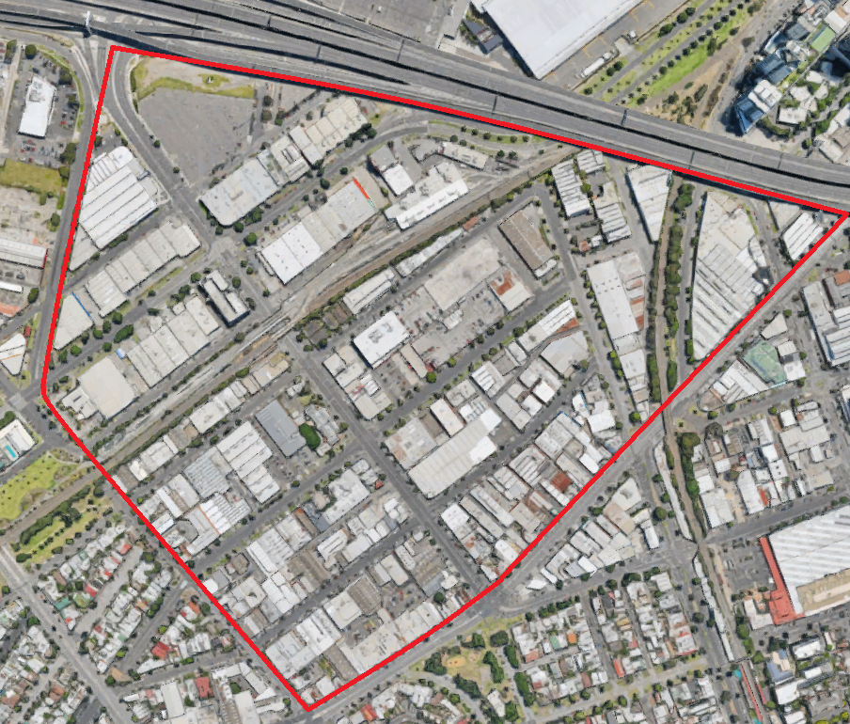

Source: Google Maps

## Existing planning controls

Schedule 1 to the Capital City Zone (CCZZ) and Schedule 30 to the Design and Development Overlay (DDO) currently apply to Montague, through Amendment GC50 (Refer to Figure 2).

Figure : Design and Development Overlay, Schedule 30

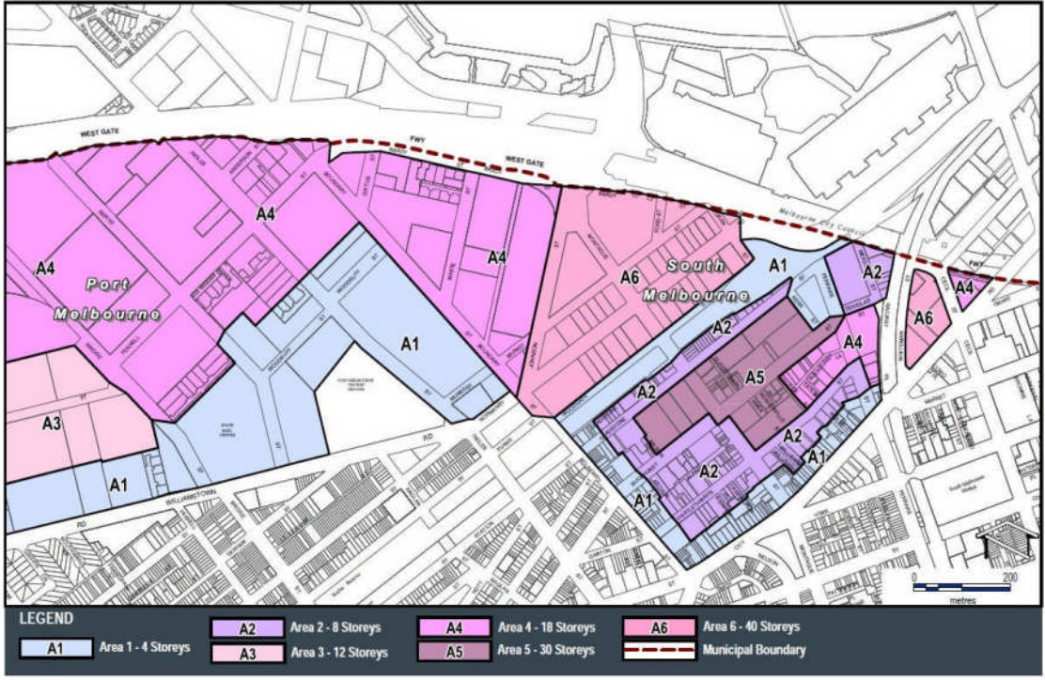

Under Schedule 30, Montague is split into six areas (A1-A6) with varied maximum building heights. A6 is predominantly located in the northwest of the precinct, with a small section in the northeast also designated. A6 has a maximum height of 40 storeys, which contrasts with the proposed maximum heights of 24 storeys under the draft Amendment.

A significant proportion of permit activity in the area has sought to utilise these existing maximum building heights in North Montague, with 13 permits and permit applications for 40 storeys or higher.

The current interim built form controls are shown in Table 1.

Table : Interim built form controls (GC50)

|  |  |
| --- | --- |
| Built Form Element | Requirement |
| Building height | Mandatory maximum:  A1 - 4 Storeys  A2 - 8 Storeys  A3 - 12 Storeys  A4 - 18 Storeys  A5 - 30 Storeys  A6 - 40 Storeys |
| Street wall height | Mandatory maximum 5 storeys or 20 metres, whichever is lesser |
| Tower setback | Mandatory minimum 10 metres to the street edge  Mandatory minimum 10 metres to all other boundaries  Setback can be taken from centre of laneway (if applicable) |
| Tower separation | Mandatory minimum 20 metres |

## Planning permit application history

Montague is the most active of the Fishermans Bend precincts and has had a significant number of planning permit approvals and applications. Consequently, Montague is under the most pressure regarding potential development opportunities.

There are currently 16 existing permits as detailed in Table 2.

Table : Existing Permits

| Address | Submitter | Permit | Proposed FAR |
| --- | --- | --- | --- |
| 199-201 Normanby Rd | 186 | 40 storeys/125.4m | 6.3:1 (core) |
| 202-214 Normanby Rd | 137 | 40 storeys/140.8m | 6.3:1 (core) |
| 228-238 Normanby Rd | 120 | 40-50 storeys/165.1m | 6.3:1 (core) |
| 245-251 Normanby Rd | 135 | 40 storeys/134.1m | 6.3:1 (core) |
| 253-273 Normanby Rd | 185 | 36-40 storeys/135.9m | 6.3:1 (core) |
| 134-142 Ferrars St | No sub | 18 storeys/66.4m | 6.3:1 (core) |
| 171-183 Ferrars St | 93 | 20 storeys/88.7m | 6.3:1 (core) |
| 51-59 Thistlethwaite St | No sub | 8 storeys/26.9m | 3.6:1 (non-core) |
| 6-78 Buckhurst St | 63 | 30 storeys/102.1m | 6.3:1 (core) |
| 134 – 150 Buckhurst St | 131.1 | 30 storeys/96.5m | 6.3:1 (core) |
| 15-85 Gladstone St | No sub | 27-30 storeys/99m | 6.3:1 (core) |
| 89 Gladstone St | No sub | 30 storeys/99m (constructed) | 6.3:1 (core) |
| 179 Gladstone St | No sub | 7 storeys/23.7m (expired) | 3.6:1 (non-core) |
| 165-167 Gladstone St | No sub | 8 storeys/27.5m | 6.3:1 (core) |
| 10-16 Boundary St | No sub | 4 storeys/13.3m | 3.6:1 (non-core) |
| 15-35 Thistlethwaite St | No sub | 8 storeys/27.8m | 6.3:1 (core) |

There are currently 20 ‘live’ planning ermit applications (Table 3). Of those permit applications, 14 have been ‘called in’ by the Minister.

Table : Permit Applications

| Address | Submitter | Permit application | Proposed FAR |
| --- | --- | --- | --- |
| 179-185 Normanby Rd | 200 | 25 storeys/107.8m (called in) | 6.3:1 (core) |
| 187-197 Normanby Rd | 87 | 40 storeys/163.7m (called in) | 6.3:1 (core) |
| 203-205 Normanby Rd | 95 | 40 storeys/128.9m (called in) | 6.3:1 (core) |
| 207-217 Normanby Rd | No sub | 39 storeys/128.1m (called in) | 6.3:1 (core) |
| 235-243 Normanby Rd | 207 | 40 storeys/138.5m (called in) | 6.3:1 (core) |
| 240-246 Normanby Rd | 230 | 40 storeys/136.8m (called in) | 6.3:1 (core) |
| 248-254 Normanby Rd | 96.1 | 39 storeys/129.2m (called in) | 6.3:1 (core) |
| 256-262 Normanby Rd | 96.2 | 38 storeys/126.6m (called in) | 6.3:1 (core) |
| 264-270 Normanby Rd | 96.3 | 40 storeys/135.9m (called in) | 6.3:1 (core) |
| 272-280 Normanby Rd | 202 | 40 storeys/131.8m (called in) | 6.3:1 (core) |
| 2-28 Montague St | 90 | 37-40 storeys/158m (called in) | 6.3:1 (core) |
| 91-95 Montague St | 94 | 30 storeys/97.5m (called in) | 6.3:1 (core) |
| 123 Montague St | 173 | Application lapsed on 8 November 2013 | 6.3:1 (core) |
| 144-148 Ferrars St | 57 | 5 storeys/21.2m | 3.6:1 (non-core) |
| 163-169 Ferrars St | No sub | 18 storeys/68.5m (called in) | 3.0:1 (non-core) |
| 400-430 City Rd | 143 | 39-40 storeys/142.2m (called in) | 6.3:1 (core) |
| 37-47 Thistlethwaite St | 156 | 8 storeys/28.2m | 3.6:1 (non-core) |
| 156-162 Thistlethwaite St | 115 | 4 storeys/13.3m | 3.6:1 (non-core) |
| 31-41 Buckhurst St | 146 | Application refused | 6.3:1 (core) |
| 166-168 Buckhurst St | 131.2 | 20 storeys/60.1m | 3.6:1 (non-core) |

The only residential development of note that has been constructed so far in Montague is the 30 storey ‘Gravity’ building on the corner of Montague and Gladstone Streets. The Review Panel does not regard this building as exemplary built form, nor should it be considered as the model going forward, particularly in relation to the way in which it has attempted to resolve the flooding constraints.

The Review Panel notes a report in the Herald Sun of 12 July 2018 that an amended permit has been granted by the Minister for a 40 storey development at 199 – 201 Normanby Road. This site is located in the core of Montague North in an area now subject to a 20 storey discretionary height limit under the proposed planning controls.

## Hearing process

The Montague Hearing was held over 13 days, generally between 18 April and 8 May 2018.

There were in the order of 38 written submissions in relation to Montague, of which approximately 26 submitters spoke to and/or called evidence in support of their submission at the Hearing.

Ms Collingwood, Mr Canavan and Mr Tweedie, and Mr Wren each represented multiple submitters at the Montague hearings.

The findings and recommendations of the Review Panel for Montague are based on the Minister’s Part C planning controls as tabled on 14 May 2018.

The Review Panel has not analysed and responded to every issue raised in every submission in detail, rather it has focussed on the higher order issues that impact on the planning controls proposed by the Minister and as amended by the Review Panel through Report No.1, Volumes 1 and 2.

Many of the issues raised in submissions and evidence in relation to Montague have been discussed in the Overview Report. The findings and recommendations of the Overview and Amended planning controls reports are relevant to Montague.

# Vision and Framework

## Montague Vision

The Vision for Montague in summary, is for a diverse and well-connected mixed-use Precinct celebrating its significant cultural and built heritage and network of gritty streets and laneways. The Precinct will comprise two neighbourhoods, each with their own distinct characteristics.

The northern neighbourhood will be strongly focused on mix-use and will include a vibrant boulevard along Normanby Road and cycling connections which link the Precinct to the CBD. It is this part of the Precinct that will accommodate the highest built form.

The southern neighbourhood will comprise a network of gritty streets and laneways that will support an array of local businesses such as cafes, shops and creative industries. The area is proposed to be diverse and lively which will contribute to its eclectic and vibrant character.

Montague will be well linked to the surrounding precincts and the CBD. It will feature several walking and cycling connections as well as a high frequency light rail and buses to connect with business, retail and employment destinations. The proposed Arts and Cultural, and Education and community hubs on Ferrars Street will provide focal points for the local community. They will be connected by the Buckhurst Street green spine, which will be at the heart of the Precinct and which will provide a “*cosmopolitan destination for retail and dining while fostering community interaction*”. [2]

The Precinct Directions from the Vision are[3]:

* celebrate heritage buildings and urban form, including fine-grain built form and laneways
* strengthen links to surrounding places, including South Melbourne, Albert Park, Bay Street, South Wharf and Docklands
* support a vibrant Buckhurst Street anchored by community hubs through mixed-use developments, active street edges and high quality public realm
* establish a green spine through the precinct along Buckhurst Street
* support two distinctive neighbourhoods to the north and south of the 109 tram line.

The target population is for 20,800 residents in 9,244 households, and a workforce of 4,000 jobs by 2050[4].

## Proposed Urban Structure

The proposed urban structure for the Montague Precinct is shown in Figure 3.

Figure 3: Urban structure Montague

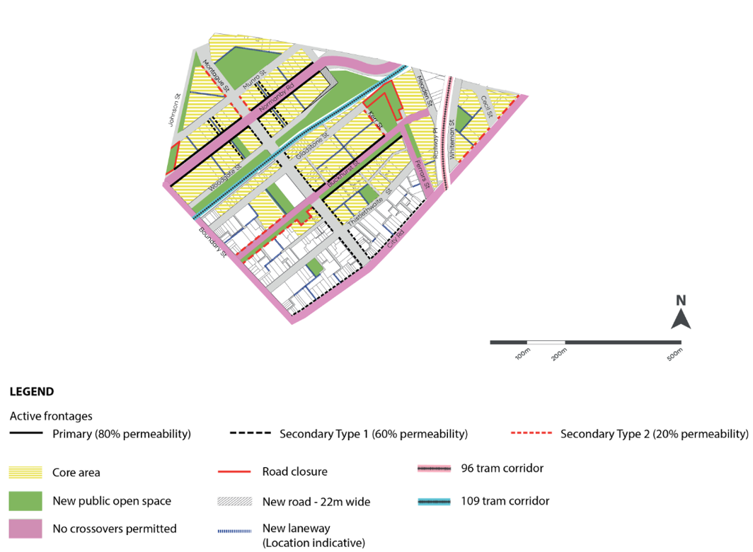

Source: Minister Part C, Map 1a (D317)

Normanby Road and Buckhurst Street are nominated as key active civic spines where a high quality pedestrian environment is sought. The core retail area is proposed along Buckhurst Street which will be complemented by the street’s green spine.

Heavy rail is no longer anticipated in the Montague Precinct. Instead, the Precinct is intended to be serviced by light rail.

Existing laneways are proposed to be connected and completed as through-block links (Montague South), and creation of new north-south links (Montague North) are proposed to improve connectivity to the Normanby Road boulevard.

Port Phillip helpfully prepared and provided an Urban Design Report for Montague (DM3B) which set out its Vision, preferred character and proposed changes for the Precinct, as well as its proposed Urban Structure. This report was well considered and articulated and provided the Review Panel with clear guidance and Port Phillip’s intent on how it saw Montague developing. This is not to say that the Review Panel agreed with all that Council put forward, but it appreciates the work that went into the Urban Design report, particularly in setting out the Montague Urban Structure. As Mr Montebello noted:

So far as Montague is concerned, Council’s Montague Urban Design Report (Montague Report) is a comprehensive document that builds on the Council ‘s endorsed submission of 13 December 2017. The Montague Report critically assesses Amendment GC81 against the Vision and further develops the ideas within the Framework. It is a refinement of work that the Taskforce has done. It represented work completed over the last 6 months by highly experienced urban designers, place makers and strategic planners.[5]

Some parties questioned the work undertaken by Port Phillip in that they saw it representing new work that was not able to be tested. However, as Mr Montebello noted, it was consistent with its written submission and sought to provide its response in plan form through the Urban Structure Plan.

The Review Panel makes the point that it would have been useful had this level of detail been prepared by the Minister for all Precincts as part of the exhibition material. This was a matter that the Minister did pick up on later in the hearing process. Such plans as prepared by Port Phillip (and for the Sandridge and Wirraway Precincts) go a long way towards highlighting how the Precinct Plans could be developed.

## Proposed built form

The *Urban Design Strategy* defines the preferred building typology in Montague as:

Tower developments are still supported in Montague North, however the overall heights have been reduced to align with revised density targets and to increase the amount of sunlight reaching the southern side of streets, particularly Normanby Road, to support the creation of a high-quality civic spine. In Montague South, height limits are set to maximise the amenity of the Buckhurst St local centres and to transition overall height limits towards the lower scale precincts of South Melbourne. Generally 8 storey height limit in the non-core areas is proposed, reducing to 4 storeys at the interface.[6]

The tallest built form for Fishermans Bend is anticipated in Montague North and parts of Montague South. Tower form is not supported in the non-core areas of Montague.[7]

The proposed DDO schedule provides for maximum discretionary building heights in the Montague core of 12-24 storeys (42.2 - 80.6 metres), with smaller areas with maximum discretionary heights of:

* 23 metres (6 storeys) on the north side of Montague North Park
* 29.4 metres (8 storeys) on the east side of Ferrars Street
* 29.4 metres and 35.8 metres (8 and 10 storeys) at the southern edge of the core
* 15.4 metres (4 storeys) to the northwest and northeast of the proposed park on Thistlethwaite Street.

## Key issues

In essence, the Review Panel supports the following key changes made by the Minister during the course of the Hearing and these are not repeated in this report or expanded upon:

* general support for the Vision for Montague and its diverse built form character
* general support for the discretionary and mandatory heights for Montague as expressed through the Part C revisions by the Minister
* subject to the Review Panel’s detailed recommendations about the form of density controls in this report and the Overview Report, it supports expanding the Montague core and revising the core density to a FAR of 6.3:1, however, the Review Panel does not support the Port Phillip position to change 134 and 95 to 117 Buckhurst Street from core to non-core
* include the Elmarn (S17), Surveyors Place (S249), Carri Nominees (S123), Marlton Investments (S164) (and relevant surrounding sites) within the Montague core
* provide a Precinct specific DDO for Montague (and the other precincts)
* prepare plans for each Precinct (and the Review Panel considers the Montague Precinct Plan should be largely based on the Urban Structure Plan prepared by Port Phillip)
* delete the open space and overshadowing controls at 87 Gladstone Street
* provide for a new public open space at 101-109 Thistlethwaite Street
* provide a 12 metre wide linear park within the Johnson Street road reserve
* undertake further work on the location of laneways and specify a minimum width of 9 metres for those that provide vehicular access
* promote a ‘tooth and gap’ typology approach to any site with a frontage over 50 metres on the north side of Buckhurst Street (between Montague and Ferrars Streets)
* minimise the risk of overshadowing at the footpaths of South Melbourne Market through the DDO
* increase the height of 123 Montague Street from 12 to 18 storeys.

The remaining key issues to be addressed are:

* urban structure and built form
* location of open space
* location of hubs
* overshadowing of Buckhurst Street and the South Melbourne Market Precinct
* roads and transport infrastructure.

# Urban structure and built form

## Context

#### Building heights

The core area of Montague includes all of Montague North, the area bound by Montague, Thistlethwaite, Kerr and Gladstone Streets, and two smaller parcels south of Montague Street on either side of Buckhurst Street.

Through Clause 21.06-8 and the DDO, six subprecincts are identified in Montague. These are shown in Figure 4.

Building heights vary by location, but these are not directly correlated with the subprecinct boundaries, or the core and non-core area boundaries.

Figure 4: Montague subprecinct map

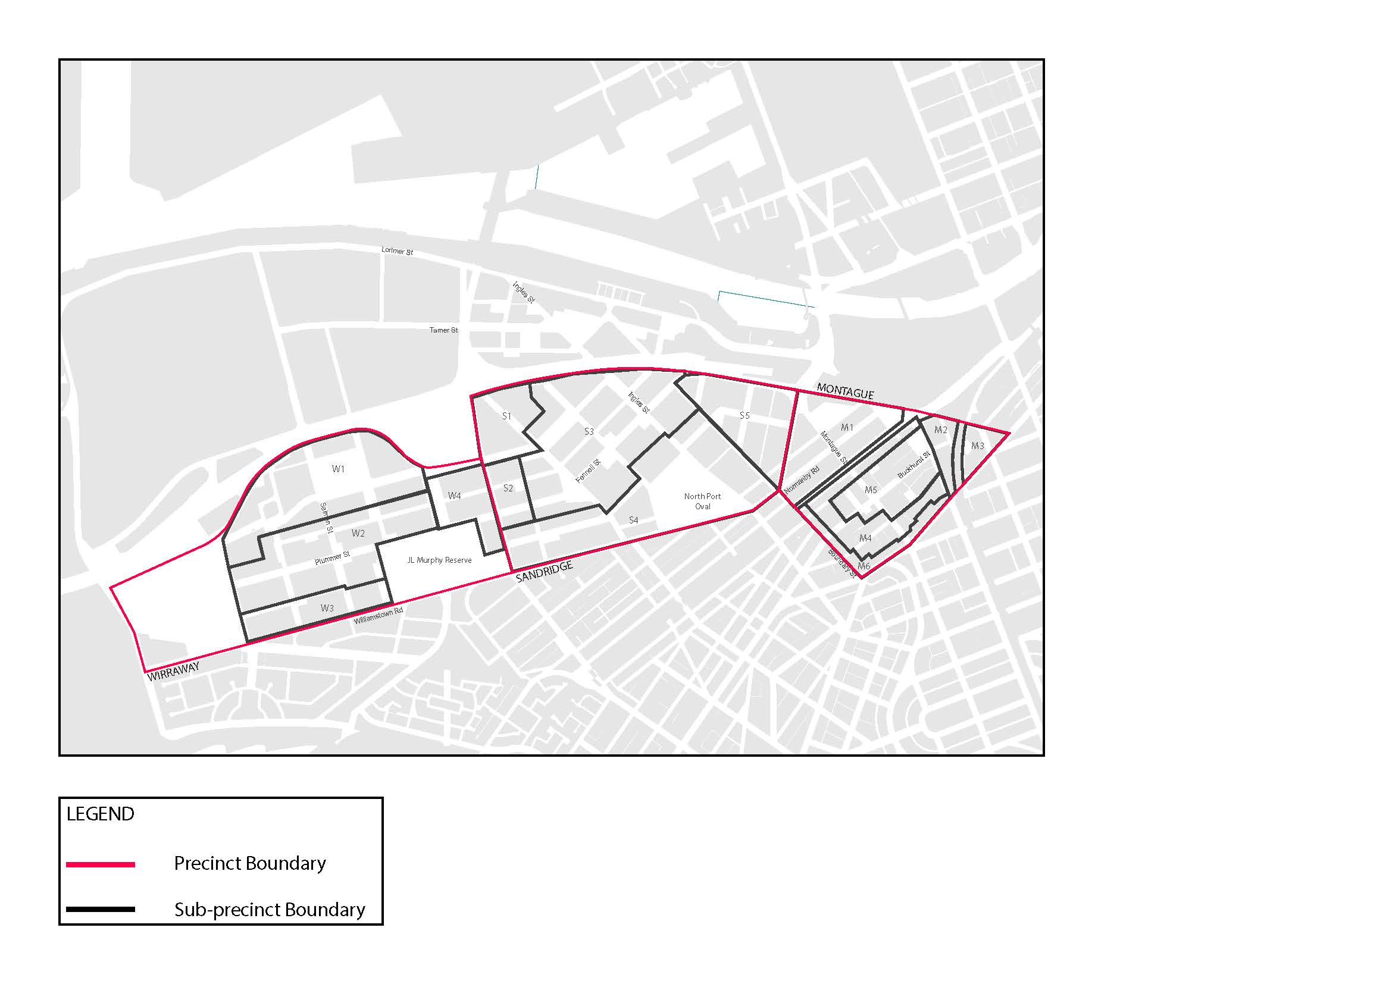

Source: Submission of the Minister for Planning for Montague Precinct (DM2)

M1 is Montague North, which is seen as the gateway to Fishermans Bend from the CBD, and is the area proposed for the highest building heights. The building typology is for mid-rise to high-rise hybrid developments and tower built forms. Montague North is proposed to have active frontages and provide good levels of amenity through access to sunlight. Under the existing planning controls, building heights of up to 40 storeys (mandatory) currently apply, and the Review Panel notes there is significant permit activity in M1 through existing permits and current applications. The proposed preferred discretionary height for M1 range from 20 to 23 storeys, except for an area north of the proposed Montague North Park which is proposed to be 6 storeys.

The M2 subprecinct includes a new vertical primary school which is now operational, diagonally opposite Montague Park, which is under construction. M2 has a preferred discretionary height of eight storeys which will provide for a mid-rise scale of development that allows for some upper levels.

M3 is located in the north east corner of Montague, east of the tram easement and City Road. It will provide for hybrid developments of mid to high-rise developments, with preferred heights ranging from 24 storeys to unlimited. It has few sensitive interfaces.

M4 provides a transition from the central core of M5 to a lower built form typology with preferred maximums of eight storeys. It includes and abuts some sensitive residential areas and interfaces to the M6 area.

M5 is the central area of Montague South, with the key focus on the Buckhurst Street civic spine. It will provide for a range of mid-rise to high-rise tower buildings, including hybrid developments on larger sites, punctuated by well-placed laneways and green spaces. Port Phillip sought to introduce the tooth and gap typology to this area. The preferred discretionary height for M5 ranges from 12 to 20 storeys.

M6 is the transition of the Precinct to South Melbourne through its interface with City Road to South Melbourne, and Boundary Street to Port Melbourne. The mandatory height for M6 is 4 storeys.

The exhibited building heights presented at the opening of the Montague Hearing[8] are shown in Figure 3.

Figure 3 Building heights in Montague

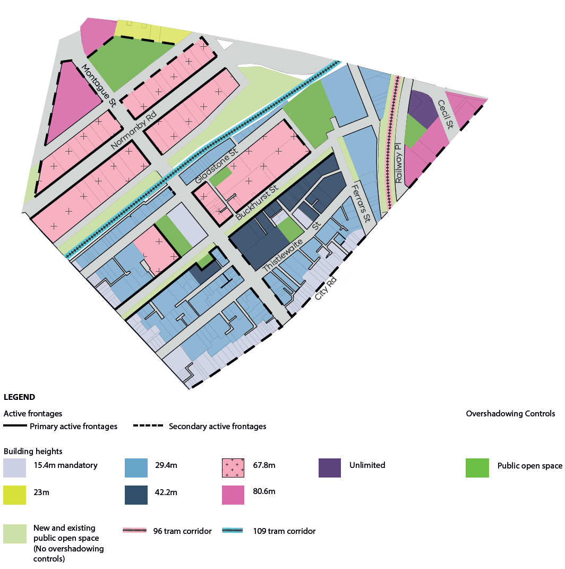

Source: Montague (DM1A), page 1

#### Street wall heights

Street wall height restrictions are proposed to ensure appropriately scaled and distinct street wall effects, street enclosure, sky views, transition to heritage places and adequate sunlight access to streets and open space. Proposed street wall heights vary depending on location.

Table 3: Street wall height

| Location | Qualification | Preferred street wall height | Maximum street wall height |
| --- | --- | --- | --- |
| on City Road |  | at least 4 storeys, except where a lower height is necessary to respond to adjoining heritage places | 4 storeys |
| At 30-38 Thistlethwaite Street, Port Melbourne |  | 6 storeys |
| Normanby Road or Buckhurst Street |  | 4 storeys | General provisions apply |
| Laneways (street ≤9 m) |  | 4 storeys | 6 storeys |
| On a street >9m and ≤22m wide |  | at least 4 storeys in height, except where a lower height is necessary to respond to adjoining heritage places | 6 storeys |
| On a street >22m wide | where the building height is ≤10 storeys | 8 storeys |
| where the building height is >10 storeys | 6 storeys |

#### Setbacks above street walls

There are a number of requirements for setbacks above the street wall which are proposed to ensure comfortable wind conditions, adequate sunlight access to streets and laneways, sky views and minimise visual bulk. Setbacks above the street wall vary depending on building height and location.

Table 4: Setbacks above the street wall

| Location | Qualification | Preferred Setback | Minimum Setback |
| --- | --- | --- | --- |
| where the building has direct interface with:   * West Gate Freeway; * CityLink overpass; * Route 96 tram corridor, Route 109 tram corridor. | if the building height is ≤ 8 storeys | 5 metres | 3 metres |
| if the building height is > 8 storeys | 10 metres | 5 metres |
| on City Road. |  | None specified | 10 metres |
| If the building fronts City Road |  | As specified for other locations | 10 metres |
| Other locations | if the building height is ≤ 8 storeys | 5 metres | 3 metres |
| if the building height is > 8 storeys and ≤ 20 storeys | 10 metres | 5 metres |
| if the overall building height is > 20 storeys | 10 metres | 10 metres |

#### Side and rear setbacks

Below street wall height, the preference is for buildings to be built to the side and rear boundaries, to create a continuous wall along all site frontages. Upper level side and rear setbacks (above street wall height) vary according to the building’s ground level setback, height and location.

Table 5: Side and rear setbacks

| Part of building | Building height | Qualification | Preferred setback | Minimum setback |
| --- | --- | --- | --- | --- |
| Below the street wall height |  | if not within 300 mm of a side or rear boundary | 9 metres | 6 metres |
| Above the street wall height | ≤ 20 storeys | where the building below the street wall is built on the boundary | 10 metres | 5 metres |
| Other buildings | 10 metres | 10 metres |
| > 20 storeys | where the building has direct interface with:   * West Gate Freeway * City Link overpass | 10 metres | 5 metres |
| Other buildings | 10 metres | 10 metres |

#### Building separation within a site

Building separation requirements are proposed to protect internal amenity, allow sunlight penetration to open space and streets, and ensure tall buildings do not appear as a continuous wall when viewed from street level or the Yarra River. Greater separation is required between tower elements above the street wall height. Building separation requirements above the street wall height vary depending on building height.

Table 6: Minimum building separation within a site

| Part of building | Qualification | Preferred building separation | Minimum building separation |
| --- | --- | --- | --- |
| Below the street wall |  | 12 metres | 6 metres |
| Above the street wall | A new building up to 20 storeys in height | 20 metres | 10 metres |
| A new building over 20 storeys in height | 20 metres | 20 metres |

## General urban structure

#### Submissions and evidence

The Minister submitted that the built form and urban structure as exhibited in the controls expressed the built form outcomes and preferred character sought through the Vision and the draft Framework.

Port Phillip preferred a refinement of the building heights and in the main, a reduction in the overall heights to reflect its proposed urban structure. Much of this was driven by the avoidance of overshadowing on key civic spines and the South Melbourne Market area. Port Phillip relied on its Urban Structure Report to define the overall heights and submitted[9]:

The character area/neighbourhood breakdown that is currently proposed for Montague in the MSS [should] be modified to allow for more refined guidance to be provided about the built form outcomes and architectural typologies that are anticipated for Montague.

Both the Minister and Port Phillip supported the distinction between Montague North and South, and the lower built form edge along City Road (to Ferrars Street) and Boundary Road. Port Phillip preferred that subprecincts M2 and M4 be combined, and include the area to the south of Montague Street.

Port Phillip proposed that Buckhurst Street, which it regarded as the most important street in Montague, *“be reimagined as a “high street” anchored by community facilities, characterised with a very high landscape quality and a range of fine grain retail, convenience shopping, local services, cafes and restaurants”.* It supported mid-rise development in Montague South, higher rise in Montague North and lower heights at the edges of Montague South to assist its integration into the adjacent areas of South Melbourne and Port Melbourne. Further, Port Phillip sought the creation of a ‘high line’ style elevated park above the route 109 tram line.

Submitters preferred a higher built form, especially in the core area and in Montague North. Many, including Mr Sheppard, noted that the character of Montague has already emerged and is defined due to the extent of planning permits already issued that, if acted upon, would have a 30 to 40 storey high-rise typology. Mr Sheppard argued that “*the horse has already bolted*”, and the general urban structure should be based upon what he considered will be the emerging character of Montague.

Mr Tweedie in opening noted that in relation to the existing permits and current applications, these must form part of the context and structure of Fishermans Bend. He and other landholders noted the existing permits and their potential to influence built form should not be ignored. Mr Montebello challenged the notion that permits that have not been acted on can define an emerging character.

#### Discussion

The Review Panel considers that in the main, the general urban structure of Montague is reasonable and can be achieved. It has a variety of building heights and typologies that will provide for an interesting and diverse built form outcome. There is little doubt that Montague will provide the majority of higher built form in Fishermans Bend, but given its abuttal with Southbank and the CBD of Melbourne, it will provide for an appropriate transition to the lower built form of Sandridge and other adjacent areas.

The Review Panel considers that even if *“the* *horse has already bolted*” in Montague and some of the current permits are acted upon, and others approved, Montague will have a varied built form outcome, albeit somewhat taller than proposed by this draft Amendment. However, it does not mean that all building heights should revert back to those currently in place under Amendment GC50.

## Proposed density

The proposed Floor Area Ratio (FAR) controls for the Montague core area are 6.1:1 with a minimum commercial FAR of 1.6:1. The Montague non-core FAR controls are proposed at 3.6:1.

For reasons outlined in the Overview Report, the Review Panel does not support the FARs, and recommends that they be replaced with a dwelling density control. Chapter 7.8 of the Overview Report explains the rationale for the Review Panel’s recommended dwelling densities in each precinct. They are based on the FARs, translated to dwelling densities. The starting point for Montague is a dwelling density of 400 dwellings per hectare in the core area and 263 dwellings per hectares in the non-core (see Table 16 in Chapter 7.8(ii) of the Overview Report).

The Review Panel found that:

* the target population of 80,000 for Fishermans Bend is too low, given its status as a State significant urban renewal area and its potential to provide a greater contribution to help cater for Melbourne’s growth
* planning for Fishermans Bend should proceed on the basis of a target population in the range of 80,000 to 120,000 by 2050
* all of the preferred typologies can deliver residential densities of at least 4:1
* there is scope to increase the densities without compromising the building typologies and preferred characters, with the possible exception of Lorimer, Montague core and Sandridge core (where the proposed densities are already higher than 4:1).

These findings are discussed in detail in Chapters 6 and 7 of the Overview Report.

This raises the question of by how much the densities for each precinct should be increased.

For Montague, the Review Panel considers that a dwelling density of 440 dwellings per hectare in the core area and 290 dwellings per hectare in the non-core is appropriate. This represents a modest 10 per cent increase in the densities proposed by the Minister in the Part C controls. This is because:

* Montague provides a natural transition from the built form of the Melbourne CBD and Southbank, and has a number of areas where a taller built form typology is encouraged due to few amenity impacts
* the successful renewal of Montague is not particularly dependent on public transport, as it is the only Precinct that is currently well served. It can therefore accommodate higher densities than some other Precincts (including a modest 10 per cent increase)
* a more substantial increase in density is not considered appropriate, because the densities in Montague are already relatively high, and if the live permit applications for Montague were approved and built, the dwelling targets for Montague would be significantly taken up (as demonstrated by the Minister’s SIN 15[10]), although there is room for some further residential development.

The Review Panel therefore recommends that the dwelling density for Montague be set at 440 dwellings per hectare in the core area and 290 dwellings per hectares in the non-core.

## Achieving a varied building typology

#### Submissions and evidence

Port Phillip argued that Montague could be enhanced by having a precinct specific DDO (which the Review Panel has already agreed to in the Overview Report) that includes statements relating to the preferred built form outcome and architectural typologies for each neighbourhood within the Precinct[11] (DM3A, Figure 3). Further, Port Phillip strongly advocated for a ‘tooth and gap’ typology for the north side of Buckhurst Street. It said:

Consideration should be given to a different approach to the traditional street wall and tower setback approach for Buckhurst Street between Montague Street and Ferrars Street to create a diversity of heights at the street interface and maximises sunlight penetration.

Landowner submissions predominantly argued that the controls were overly prescriptive and contrary to performance based planning, and would act to stifle architectural expression, innovation and site responsive design. Submitters generally argued in favour of discretionary planning controls with a higher built form typology. There was some support for tower forms in Montague North and lower forms to the south, however landowners submitted that the proposed heights in the draft Amendment were too low.

Mr McGurn gave evidence that it is imperative that opportunities in Montague be maximised due to its proximity to the CBD and that the planning controls should assist to deliver optimal opportunity for delivering on Government outcomes, including playing a greater role in accommodating Melbourne’s growth.

Port Phillip disagreed entirely with that proposition and argued it would be a ‘lost’ opportunity if the existing controls were allowed to continue.

#### Discussion

The Review Panel generally supports the built form controls for Montague, and considers that they will deliver building typologies and diverse built form outcomes sought through the Vision and the draft Framework. Through its Overview Report, the Review Panel has made significant changes to the DDOs to better articulate the built form outcomes, preferred typologies and preferred character sought for each precinct. The Review Panel is confident that these changes will assist in delivering the varied building typology sought in Montague.

One of the features of Montague is its gritty urban built form, with bluestone lanes and heritage buildings. These should be celebrated as being key characteristics and defining features of Montague. New development should work to support this character to ensure and enhance a diverse and interesting built form outcome.

The Review Panel notes that the revised building typology (Map 1 in revised DDO, D307) shows some changes, which it supports.

## Building heights

#### Submissions and evidence

The Minister submitted that the varied building heights proposed for Montague were necessary to maintain a clear distinction between the higher built form in Montague North and the lower built form in Montague South, as well as the varied building typologies and preferred character envisaged for Montague through the Vision and the draft Framework.

Port Phillip argued for lower heights in the following areas:

* scaling down from 30 to 12 storeys on the south side of Gladstone Street, from Montague to Kerr Streets (to create a transition through to Montague Park)
* from 20 to 12 to 8 storeys on the north side of the Buckhurst Street spine (to prevent shadow along the open space spine)
* from 24 and unlimited to 12 to 20 storeys at 400 – 430 City Road (to prevent overshadowing of the adjacent South Melbourne area).

Many of the existing permits along Buckhurst Street allow 30 storeys. When asked by the Review Panel about the extent of change proposed by Port Phillip in relation to the Buckhurst Street spine, and whether this could be achieved given the existing permits, Mr Montebello responded that there would need to be good landholder collaboration. He noted that “*permits do not last forever*”. He argued this spine is the critical area of Montague South and it provides the opportunity to exploit the FAU to achieve greater heights in some areas, with lower built form in others (the ‘tooth and gap’ approach). He observed Port Phillip was putting its efforts into place making in this area, and was not seeking any substantial changes in Montague North in terms of height.

Building heights were the focus of many submissions in Montague. The majority of these submitted that heights should be as they currently stand under Amendment GC50, but expressed in discretionary terms. It was argued that changes in heights from the interim controls have not been justified and do not appear to be able to achieve projected population and job targets, creating a risk of underdevelopment. Many argued strongly that existing permits should be recognised under provisional arrangements, and should influence the proposed heights in Montague.

#### Discussion

The Review Panel supports the revised building heights (Map 2 in revised DDO, D307) that indicate some changes, including:

* Increase in height in Area M6 along City Road up to Ferrars Street (from four storey mandatory to six storey mandatory). The six storey mandatory is appropriate given the role and function of City Road and the transition down from the eight storey M4 area.
* Increase in height on the extended corner of Thistlethwaite and Montague Streets (from 12 to 18 storeys) given its prominent position and landholdings and that it enables a range of outcomes, including laneways.

As the Review Panel supports the whole of the Montague North Park site to be set aside for public open space, it does not support any heights in this area. However, if this recommendation is not supported, then the revised the six storey height along the northern part of the proposed Montague North Park (no change) but ‘none specified’ in the top north west corner (previously 24 storeys) is supported.

Montague is the area that will develop early in the evolution of Fishermans Bend and will, together with the southern part of Lorimer, have the highest and most likely, densest built form (through the existing permits, any live applications approved and the revised planning controls). This may result in a dense urban area, but this will not be inappropriate given its context in relation to the Melbourne CBD, Southbank and to a lesser extent, Docklands. However, it should not maintain unlimited or 30 to 40 storey heights, nor should the more sensitive areas of Montague be compromised.

Modelling undertaken by Ms Hodyl and others demonstrates that the proposed heights are capable of accommodating the modest increase in densities in Montague recommended by the Review Panel, with some room left for social housing uplift. The heights provide for an appropriate transition from the CBD and Southbank to the lower density areas of South Melbourne and Port Melbourne, and the variation in heights across the Precinct will assist to deliver a well-considered variation in built form.

## Street wall heights

#### Submissions and evidence

Submissions relating to street wall heights generally expressed confusion about the drafting or requested a more contextual, site specific approach in determining the heights.

Through his evidence, Mr Sheppard supported the street wall heights at 11 Montague Street (Montague North Park) to be 8 storeys, a position that the Minister did not support.

#### Discussion

As the Review Panel is supporting the position of Port Phillip with regard to the Montague North Park area (see Chapter 4.3), the issue of the appropriate street wall height at 11 Montague Street is a moot point.

The Review Panel is satisfied that the street wall heights as proposed by the Minister in the Part C controls are appropriate.

In its Overview Report, the Review Panel has undertaken a significant review of how the street wall heights are expressed. This is reflected in the Review Panel’s preferred version of the Montague DDO, contained in Appendix B.5 of Volume 2 of Report No. 1.

## Designation of a core retail area and active frontages

#### Submissions and evidence

Port Phillip submitted that the core area is too large to create vibrant activity centres in Montague, and it should be confined to the block contained within Gladstone, Kerr, Ferrars and Thistlethwaite Streets, with Montague and Buckhurst Streets as ‘main’ streets. Port Phillip supported the application of a DPO over this area to ensure key anchor uses can be properly master planned.

Port Phillip sought several changes to the designation of active frontages in Montague, the key ones including:

* Normanby Road and Montague Street change from ‘primary’ to ‘secondary’ due to the overall width of the roads and the amount of traffic carried
* deletion of the ‘secondary’ designation along the northern edge of Montague North Park
* Deletion of the ‘secondary’ designation along Johnson Street.

In his response, the Minister noted that the extent of the active frontages was being considered in light of the findings of the retail assessment. The Minister provided a revised DDO for Montague the Minister (D307) which showed no change to Normanby Road, but what appears to be a change from ‘primary’ to ‘secondary’ along Montague Street. Further, it appeared to delete the designation along Johnson Street.

#### Discussion

The Review Panel has already commented on the use of a DPO to assist in master planning of key sites and areas on an opt in basis. Once the Montague Precinct Plan is prepared and the extent of the core retail activity area is resolved, this might result in the opportunity to apply a DPO. Further, the appropriate designation of a core retail area could then be designated on the Precinct Plan.

The Review Panel agrees with Port Phillip that finding and identifying an appropriate site for a full sized supermarket and supporting retail will be critical in the first instance as part of the precinct planning process, particularly given the fragmented nature of the landholdings in Montague South.

The Review Panel supports the distinction between primary and secondary active frontages. While it does not agree that the identification of primary and secondary active frontages should be deferred until the precinct planning process, it considers that the extent of primary and secondary active frontages can be further considered in the Precinct Plans and adjusted accordingly if required.

For these reasons, it accepts the designations as shown in the revised DDO for Montague, with the exception of the secondary active frontage designation along Johnson Street, which it considers to be superfluous to its role and function. Given that the Review Panel supports the designation of the whole of the northern area for Montague North Park, it considers the secondary active frontage along its northern edge is not warranted and the Review Panel supports its removal.

## Findings

The Review Panel finds:

* The built form of Montague will comprise diverse outcomes in the form of high rise, hybrid and mid-rise typologies. The Review Panel supports Port Phillip’s proposed ‘tooth and gap’ approach along the northern side of Buckhurst Street between Montague and Ferrars Streets.
* Montague lends itself to taller buildings in the inner core and to its north and north east.
* The key spines of Montague and Buckhurst Streets and the further spines of City and Normandy Roads, while being major transit corridors, have the potential to be significant civic spines that provide good connectivity between various uses.
* The gritty urban built form of areas within Montague South should be celebrated as defining features to enhance its overall urban context.
* The discretionary and mandatory building heights for Montague are supported as shown in the revised Map 3 to the Montague Design and Development Overlay.
* The deletion of the secondary access designations for Johnson and the northern part of Montague Street is supported.

# Location of open space

## Context

The draft Framework provides for a number of sites for ‘Future open space’. These include larger regional open space and a number of linear or connected spines. The key spaces include:

* Montague Park (under construction)
* Montague North Park
* Buckhurst Linear Park
* other smaller spaces located throughout the Precinct.

## Submissions and evidence

Port Phillip made a number of submissions about the location of open space in Montague.

In relation to Montague North Park, Port Phillip submitted that:

The Montague North Park is proposed on existing Crown land, part of which is proposed to be sold for private development. Council submits that the whole of that Crown land should be retained in public ownership and used for the purposes of a park and a Sport and Recreation Hub.[12]

Port Phillip noted that the site is approximately 20,000 square metres, of which 11,000 square metres is proposed for open space, and 9,000 for development purposes.

The Minister did not support this position and noted that the land could provide a significant housing opportunity that would assist in meeting affordable housing objectives.

For the other public open spaces, Port Phillip submitted that it generally supported the proposals provided in the draft Framework and the changes sought by Ms Thompson. Notwithstanding, Port Phillip considered the space proposed for 87 Gladstone Street should be relocated to 34-47 Thistlethwaite Street, opposite a designated space north of the street. The Minister agreed to the deletion of the open space at 87 Gladstone Street, but not the addition of the Port Phillip preferred parcel at 34-47 Thistlethwaite Street. (The Review Panel notes the overshadowing controls that previously applied to 87 Gladstone Street have been amended).

Both the Minister and Port Phillip endorsed the recommendations of Ms Thompson for location of a new space at 101-109 Thistlethwaite Street.

Part of Johnson Street is proposed to be closed with a 12 metre width to be used as linear open space.

There is proposed to be a small increase of 1,333 square metres in public open space as a result of Ms Thompsons recommendations, going from 63,627 to 64, 960 square metres.

Other submissions on open space were generally focused on the unclear justifications for the sites proposed. Many submissions requested clarity on how this open space would be acquired and delivered. These issues are dealt with in the Overview Report.

Wadhawan Holdings Pty Ltd owns the land in the triangle of Railway Parade, City Road and Cecil Street. There is unlimited height to the north of that site and 24 storeys along City Road. One of the issues raised in submission by Ms Collingwood was that the area allocated for public open space (1,835 square metres) is unnecessary, in that it is a poor location for open space. She submitted that, if it is to be provided, it should be in a different location to that shown on the draft Framework.

## Discussion

The Review Panel is generally satisfied with the overall allocation and location of public open space in Montague. Recognising that Montague will be the most densely populated part of Fishermans Bend, there is a good mix of large parks and spaces, with smaller parks and two linear green spines.

**Montague North Park**

The Review Panel considers that the opportunity to provide a larger area of public open space, encompassing the whole of the Montague North Park site, is a good idea. It is land that is publicly owned (currently used for an open lot car park) and unencumbered by development interests. It can be progressed at an early stage in the life of Fishermans Bend without any amenity impact or significant cost, and is large enough to support the Sport and Recreation Hub identified for Montague North.

The Review Panel considers development of the land in this way will provide a green break between the dense development and intrusive built form of the West Gate Freeway and Southbank, and will allow for a gentler entrance into Fishermans Bend from Montague Street. Further, it could be designed to enhance pedestrian and cycle connectivity to the City. The Review Panel questioned Port Phillip on whether the area of 9,000 square metres, if removed as development potential, could be substituted elsewhere, a position which Mr Montebello advised, Port Phillip did not support.

The Review Panel does not consider the remaining development parcel is a good location for housing given its immediate proximity hard up against the West Gate Freeway.

The Review Panel considers that the whole of the Montague North site should be used for public open space purposes. Montague has the lowest amount of open space per resident and worker (see Chapter 9.2 on the Overview Report), and increasing the amount of public open space by expanding Montague North Park will be a good outcome. It agrees with Port Phillip that the expanded park:

* would assist to ameliorate the impacts of the West Gate Freeway
* would create a major civic spine as an entry to Fishermans Bend from Docklands and Southbank
* frees up land for the location of a major Sport and Recreation hub, which will create excellent synergies.

**Wadhawan Holdings site (400 – 430 City Road)**

After further inspecting the Wadhawan site and its surrounds, the Review Panel agrees with the submission of Ms Collingwood. It does not meet the tests of accessibility and usability proposed by Ms Thompson, as it will not be easy to access and use by others external to that site. It therefore considers that public open space at this location is not appropriate.

This is not to say that the site should not provide open space. The Review Panel considers the site is large enough to ensure a superior built form outcome that uses the site well, makes the most of its island nature and provides a large area, equivalent to that designated for public open space, to provide walkways, links and communal open spaces, all of which can be publicly accessible to others accessing the tram stop next to the school in Railway Place, as well as passing through to the school and other community facilities, and the Buckhurst Street spine.

**Other open spaces**

The Review Panel supports the revised open spaces as shown in Figure (vi) of M1A (refer to Figure 3), except for the Montague North site and the specific location for the 400 – 430 City Road site.

The Review Panel observes that if the whole of Montague North is to be designated as public open space, it will add 9,000 square metres to that total of 64,960 as calculated by Ms Thompson. The Review Panel considers that this is appropriate, given the low provision rate of open space in Montague. It will also offset some of the proposed increase in dwelling density for Montague.

## Findings and recommendations

The Review Panel finds:

* The allocation of the public open spaces as shown in DM1a in Montague is generally sound. Open spaces are well spaced and located.
* There is merit in the Port Phillip position of providing the major area of public open space in the triangle of the West Gate Freeway, Montague Street and Munro Street, by expanding the proposed open space to the freeway, supported by a Precinct wide Sport and Recreation Hub.
* The central spine of open space along the tram line between Woodgate and Gladstone Streets is supported.
* The location of Montague Park (diagonally opposite the school) and its extension to the north of the tram line is supported.
* The designation of open space on the Wadhawan Holdings site at 400 – 430 City Road should be retained, but a note added to show that it is communal open space to be accessible to the public, and in an indicative location only, subject to site design. It should not be counted as being public open space, but it should provide a link from City Road though to the tram stop.
* Any future update of the draft Framework should make the public open space changes accordingly.

The Review Panel recommends:

1. Amend Map 2 to the Montague Design and Development Overlay to show the whole of the Montague North site as public open space.
2. Amend Map 2 to the Montague Design and Development Overlay to show the open space designation on the site at 400 – 430 City Road as ‘communal open space – location indicative, subject to site design’.

# Location of hubs

## Context

The draft Framework provides for three ‘Investigation areas – Montague Arts and Cultural Hub’ centred around Montague, Buckhurst and Gladstone Streets.

A further ‘Investigation area - Sports and Recreation Hub’ is centred north-west of Normanby Road to the West Gate Freeway and Johnson Street. Part of this Hub includes the Montague North Park.

The Ferrars Street Education and Community Hub is now operational to the extent that the primary school was opened early 2018. The location of the Investigation Area for this Hub is therefore appropriate, and the Review Panel finds there is no reason to further discuss this hub investigation area.

The key issues to be addressed are the locations of the:

* Arts and Cultural Hub
* Sports and Recreation Hub.

## Submissions and evidence

**Arts and Cultural Hub**

Port Phillip submitted that:

The existing Continuing Education School (a heritage building) on the north-west corner of Montague Street and Buckhurst Street should be specifically shown as a proposed Art and Cultural Hub. The Hub should be co-located with the existing school, or located on the site as a stand-alone facility if the school relocates. [13]

Mr Montebello argued that the site did not need to be shown as an investigation area as the State already owns it.

In closing for Montague, the Minister noted he wished *“ … to preserve the opportunity for the arts and community hub to be provided within the investigation area as part of the FAU scheme”.* The situation regarding the FAU scheme and the potential for FAU and what it might include has changed since this closing statement.

**Sports and Recreation Hub**

While seeking to nominate the whole of the Montague North Park site for public open space, Port Phillip further sought to amend the building heights of 24 and 6 storeys from the northern edge in the DDO. Port Phillip sought a maximum 6 storey height to allow a recreation building that did not overshadow the public open space component.

## Discussion

**Arts and Cultural Hub**

The Review Panel considers that where existing infrastructure can be used to provide community facilities, it should be pursued in the first instance to determine whether it is feasible and practical. Issues to be taken into account (include but are not limited to) include the land ownership (public or private), current uses on the site, opportunities for bringing forward its ultimate use, synergies with other uses and cost of acquisition.

The Montague Continuing Education School site is well located within the Precinct and is currently used for public purposes. It abuts a proposed area of open space linking Gladstone and Buckhurst Streets. Port Phillip submitted it is an ideal site for a community hub and the Review Panel agrees.

**Sports and Recreation Hub**

The Minister supported Port Phillip’s proposal in part, in that the overall height should be reduced from 24 to 12 storeys to prevent overshadowing. While not accepting that 6 storeys is warranted, the Minister agreed to the designation of the land as a potential community hub or for it to be used as affordable housing. He did not agree to expand the totality of the open space over the whole site and noted he wishes to:

… preserve the opportunity to deliver social housing ort other community infrastructure on this parcel of Government owned land in addition to open space.[14]

There was no dispute amongst submitters that Montague North Park should be located as designated in the draft Framework. The key issues to be resolved is the extent of that Park and whether it should be co-located with the Sports and Recreation Hub, as proposed by Port Phillip. The Review Panel agrees with Port Phillip that it should.

The site is large enough to be a well-planned precinct with considerable opportunity to be the precinct wide large open space, complemented by a ‘high ball’ recreation and sports activity area to serve Montague. It does not impose any amenity constraints as it abuts the West Gate Freeway and Montague Street. It has the significant advantage that it is located wholly on Government owned land and that it can be development ready as the population increases in Montague. It will complement the developing Montague Park south of the tram line and will ensure the opportunity for significant open space and recreation facilities. In short it makes use of an area that can take advantage of a large space encumbered by its abuttal against a freeway. The Review Panel is less enamoured to support the site for social or affordable housing abutting a freeway.

## Findings

The Review Panel finds:

* There is merit in the Arts and Cultural Hub being located on the site of the existing school at Montague Street as per Councils proposed urban structure, however no change to the draft Amendment or draft Framework is required.
* The Review Panel supports Port Phillip’s proposal to provide for the Sport and Recreation Hub in the Montague North open space area.

# Overshadowing

## Context

Two specific issues were raised regarding overshadowing. The first relates to the potential for taller building forms to overshadow Buckhurst Street and the second for the proposed buildings on the corner of City Road and Cecil Street to overshadow areas to the south, including the South Melbourne Market. These areas are protected from overshadowing by DDO8 to the Port Phillip Planning Scheme.

## Submissions and evidence

**Buckhurst Street**

Port Phillip submitted that in the Montague retail core, *“Consideration be given to a different approach to the traditional street wall and tower setback approach for Buckhurst Street between Montague Street and Ferrars Street to create a diversity of heights at the street interface and maximise sunlight penetration.”* It argued that the heights should be lowered from 20 to 12 storeys on the north side of Buckhurst Street and to apply the ‘tooth and gap’ building typology. Figure 4 shows the tooth and gap typology and preferred heights sought by Port Phillip.

Figure 4: Tooth and gap typology, with preferred heights

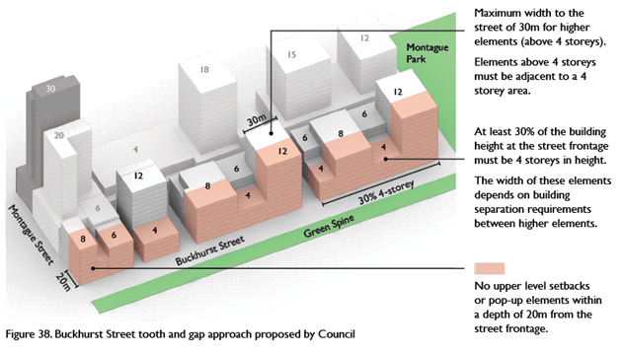

Source Port Phillip submission: DM3a

Port Phillip noted that the key outcomes of the ’tooth and gap’ approach include:

* Variations in height allowing daylight and sunlight into the centre of the block
* Individual buildings providing opportunities for greater variation in volume, appearance and material; and
* Opportunities for small; setbacks to provide pocket parks along the street and or a variety of communal open spaces.

The Minister did not support these recommendations, particularly in the context of the heights proposed. Neither did the landholders.

**Design and Development Overlay 8**

Port Phillip submitted that building heights at 400 – 430 City Road “*… have the potential to cast shadow over areas that are currently protected from overshadowing by mandatory overshadowing controls in the adjoining part of South Melbourne contained within DDO8*”.

It sought to amend the overshadowing requirements in DDO30 to include overshadowing controls for the entire width of the southern footpath on property frontages on York and Market Streets South Melbourne to prevent overshadowing on and around the South Melbourne Market between 11am and 2pm on 21 June. Mr Montebello noted it would be a “*curious outcome*” should this not be rectified.

Further, Port Phillip sought to reduce the building heights in the area bound by City Road, Whiteman and Cecil Streets from 24 to 12-15, and 20 storeys.

The Minister supported this in part and proposed a decision guidelines to ‘minimise’ overshadowing to the Market. However the Minister did not accept the reduction in building heights.

Wadhawan argued strongly against this. It noted that the land is large (1.2 hectares), it is an island site with strong physical barriers, it is well located to access public transport and it is *“Ripe for substantial redevelopment that optimises the amenity benefits of its co-location with the CBD and South Melbourne central”.* Ms Collingwood noted that the site has long been identified for intensive development and through a Priority Development Panel process in 2009, Amendment C83 to the Port Phillip Planning Scheme was gazetted in in April 2010which introduced an Incorporated Plan to facilitate development of the site. A planning permit was granted for a mixed use scheme comprising four towers ranging between 96 and 135 metres for apartments, a hotel, serviced apartments and retail uses.

Ms Collingwood advised that when the former Minister rezoned Fishermans Bend to CCZ, her client’s site was included in that area, even though the land had previously been considered as being part of Southbank. Importantly, DDO8, which applied to the site, was removed. Port Phillip advised that it did not support removal of the overlay.

## Discussion

**Buckhurst Street**

The Review Panel observes that the decrease in height along Buckhurst Street proposed by Port Phillip is a major departure from what currently exists and what is proposed by the draft Amendment, reducing from 30 storey (GC50), 20 storeys (GC81) to 12 (Port Phillip). Additionally, there is currently a live permit approval for four buildings, each at 30 storeys at 6 to 78 Buckhurst Street (Little Lane, S63). This site commences at Kerr Street and takes up half a block. Further along, there is another granted permit, also of 30 storeys at 134 to 150 Buckhurst Street.

The Review Panel notes the Minister did not support the proposed reduced heights, although no reasons were provided for this opinion (DM41).

The Review Panel acknowledges the dilemma that this provides. Port Phillip urged the Review Panel to think about the ultimate Vision it proposed for this part of Fishermans Bend and to not be persuaded by the Minister or the submitters. It saw its proposal as an opportunity to provide for an urban built form that would be a legacy of good planning for an urban renewal area. On balance, the Review Panel supports the exhibited heights.

**Design and Development Overlay 8**

Again, the Review Panel understands the position of Port Phillip but considers that this site has long been designated for a taller built form. It is a site unencumbered by adjacent amenity impacts and the Review Panel agrees with Ms Collingwood, that when viewing it, the site is more aligned to Southbank than Fishermans Bend. The adjacent tram line is an appropriate built form buffer to the areas further south.

The Review Panel supports the position of Wadhawan Holdings in this regard and considers the heights should remain as exhibited, but any final plans for its ultimate development should ensure that there is no overshadowing of the South Melbourne market or its (immediate) adjacent footpath. This specific provision has been included in the DDO for Montague.

## Findings

The Review Panel finds:

* It supports the ‘tooth and gap’ typology for the north side of Buckhurst Street, but not the reduced heights sought by Council. This typology has been include in the revised Montague Design and Development Overlay at Clause 1.0, Table 1 and Table 3.
* It supports the exhibited heights for the Wadhawan site at 400 – 430 City Road, but considers that any future development be designed to ensure that it does not overshadow the footpaths at the South Melbourne Market. This provision has been included in the revised Montague Design and Development Overlay at Clauses 2.5 and 2.8.

# Roads and transport infrastructure

Montague Precinct is envisaged to be a diverse and well-connected mixed use precinct complemented by a network of “gritty streets and laneways”.

The area is currently well served by public transport with the No. 109 tram route bisecting precinct and the No. 96 tram route located towards the eastern edge, bus services operate along City Road and at the northern end of Normanby Road and Montague Street.

Due to the generally smaller block sizes and existing road network, there is only one proposed road (to connect Woodgate Street (south side of South Melbourne Toyota to Normanby Road)) and series of new laneways, some which provide ‘missing links’ by connecting disjointed laneways to enhance permeability.

Mr Kiriakidis, Mr Fooks, Ms Dunstan and Mr Walsh provided a high level review of Fishermans Bend transport network. Ms Dunstan and Mr Walsh then provided site specific expert traffic evidence for developers and land owners.

The majority of roads and transport infrastructure issues centred around laneway locations and their attributes. Laneway attributes, such as location, alignment and function are discussed in the Overview Report, however it is appropriate to briefly discuss site specific issues raised in the Montague Precinct.

The key issues to be addressed are:

* Normanby Road’s ‘no crossover’ status
* laneways.

Other issues raised which are discussed in the Overview Report are:

* parking, land acquisition and compensation mechanisms
* proposed laneways and their attributes (i.e. width, function).

## 187 – 197 Normanby Road ‘no crossovers’ status

Normanby Road is in the Montague core area with primary active frontages and as such, no crossovers are proposed to apply to this road.

#### Submissions and evidence

Mr Tweedie made submissions (DM8) on behalf of Lie Property Group which own 187 – 197 Normanby Road, Southbank – Lie Property Pty Ltd (currently Total Tools South Melbourne) which sits between Normanby Road and Woodgate Street. In particular he argued “it is unreasonable for no crossovers to occur on Normanby Road given the large street frontage and difficulty in solely relying on Woodgate Street considering the existing conditions and likely time required to evolve into a roadway suitable for access”.

The Minister did not specifically respond to this issue.

Port Phillip referred to its Montague Urban Design Report that showed Normanby Road in the core area with its support for the ‘no crossovers’ status for this road.

#### Discussion

The draft Framework and maps identify Normanby Road as a core area and consequently crossovers are discouraged unless there are no other alternatives. Lie Property Group argued that vehicle access should remain on Normanby Road as Woodgate Street access is more difficult, in particular until road widening and connection to Normanby Road occurs.

This site highlights the tension which occurs when developing sites within an area which is transforming. The Review Panel accepts the principles for Normanby Road to be ‘no crossovers’ status are appropriate and as such, this site should provide vehicle access from Woodgate Street. Site inspections confirm that access at the south east corner of the site would be feasible but modifications to existing parking and other works may be required in the short term. Further investigations to determine vehicle access arrangements can be undertaken as part of a planning permit application or during the precinct planning phase.

#### Findings

The Review Panel finds:

* 187 - 197 Normanby Road should utilise Woodgate Street for vehicle access. Further site access investigations can be undertaken as part of a planning permit application.

## Laneways

#### Submissions and evidence

The Minister’s opening submission for Montague (DM2) identified the fine grade laneways and through block links are to provide permeability and connectivity. New laneways are proposed to:

* complete ‘missing links’ between primary and secondary streets
* provide rear/side lane access to buildings
* facilitate connection to the tram and neighbourhood precincts.

Port Phillip referred to its Montague Urban Design Report and suggested additional laneways, modifications to the location and width of a number of other laneways.

The Minister accepted that further work is required, including using GIS software to provide accurate information to be incorporated into the maps. He contended that the precise location of laneways, width, function and character should continue to be shown as ‘indicative’ but would be finalised as part of the Precinct plan phase.

**6 - 78 Buckhurst Street, South Melbourne – Little Lane Early Learning Pty Ltd**

The endorsed masterplan (DM19) for 6 - 78 Buckhurst Street, South Melbourne – Little Lane Early Learning Pty Ltd consists of a four tower-podium development. The draft Amendment’s requirement for vehicular access from a central laneway onto Buckhurst Street is reasonable, however the rear laneway is not required (and was originally not required with the approved plans).

**400 – 430 City Road, Southbank - Wadhawan Holdings Pty Ltd**

Mr Walsh submitted traffic evidence on behalf of Wadhawan Holdings Pty Ltd regarding the draft Amendment’s impact on 400 – 430 City Road, Southbank. It is an island site bounded by City Road (arterial road, ‘no crossovers’, nominated with future on-road bicycle lanes), Cecil Street (strategic cycling corridor) and Whiteman Street.

Mr Walsh’s evidence was that the proposed indicative laneway bisecting the site between City Road and Whiteman Street provides relatively limited benefit to site access considering current spacing of the surrounding road network. The laneway does not benefit access to the light rail stop on Railway Place (next to the school) as the access ramp commences near Whiteman Street/City Road intersection.

From a traffic engineering perspective, Mr Walsh was of the view that this site is isolated from the larger precinct and should be considered separately.

In response, the Minister noted that the laneway can be resolved as part of the precinct plan phase though it is considered that this laneway would provide convenient access to the proposed open space for residents on the east side of Cecil Street.

#### Discussion

The principal issue in the Montague Precinct centred around the additional laneways and their attributes or whether particular laneways were needed.

The Montague Precinct is challenging in relation to providing laneways due the smaller sites, and the range and location of the existing laneway network.

As discussed in the Overview report, the Review Panel recommends that laneways should be shown if they are essential for vehicle access, such as land locked sites or where a road is classified as ‘no crossovers’ and all other laneways should be resolved during the precinct planning phase.

The Review Panel’s assessment of the Montague CCZ Map 1 suggests a number of properties toward the southern end of the precinct would require laneways, essential for traffic access, to support the ‘no crossover’ status of City Road and Buckhurst Street. These are highlighted on Figure 4.

Figure 4 Essential laneways for traffic access and typical restricted access sites



During the course of the Hearing, the Minister agreed to show laneways in the Maps to the DDO as ‘indicative’. The Review Panel supports that position and believes that optimal outcomes, and potentially superior solutions can be realised where flexibility is provided to designers and architects. In the Overview Report, the Review Panel found that non-essential laneways should not be shown on the maps until precinct planning was undertaken. Accordingly, only the two laneways indicated on Figure 4 above should be shown on the maps at this stage.

As such, the laneway issues associated with 6 – 78 Buckhurst Street and 400 – 430 City Road should be resolved during the Precinct plan phase where a finer level of detail will be available.

Figure 5 of the Port Phillip submission shows the existing laneway widths in Montague. The Review Panel considers these contribute considerably to the fine grained character of Montague and as many should be retained as possible in the future planning of Montague. Noting that some of the smaller laneways will need to be widened to fulfil a vehicular access function, retention of these and/or building upon the laneway structure already evident, should be taken into account going forward. The Review Panel agrees with Port Phillip that where there is a more diverse laneway network, a more diverse and modular outcome can be achieved that provides good breaks, and creates pedestrian and vehicular access and permeability.

Further, Port Phillip noted that in the case of George Street, *“… an emerging character of laneway activation has already started to occur. Council considers there is an opportunity to make these laneways the key feature of Montague South”,* a position with which the Review Panel agrees, particularly to ensure they do not evolve into access streets.

#### Findings

The Review Panel finds:

* Only the two laneways indicated on Figure 4 above should be included on the maps. The final location of laneways will be resolved and clarified during the Precinct plan and/or permit application stage.

## Other traffic issues

Ms Dunstan submitted traffic evidence on behalf of Samma Group and Spec Property Development Pty Ltd (S202) regarding the draft Amendment’s impact on 272 – 280 Normanby Road, South Melbourne.

The application was for a mixed use development with 5 levels of car parking (one basement level and four podium levels) and vehicle access from Munro Street (generally in the same position as the existing vehicle crossing).

She noted that the proposed road closure of Johnson Street should be clarified as Map 2 shows the road closure finishing short of Munro Street, while the draft Framework shows the road closure finishing in line with Munro Street. The Review Panel notes that the maps have now been updated and show the road closure consistently in line with Munro Street.

Much of Ms Dunstan’s evidence explored car parking rates and requirements, adaptable car parking areas and these issues are discussed in the Overview report.

# Site specific issues

This chapter highlights the key issues raised in the submissions for Montague. The Review Panel’s findings in relation to these issues are dealt with the previous Chapters, and in the Overview Report.

## Bay Street (S9)

This submission raised concerns about traffic congestion, safety and local traffic for proposed cycle paths and the impacts of flooding on Montague Street.

## 70 – 104 Gladstone Street (S17)

Elmarn Pty Ltd was represented by Mr Kalder who contended that the exhibited core FAR of 6.1 would be more appropriate for their site as he considered that the site could support higher density. He argued that the site's location between two core activity areas justifies a higher FAR and that any greater development would not adversely impact Montague's population density. Mr Kalder further argued that a discretionary height limit of eight storeys is inconsistent with the emerging character of Montague.

Mr Kalder submitted that the park identified for 87 Gladstone Street is compromised due to the existing strata-subdivision layout of the site and the redevelopment of the site for public open space would be an ineffective use of public money.

This site has now been included in the core area of Montague.

## 144 Ferrars Street (S57)

This submission argued that there is insufficient justification for the land at 144 Ferrars Street to be subject to heritage protection. The submission opposed the use of mandatory controls and contended that existing permits and current applications be considered under transitional provisions.

## 6 – 78 Buckhurst Street (S63)

Mr Pearce of Human Habitats spoke to this submission for Little Lane Child Care, which opposed the draft Fframework and planning controls. Mr Pearce noted that the limitations the draft Amendment would impose on development in locations such as Montague *“would not serve the community well*”.

Specifically he argued that a FAR of 6.1:1 is too low for this site, noting that it already had a planning permit granted for four 30 storey mixed use development towers in late 2017. It was contended that the proposed 20 storey limit was inconsistent with surrounding existing and approved built form. Mr Pearce contended that setbacks and building separation should not be subject to mandatory controls, instead preferring that a performance based approach be considered.

Mr Pearce argued that heritage controls were not appropriate for this site, given a permit has been issued for the demolition of the existing building at 6 Buckhurst Street. Finally, Mr Pearce maintained that existing planning permits should be subject to transitional provisions.

The Review Panel observes this is a significant site that will be critically important in defining how Buckhurst Street and the Montague South core will develop.

## 36 – 44 Gladstone Street (S67)

CBQ Corp was represented by Mr Riordan, who submitted that the FAR for their site is too low and that it does not align with the built form and character sought for Montague. It recognised that while narrow, their site was capable of being developed into a mid-rise, eight storey building.

The submission contended the FAU mechanism should be revisited and that the draft Amendment lacked detail around the amount of FAU permissible and transparency in the cost associated with calculating FAU. The submission recommended a similar transparent process such as that of *Clause 22.03 - Floor Area Uplift and Delivery of Public* *Benefits* of the Melbourne Planning Scheme.

Mr Riordan argued that the building heights and setback requirements should be expressed in discretionary terms to provide flexibility to landowners. Mr Riorden sought that the Parking Overlay be reconsidered to provide a minimum of one parking space for three bedroom dwellings.

## 43 - 49, 51 – 65 Buckhurst Street et al (S83)

Whilst the public transport and open space initiatives were supported, the proposed mandatory built form controls, including setbacks and FAUs were opposed as they were considered unfeasible in Montague.

The submission contrasted the proposed controls with existing development in Cremorne, North and West Melbourne and Preston, arguing that these areas have a greater density than that proposed in Montague.

The submission argued that the proposed FAUs in Montague were innappropriate due to the small size of the lots. It contended that Montague should not be included within the Fishermans Bend renewal precinct as it is more akin to South Melbourne.

Issues of land contamination were raised and it was contended that this be addressed on a Precinct wide basis, as opposed to site by site. Mitigation responses to flooding were discussed and it was contended that raised floor levels are inappropriate as they could be used for café and retail uses. Left undeveloped, they are visually unappealing.

## 187 – 197 Normanby Road (S87) and others

Mr Tweedie spoke to:

* 187 – 197 Normanby Road (S87 - Lie Property) Pty Ltd
* 228 – 238 Normanby Road (S120 - Perpetual Normanby Pty Ltd)
* 235-243 Normanby Road (S207 - Normanby Road Developments Pty Ltd)

He relied on the evidence from Mr Sheppard, Mr McGurn and Ms Dunstan. The site specific submissions made by Mr Tweedie supplemented his clients primary submission made on behalf of various clients across all Precincts.

Lie Property has land at 187-197 Normanby Road and has submitted a planning permit application for a 40 storey podium tower that has been called in by the Minister.

Normanby Road Developments has a current planning permit application for a 40 storey complex at 235-239 and 241-243 Normanby Road, and the site is now subject to a proposed 20 storey discretionary height.

Perpetual Normanby has an existing planning permit for two mixed use towers at 39 and 49 storeys at 228-238 Normanby Road.

Mr Tweedie’s submissions raised general concerns as well as site specific concerns for each of his clients. The general concerns related to building heights and FAR, mandatory requirements, proposed laneways, parking rates, population targets, transitional provisions, drafting errors in the planning controls. These matters have been considered in the Overview report

Mr Tweedie submitted that higher heights are warranted in Montague for his clients sites due to proximity to the CBD and tram routes, the emerging character of the area, lack of sensitive abuttals, few impacts on heritage, flooding or environmental issues.

The Review Panel has dealt with many of the issues raised by Mr Tweedie in its Overview report. In this Montague report, the Review Panel has noted that it generally supports the heights as exhibited coupled with a dwelling density control. The Review Panel makes the observation that the built form for Montague will be of taller building elements, especially in Montague North. It further observes that this built form character will no doubt be punctuated with even taller built form elements should existing permits be realised, and some current applications being granted, as is the case with the recent approval of 199-201 Normanby Road.

## 2 – 28 Montague Street and 80 Munro Street (S90) and others

Mr Wren spoke to:

* 2 – 28 Montague Street and 80 Munro Street (S90 – Gurner)
* 30 – 38 Thistlethwaite Street (S91 – E133 Property Development Pty Ltd)
* 91 – 93 Montague Street (S94 – Thousand Degree Pty Ltd)
* 203 – 205 Normanby Road (S95 – Lutkas Pty Ltd)
* 248 – 254, 256 – 262, 264 – 270 Normanby Road (S96 – Gladyslake Pty Ltd, Ausun Property CBD Pty Ltd, DW Keira Pty Ltd)
* 123 Montague Street (S173 – EPC Pacific Pty Ltd)
* 166 and 134-150 Buckhurst Street (S131 – the Jane Property Group).

Mr Wren supplemented his primary submissions and relied on the evidence of Mr Sheppard. He contended that the population and employment targets lack sufficient justification and questioned the scope of review of the Review Panel. In considering the longer term viability of the redevelopment of Montague, Mr Wren questioned the ability for the additional targeted commercial land use to be realistically delivered, marketed and tenanted.

In relation to built form controls, Mr Wren submitted that the proposed FAR is low, meaning that in many cases the FAU mechanism will need to be utilised to ensure the development is viable. Mr Wren argued that the controls should not be expressed as mandatory in order to allow for architectural expression and site responsive design. He considered that the Parking Overlay provisions required reconsideration for both office and dwelling.

In discussing the FAU, Mr Wren held that the ability to achieve the FAU is limited to specific terms and does not clearly establish a nexus or need method, with limited transparency to the securing of the benefit. Mr Wren argued that the lack of transitional provisions would have a significant impact on existing planning permit applications and threated the confidence of investment within Fishermans Bend.

Mr Wren relied on his opening submissions (D263), as well as D48 which was a book of plans provided at the second site inspection that detailed his clients sites within Montague and other precincts. Further, he submitted DM11 and DM12, which included an addenda from Mr Sheppard.

Mr Wren raised concern with the nomination of the Montague Arts and Cultural Hub on land at 134-150 Buckhurst Street. Additionally, it was argued that the application of the DPO, combined with the other planning provisions would result in an overly prescriptive approach.

As with the clients of Mr Tweedie in Chapter 8.7, these matters have been dealt with in the Overview report.

Most specifically, the Review Panel agrees with the recommendation that 123 Montague Street by increased in height to 18 storeys.

## 171 – 183 Ferrars Street (S93)

One Eight One Pty Ltd argued through its written submission that the shift from 18 storey to 8 storey heights is unjustified and will not enable population targets to be met. Further it noted there is a lack of government commitment to delivering public transport proposals. Transitional provisions that protect existing permits and application should be introduced.

## 156 – 162 Thistlethwaite Street (S115)

Thistlethwaite Street Pty Ltd was represented by Ms Collingwood and submitted that the application for the standard Clause 52.06 requirements should be maintained and the Parking Overlay be reconsidered. The submission supported the evidence of Mr Barnes and concerns expressed by Ms Dunstan and Mr Walsh in relation to the application of a 0.5 car parking rate per dwelling, prior to the provision of public transport.

## 176 – 188 Gladstone Street (S123)

Carri Nominees Pty Ltd were represented by Ms Collingwood and its principle issue was that the eight storey height limit is unjustified and should be revised to 12 storeys.

It was submitted that proposed non-core FAR of 3.6:1 in this part of Montague created a mismatch with the proposed height limit, generating a maximum building height substantially lower than the discretionary building height of eight storeys.

The Review Panel accepts that the site should be in the core of Montague but it does not accept that the height should be increased from 8 to 12 storeys.

## 245 – 251 Normanby Road (S135), 202-214 Normanby Road (S137)

BEG Properties Pty Ltd (S135) and 202N Pty Ltd (S137) provided written submissions, prepared by HWL Ebsworth Lawyers. The submissions contended that detailed design is premature due to uncertainty around the projected population densities, that the proposed FAR for the site would represent a poor planning outcome and that the proposed height limit will result in undercapitalisation of the Precinct.

202N Pty Ltd was represented by Mr Gelber who detailed the significant costs incurred since the commencement of a planning process for the development of the site. Mr Gelber raised concerns about the Parking Overlay, the need for further detail in relation to the FAU mechanisms and the need for transitional provisions.

## 400 – 430 City Road (S143)

Wadhawan Holdings Pty Ltd was represented by Ms Collingwood and relied on the evidence of Mr Song and Mr Walsh.

Ms Collingwood raised a number of matters, primarily arguing that there was a lack of strategic justification for the proposed provision of open space at 400-430 City Road. Ms Collingwood noted the strategic location of the site, highlighting that former planning processes had identified the site as the ‘City Road Wedge’ appropriate for intensive development. The process proposed for acquiring and delivering new open space was addressed.

Ms Collingwood argued that the site is subject to setback requirements and mandatory open space provisions which will significantly restrict the site’s development potential. She contended that transitional provisions should be applied to ensure fairness is afforded to all landowners.

## 11 – 27, 31 – 41 Buckhurst Street (S146)

Tract Consultants made a written submission on behalf of Alpha 14 Pty Ltd, which contended that the proposed height and FAR is too low for Montague and may result in an underdevelopment of the area.

Specifically, it sought that the proposed discretionary height of 12 storeys be increased to 18 storeys. Further, it contended that the drafting of the FAR and FAU was confusing and lacked sufficient detail as to how the FAU is to be calculated. It argued that the FAR needed clarification to note the inclusion of commerical floor space and that Clause 22.15 should be amended to read as a ‘dwelling target’ policy instead of a mandatory density cap.

It was contended that setbacks and street walls in DDOs are confusing and require clarification. The submission strongly opposed the application of the DPO to part of Montague, citing concerns of the need for a further planning process and the associated delay and holding costs.

The submission maintained that the Parking Overlay be reviewed to adopt a maximum rate of one space per dwelling to provide consistency with the provisions of other parking overlays with the City of Melbourne.

## 37 – 47 Thistlethwaite Street (S156)

This submitter was represented by Mr Calabro of SAC Building Workshop, who contended primarily that the proposed controls would significantly limit the development potential of the site. Specifically Mr Calabro submitted that the height, setback controls and FAR should be discretionary to provide for appropriate flexibility. He contended that the proposed height of eight storeys is not sufficiently justified.

The submission argued that public transport infrastructure has not been appropriately prioritised as a component into the planning for Fishermans Bend.

## 189 – 191 Ferrars Street (S164)

Mr De Silva of Mesh represented Marlton Investments, whose submission queried the feasibility of compliance with the proposed requirements for car parking, particularly on smaller parcels of land. The submission argued that the Environmental Audit Overlay requirements required more clarity regarding the conditions under which an audit will not be required. The submission contended that further information is required on design standards for the utilisation of the affordable housing uplift incentive and the handover process.

## 253 – 273 Normanby Road (S185)

SM253 Pty Ltd was represented by Mr Finanzio who primarily noted their outstanding issues had been resolved. SM253 had a planning permit to develop its site (issued in December 2017). The submission raised transitional issues.

The submission outlined broad concerns with the planning controls, including that the building heights are arbitrary and do not take the context of the land into account, that mandatory controls and overshadowing requirements are unnecessarily restrictive and that car parking requirements are inadequate. SM253 supported the provision of affordable housing but submitted that the mechanism proposed is vague, unnecessarily onerous and is based on an arbitrary percentage.

## 199 – 201 Normanby Road (S186)

Capital Alliance Investment initially requested make a presentation at the Hearing and was allocated time, however withdrew that request during the course of the Hearing. A planning permit for the use and development of the land of a multi-storey, mixed use building comprising residential apartments was issued on 1 September 2013, and amended on 23 February 2014.

The Review Panel has already noted that the Minister for Planning approved an amendment to the existing planning permit to allow for the use of the land for a hotel and apartments, amongst associated amendments to the plans at a height of 30 storeys.

## 179 – 185 Normanby Road (S200)

Normanby Group Holdings provided a written submission, prepared by Hansen Partnership. The submission advised that a live planning permit application existed for the site, which was lodged in May 2016.

Specifically in relation to its site, it was submitted that there was a discrepancy between the height control and FAR, that the 20 storey height limit proposed for the site was conservative and that the location of reserve adjacent to the site was inappropriate.

## 168 – 172 Gladstone Street (S201)

Osten Pty Ltd through its written submission, argued that the mandatory nature of the controls were onerous and not strategically justified. The submission supported the approach taken to street wall height and side setback, however contended that the mandatory nature of the controls may limit the potential to accommodate significant growth. Further, the controls do not allow for the varying size and shape of lots in Fishermans Bend.

## 272 Normanby Road (S202)

The Samma Group and Spec Property Development was represented by Mr Morris and referred to evidence called from Mr Czarny, Ms Bell and Ms Dunstan. The Samma Group and Spec Property purchased this site in January 2018 which was subject to a live planning permit application, lodged by the previous owner of the site. The proposed development would be prohibited under the draft Amendment as it significantly exceeds the site’s proposed FAR.

Mr Morris addressed broader issues such as the lack of justification to underpin the popoulation target and the maximum building heights derrived from such target, the lack of justification of the FAR, the inappropriate use of the FAR as a density control and the onerous nature of the car parking controls. He submitted that the draft Amendment was premature due to the lack of funding towards key infrastructure and lack of identification on the Metro rail alignment. Mr Morris recommended that transitional provisions be applied to protect existing permit applicants from the retrospective operation of the draft Amendment.

## 28 Thistlethwaite Street (S237)

Diger Nominees Pty Ltd opposed the draft Amendment due to the proposed change of the current 18 storey mandatory height to a 12 storey discretionary height. The submission opposed the use of the FAR and FAU.

## 121 – 123 Ferrars Street (S244), 111 Ferrars Street (S249)

Mr Murphy represented Kembla No 16 Pty Ltd (S244) and Surveyors Place Owners Corporation (S249). He submitted the proposed population forecasts and housing delivery would not contribute to the 8 million people forecast in *Plan Melbourne*.

He noted an inconsistency with how these sites were designated between the draft Framework and draft Amendment, and that their sites should be nominated 'core activity' due to neighbouring sites being nominated 'core', the location of the site in relation to the Buckhurst Street activity spine, tram corridors and strategic cycling corridor, and potential as a pedestrian thoroughfare. He submitted that the height should be increased from a discretionary height of eight storeys to 20 stroreys to reflect the core area location.

He submitted that the FAU was too complex and required more clarity, and that setbacks should not be mandatory. With regard to implementation, he submitted that parties should have an opportunity to revise and provide further comment on the Review Panel’s findings.

## 87 Gladstone Street (S252)

Mr Pitt represented Industry Business Hub PS607275B and outlined the nature of the site which comprises 77 primary lots and is occupied by 70 businesses.

Mr Pitt supported the evidence of Ms Thompson, that the draft Amendment be changed so that the proposed public open space in Gladstone Street is relocated further south opposite the proposed open space on Thistlethwaite Street. Mr Pitt submitted that Ms Thompson’s evidence was fully justified based on a number of factors, including that the existing land use at 87 Gladstone Street is strata-titled and contains a contemporary development that contributes to employment within the Precinct.

## Conclusion of site specific issues

The Review Panel has considered all matter raised in submissions. The Review Panel has found that most of the issues raised with regard to Montague have been considered and addresses in the Overview Report, and where appropriate, resolved through the amended planning controls in Volume 2 of Report No. 1. General issues raised by the submitters listed have been addressed in:

* the population and employment targets in Chapter 6
* the FAR and FAU, including mandatory heights in Chapter 7
* the provision of affordable housing contribution in Chapter 8
* car parking requirements in Chapter 10.5
* funding of open space in Chapter 9.5
* transitional provisions in Chapter 15.

The remaining matters raised in relation to the Montague Precinct, including building heights, designation of core areas, location of open space and hubs, and overshadowing are discussed in this report.

The Review Panel noted in Chapter 17.1(ii) of the Overview Report that if its recommendations in relation to the draft Amendment are accepted, there will be a significant disjunct between the draft Framework and the draft Amendment. Given the Review Panel recommends that the draft Framework be retained as a Reference Document, it may be appropriate to update the draft Framework to make it consistent with the Amendment. The Review Panel considered whether to make changes to the draft Framework and resolved that any changes should be made once the Precinct plans are prepared and in place. The Review Panel’s findings and recommendations should be taken into account as this matter progresses.

Appendix A Document list

| No. | Date | Description | Presented by |
| --- | --- | --- | --- |
| M1 | 18/04/18 | Changes to document 156B   1. Mapping changes 2. Explanatory table | Ms Brennan |
| M2 | “ | Written submission, Montague | “ |
| M3 |  | 1. Written submission 2. Montague Precinct Urban Design Report 3. Plans from the Urban Design Report | Mr Montebello |
| M4 | “ | DDO8 to the Port Phillip Policy Scheme | “ |
| M5 | 19/04/18 | PowerPoint presentation, Mr Sheppard | Ms Sharp |
| M6 | 20/04/18 | Modelling of sunlight on Normanby Road prepared by Ms Hodyl | Ms Brennan |
| M7 | “ | Extract from Plan Melbourne | “ |
| M8 | “ | Written submission, Lie Property P/L | Mr Tweedie |
| M9 | “ | Written submission, Normanby Road Developments | “ |
| M10 | “ | Written submission, Perpetual Normanby P/L | “ |
| M11 | 23/04/18 | PowerPoint presentation, Montague – Part 2, Mr Sheppard | Mr Wren |
| M12 | “ | Connecting a new neighbourhood images – extracts from permit application for 2-28 Montague Street and 80 Munro Street | “ |
| M13 | “ | MAC report No 1 | “ |
| M14 | “ | Montague precinct – urban growth extracts, Hodyl & Co | “ |
| M15 | “ | Endorsed plans for permit at 228 – 238 Normanby Road | Ms Choi |
| M16 | 26/04/18 | Montague building heights applications issued permits | Ms Brennan |
| M17 | 30/04/18 | Submission for Surveyors Place, including appendices | Mr Walsh |
| M18 | “ | Written submissions, Carri Nominees Pty Ltd | Ms Collingwood |
| M19 | “ | PowerPoint presentation for Little Lane Child Care | Mr Pearce, Human Habitats |
| M20 | “ | PowerPoint presentation for Salta Properties | “ |
| M21 | “ | Written submission from Salta Properties | “ |
| M22 | 1/05/18 | Written submission 189 – 193 Ferrars Street | Mr de Silva, Mesh Planning |
| M23 | “ | Plan of 189 – 193 Ferrars Street | “ |
| M24 | “ | Letter from Mesh Planning dated 7 July 2016 | “ |
| M25 | “ | Written submission – Wadhawan Holdings including attachments | Ms Collingwood |
| M26 | “ | Clause 56.06 - Car Parking | Mr Watters |
| M27 | “ | Incorporated Document for the City Road wedge | Ms Collingwood |
| M28 | “ | Extracts from plans for permit applications for 400-430 City Road | “ |
| M29 | “ | Summary of costs for planning at 400-430 City Road – 3 tower scheme | “ |
| M30 | “ | Summary of costs for planning at 400-430 City Road – 4 tower scheme | “ |
| M31 | 02/05/18 | Table of Montague submitters with permits applications, recommended heights, FAR | Ms Brennan |
| M32 | “ | PowerPoint, Sheppard modelling for joint Properties sites | Mr Wren |
| M33 | 04/05/18 | Planning Permit PA170223, 253-273 Normanby Road | Mr Finanzio |
| M34 | “ | Perspectives, 253-773 Normanby Road | “ |
| M35 | “ | Permit 1146/2017, 253-273 Normanby Road | “ |
| M36 | “ | Chronology of SM253’s permit applications | “ |
| M37 | “ | Table of how existing permissions for 253-273 Normanby Road are affected by GC81 (Doc 156A version) | “ |
| M38 | 07/05/18 | 1. Written Submission for Elmarn Pty Ltd 2. Attachments 3. Markup of the DDO | Mr Riordon, Tract Consultants |
| M39 | “ | SM253 Pty Ltd Response to matters taken on notice | Ms Somerville, Herbert Smith Freehills |
| M40 | 08/05/18 | 202N Pty Ltd Submission | Mr Gelber, HWL Ebsworth |
| M41 | “ | Minister for Planning’s closing submissions – Montague | Ms Brennan |
| M42 | “ | CoPP closing submissions – Montague | Mr Montebello |
| M43 | 15/05/18 | Addenda 1 to the evidence of Ms Bell | Mr Morris |
| M44 | 18/05/18 | Written submission for Samma Group and Spec Properties | “ |
| M45 | “ | Extract from Victoria Planning Appeal decisions | “ |
| M46 | “ | Reasons for Intervention for VC136 | “ |
| M47 | “ | Gazette notice for approval of VC136 | “ |
| M48 | “ | PowerPoint presentation, Julia Bell | Ms Porter |
| M49 | “ | Extract from Plan Melbourne Implementation Plan   * + - * 1. Overshadowing review for 272-280 Normanby Road | Ms Brennan |
| M50 | 21/05/18 | Written submission for Industry Business Hub | Mr Pitt |
| M51 | “ | Letter from Industry Business Hub to Fishermans Bend Taskforce dated 5/2/18 | “ |
| M52 | “ | Extract from Fitzwood Pty Ltd v Whittlesea Shire Council | “ |
| M53 | “ | Extract from Eddie Barron Construction Pty Ltd v Pakenham City Council | “ |

1. Fishermans Bend Framework, page 17.
2. Fishermans Bend Vision, page 16
3. Fishermans Bend Framework, page 70
4. Fishermans Bend Framework, page 70
5. CoPP Closing Submissions – Montague (DM42), para 3.
6. Hodyl + Co, *Fishermans Bend Urban Design Strategy* (D53), page 88.
7. Hodyl + Co, *Fishermans Bend Urban Design Strategy* (D53), page 69.
8. Minister opening submission, DM1A.
9. Port Phillip, DM3A, [10].
10. D305, with corrections contained in D322.
11. Montague submission (M3A), figure 3.
12. Montague submission for CoPP (M3a), [12].
13. Montague submission (DM3A), para 14.
14. Minister closing submission, DM41, para 9.4.