Fishermans Bend Framework

The next chapter in Melbourne’s growth story

Disclaimer
Concepts, strategies and ideas build on the Fishermans Bend Vision feedback from community and stakeholder engagement, background reports and subsequent planning work for Fishermans Bend.
This publication may be of assistance to you but the State of Victoria and its employees do not guarantee that the publication is without flaw of any kind or is wholly appropriate for your particular purposes and therefore disclaims all liability for any error, loss or other consequence which may arise from you relying on any information in this publication.
© The State of Victoria Department of Environment, Land, Water and Planning 2018
This work is licensed under a Creative Commons Attribution 4.0 International licence. You are free to re-use the work under that licence, on the condition that you credit the State of Victoria as author. The licence does not apply to any images, photographs or branding, including the Victorian Coat of Arms, the Victorian Government logo and the Department of Environment, Land, Water and Planning (DELWP) logo.
To view a copy of this licence, visit http://creativecommons.org/licenses/by/4.0/
Printed by: Department of Environment, Land, Water and Planning
ISBN 978-1-76047-141-5 (Print)
ISBN 978-1-76047-142-2 (PDF/online)
September 2018

Accessibility
If you would like to receive this publication in an alternative format, please telephone the DELWP Customer Service Centre on 136 186, email fishermansbend@delwp.vic.gov.au, or via the National Relay Service on 133 677 www.relayservice.com.au. This document is also available on the internet at www.delwp.vic.gov.au and www.fishermansbend.vic.gov.au

Contents
Foreword 5
Minister for Planning 5
Executive summary 6
Context 9
Historical and social context 10
Historic timeline 11
Metropolitan and economic context 12
Environmental challenges 14
Infrastructure provision 15
Vision 16
Distinctive precincts 17
Strategic directions 19
The Framework 20
Sustainability goals 21
1. A connected and liveable community 22
2. A prosperous community 37
3. An inclusive and healthy community 42
4. A climate resilient community 51
5. A water sensitive community 52
6. A biodiverse community 54
7. A low carbon community 55
8. A low waste community 56
Next steps 57
Completing the planning 57
Current activities 59
Precinct actions 60
Delivering Montague 61
Delivering Lorimer 63
Delivering Sandridge 65
Delivering Wirraway 67
Delivering the Employment Precinct 69
Appendix 71
Background reports overview 71
Glossary 73
Contact us 75

Acknowledgement of Victoria’s Aboriginal communities
The Victorian Government proudly acknowledges Victoria’s Aboriginal communities and their rich culture; and pays its respects to their Elders past and present. The government also recognises the intrinsic connection of Traditional Owners to Country and acknowledges their contribution in the management of land, water and resources.
We acknowledge Aboriginal people as Australia’s first peoples and as the Traditional Owners and custodians of the land and water on which we rely. We recognise and value the ongoing contribution of Aboriginal people and communities to Victorian life and how this enriches us. We embrace the spirit of reconciliation, working towards the equality of outcomes and ensuring an equal voice.

Foreword

Minister for Planning
I’m pleased to present the Fishermans Bend Framework, a plan that puts the community at the heart of this transformative precinct.
Fishermans Bend is an urban renewal project unlike any other in Australia. With 480 hectares of land within five kilometres of the CBD, this precinct will eventually be home to 80,000 residents and support 80,000 jobs.
It’s an incredible opportunity for our city and for our state.
Before that happens, we need to make sure we get the basics right. That means planning for and building the services we need, and that people can rely on. Like good quality schools for new families, open spaces for community enjoyment and public transport links that connect people with jobs.
This Framework is critical to delivering on these investments. Importantly, it’s also the culmination of extensive public consultation and input. More than 250 Victorians made submissions to the independent planning panel. Those submissions, together with the panel’s recommendations, have shaped the Framework and planning controls.
But our work doesn’t end there.
The Framework will change as we continue our conversations with the community – and the next step is working with you on the finer grain detail for each neighbourhood.
Partnerships like these – between all levels of government, the private sector, and the community – are critical to making Fishermans Bend everything we know it can be.
I wish to thank the City of Port Phillip and City of Melbourne for their ongoing collaboration and thank the Chair and members of the Ministerial Advisory Committee for their tireless work.
I’d also like to thank every single person who has taken the time to share their views and influence the future of Fishermans Bend.
Together, we’re shaping the future of this site, and our city.

The Hon Richard Wynne MP
Minister for Planning

Executive summary

The opportunity
Fishermans Bend is an unparalleled opportunity for urban renewal on the doorstep of Melbourne’s CBD. At approximately 480 hectares and more than twice the size of the current CBD, Fishermans Bend is Australia's largest urban renewal area, and will play a key role in the further evolution of central Melbourne as a world leading place to live, work, visit and invest.
Currently dominated by low scale industrial and warehousing uses, Fishermans Bend's transformation into a series of vibrant, mixed use, medium and high density neighbourhoods will take decades. The scale of change proposed in Fishermans Bend is significant. The majority of land is privately owned and realising the opportunities presented will be reliant on successful partnerships between all levels of government, private sector and the community.
The four capital city zoned precincts–Montague, Lorimer, Sandridge and Wirraway–were rezoned to Capital City Zone in 2012, while the Employment Precinct was included in the renewal area in 2015 and retained its industrial zoning.
Given the different zoning for the Employment Precinct, detailed planning is not included in this Framework. This Framework outlines aspirations for the Employment Precinct and addresses issues of integration between the Employment Precinct and the four capital city zoned precincts.

The purpose
The Framework is a long-term strategic plan for the development of Fishermans Bend to 2050. It will guide investment and development by the Victorian Government, local governments and the private sector.
The Framework builds on the previously released Fishermans Bend Vision and has been prepared with input from the community, industry, key stakeholders and local councils.
It will guide the transition of Fishermans Bend into a connected, liveable, prosperous, inclusive, healthy and environmentally sustainable place, home to a target of 80,000 residents and host to 80,000 jobs. This transition will occur across the five precincts of Fishermans Bend, including the jobs focused Employment Precinct.
The Framework provides direction on how the transition of the area will be managed, creating certainty for the community, landowners, developers, businesses and investors. The Framework provides:
• a long term plan extending to 2050
• a guide to inform the preparation and consideration of planning permit applications
• clear strategic planning directions to inform public and private investment
• a plan that enables the community, businesses and investors to make informed decisions that will assist in the realisation of the Vision

Fishermans Bend planning stages

The structure
The Framework is structured around eight sustainability goals identified in the Vision. The goals are based on the Green Star – Communities approach and will guide the development of Fishermans Bend with a focus on environmental, economic and social sustainability.
Sitting within each of the eight sustainability goals are objectives and strategies. These are broader than land use planning and have been informed by community feedback that indicated a need to create a great-people-focused place.
A suite of planning controls have been prepared to realise the objectives and strategies in the Framework. The planning controls sit within the Port Phillip and Melbourne Planning Schemes.
Key elements of the planning controls include:
• the introduction of a Dwelling Density Ratio
• a Social Housing Uplift scheme to deliver social housing
• height controls
• overshadowing controls to protect public open space
• building setback controls
• revised car parking controls and rates
• encouragment of dwelling diversity and a range of building types
• water storage and reuse across buildings
• requirement for all new buildings to meet a minimum 4 Star Green Star rating and large scale buildings to meet a 5 Star Green Star rating
• recognition of the role of existing industry in Fishermans Bend, while balancing the needs of future residents
In addition, the Framework includes key policy initiatives such as:
• delivery of six per cent affordable housing
• delivery of public open space, major roads, and community infrastructure through an Infrastructure Contributions Plan
• minimum employment floor space in designated core areas
These controls and the Framework replace the Strategic Framework Plan and interim guidelines introduced in November 2016.
The Framework was developed by the Fishermans Bend Taskforce, a cross-government body with input from the Fishermans Bend Ministerial Advisory Committee and officers from the City of Melbourne and the City of Port Phillip. Feedback from public and industry engagement activities and submissions together with recommendations from an independent panel, have informed and shaped the Framework and the planning controls.

Decision making process to support the delivery of Fishermans Bend
The Fishermans Bend Framework is a statement of policy intent. Detailed decisions about the implementation and timing of actions and infrastructure delivery will only be made after community consultation and normal government policy and budget processes.
All projects and initiatives requiring funding will be carefully assessed against budget capacity, with rigorous business cases and cost benefit analyses applied as part of their economic impact assessment.
For infrastructure projects, this will require ensuring consistency with the government's Investment Lifecycle and High Value/High Risk Guidelines. For all other initiatives and actions, implementation will depend on the evidence base and likely net benefits.

Fishermans Bend precincts
Figure 1
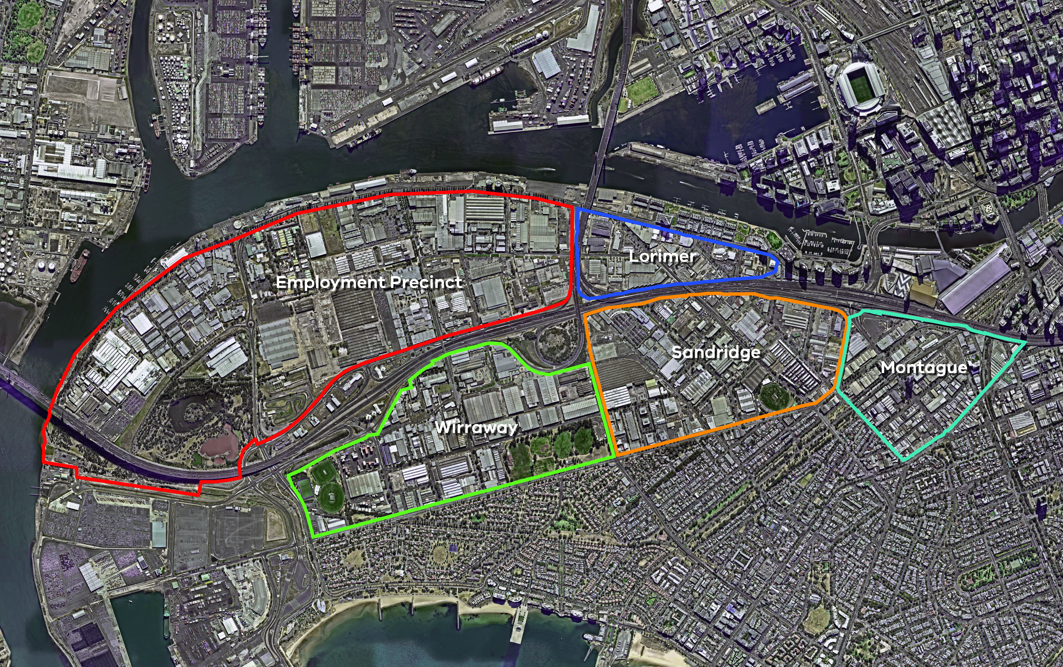
Fishermans Bend comprises five linked precincts:
• Montague
• Lorimer
• Sandridge
• Wirraway
• Employment Precinct

Context
Fishermans Bend is not a blank canvas. It has played a significant role in the development of Melbourne and has a rich history.
Planning for Fishermans Bend's renewal has considered the area's past and environmental and physical constraints.

Caring for Country
Caring for Country is a term used to describe the different sustainable land management practices and initiatives that Aboriginal and Torres Strait Islander people undertake, and the key role these practices play in continuing culture. Caring for Country encompasses the entirety of country – its past and future, its people, its flora and fauna, its natural landscapes and its urban forms, its history and its culture. Caring for Country is intrinsic to Aboriginal knowledge and a fundamental expression of Aboriginal culture.
Caring for Country applies to rural areas as much as it does to the urban environment. By integrating Aboriginal traditional ecological knowledge with contemporary ecological knowledge we can deliver better environmental outcomes and make communities more liveable, sustainable and inclusive.
We respect and acknowledge Aboriginal culture and will work in partnership with Aboriginal Victorians across landscapes, communities and natural resources.

Historical and social context
The gentle curve of the Yarra River (Birrarung) and the arrow-straight Williamstown Road are the human-made boundaries of Fishermans Bend. One was created by the excavation of the Coode Canal, the other as the 'short road' to the ferry at Williamstown.
Continuous change and renewal mark the history of this area. It started as a tidal estuary following rising sea levels and flooding of Port Phillip Bay (Nerm). It became wetlands and sand ridges, with modifications by Aboriginal fire management. It became the home of some of our nation’s most important industries, providing work and security to generations of Victorians. And now, it is set to become a new chapter in Melbourne's growth and evolution.
Much of the Fishermans Bend district lies on the Coode Island silt deposited by the Yarra and Maribyrnong Rivers, overlaid with sand ridges from old beach dunes, separated by intervening swamps. The wooded Batman’s Hill and Emerald Hill formed the first high ground upstream. This was a rich environment for diverse plant life and animals and supported Aboriginal people for thousands of years.
Aboriginal people from the Bunurong and Woiwurung language groups shared territory at the head of Port Phillip Bay. We know of particular clans who claimed the land between the mouth of the Yarra River and Melbourne. Billibillary (1799-1846) was Ngurungaeta (or leader) of a group known as ‘Billibillary’s mob’ who belonged to the Wurundjeri Willam clan (meaning ‘white gum dwellers’) of the Woiwurung. He was one of the signatories to Batman’s treaty and custodian of the Mount William stone axe quarry. Derrimut (1808/14-1864) was the Arweet (also leader) of the Yaluket Weelam clan (meaning ‘river dwellers’) of the Bunurong, who despite having his wife kidnapped by sealers, stayed at the Port Phillip settlement and protected Fawkner’s hut from a rumoured attack in 1835.
Both groups comprised several extended families who took advantage of the seasonal abundance of the beach, swamps and river at Fishermans Bend. They managed the landscape with fire and travelled to other areas to rest the land and allow it to regenerate.
Salt and fresh water met at ‘The Falls’, a rock bar on the Yarra near the foot of Queen Street. Aboriginal people took advantage of this to trap fish and cross the river. When Charles Grimes explored Port Phillip in 1803, and Batman and Fawkner took up residence in 1835, this was the obvious place for the settlement, avoiding the flood-prone flats and sand ridges.
The river, however, was winding, shallow and full of snags, so larger ships anchored in the bay, and passengers walked across the flats to Melbourne, following well-worn Aboriginal paths. These paths became the basis for the modern roads, including City Road and Williamstown Road, transporting goods from the Port Melbourne piers to the city. Australia’s first train, the Hobson’s Bay Railway ran parallel from 1854.
Fishermans Bend created an obstacle to the economic progress of the Port of Melbourne because of the distance between Sandridge (Port Melbourne) and the township of Melbourne on the Yarra. The government's initiative to build the Coode Canal for shipping in the 1880s and the West Gate Bridge for road transport in the 1970s each changed how the land was used and how local communities formed.
As Melbourne grew, the river was widened, straightened by the Coode Canal, and wharves extended downstream from the ‘Pool of Melbourne’, the wide, deep section of river below the falls. Adjoining wharves, dry docks, foundries, factories and warehouses served the shipping trade. The Montague Shipping Sheds stored the goods that were transferred from the railways, while vast open timber yards covered the blocks south of Lorimer Street.
Beyond the docks and railway was a wasteland – used and misused for sand quarrying, rubbish dumping and manure depots. A few isolated noxious industries were established from the 1840s; abattoirs, fell mongers, chemical works, soap and candle makers. These facilities were sufficiently distant to avoid causing nuisance to Melburnians, but were close by for convenience. Fishermans Bend could have served an essential purpose, but instead remained a forgotten and ignored fringe.
At the same time it was a paradise of wildlife. The swamps and sand hills harboured a diversity of bird life; snakes and small mammals and some of the last salt marsh and natural wetlands on the estuary. As recently as the 1960s, the Field naturalist and bird observers clubs made regular excursions to record and study this remnant oasis on Melbourne’s doorstep. Some idea of its richness can still be gained from the reconstructed wetlands of Westgate Park, which was created from former sand pits in the 1980s.
Fishermans Bend itself has migrated, initially from the sharp bend in the Yarra near Footscray, then to the bend in the Coode Canal, and finally to the land between the canal and the beach. Known just as ‘The Bend’, this land became home to a small community, mostly fisher-folk, eking out an existence in the relatively primitive conditions in the nineteenth and early twentieth centuries. Those living at the fishing settlement were mostly of British origin, but there were also several German families, Chinese fishermen and other diverse communities.
There were a few scattered residences in Fishermans Bend until a speculative venture saw the creation of the Montague district between City Road and the railway line. By the 1860s, on what was once a swamp that regularly flooded, small timber cottages were promoted for ‘persons of the artisan class’. By 1900, over a thousand homes were crammed into the small area, with 200 houses on the back lanes and little streets. Occupied by labourers, fishermen, boilermakers, mariners and shipwrights, Montague was renowned for its close-knit community, with its own school, church, police station, kindergarten, football team, hotels, post office, bank and shops. Nearby North Port Oval hosted the sometimes wild Victorian Football Association matches.
The self-contained suburb of intricate laneways deteriorated in the early 20th century into one of Melbourne’s most notorious “slums”. Social reformers F. Oswald Barnett and Oswald Burt campaigned for better housing, leading to the establishment of the Slum Abolition Board, and ultimately the Housing Commission of Victoria.
Social innovations were trialed to alleviate poverty and homelessness in Fishermans Bend, including the opening of the first purpose-built kindergarten in Victoria in 1909. The State Savings Bank financed construction of homes in Garden City from 1926, and undertook the first attempt at reclamation with the South Melbourne Council, in Gladstone Street in 1935. Many of the Montague residents shifted to Garden City under the Housing Commission schemes in the 1930s, when a concerted attempt was made to provide suitable housing and to address the overcrowding and poor conditions.
In the 1930s, a new endeavour, General Motors (Holden) was established on the vast empty expanse of Fishermans Bend. It initially assembled imported chassis and engines with locally built bodies, but the arrival of the FJ Holden saw Australia’s first locally mass-produced car. Launched by Prime Minister Ben Chifley, the arrival of the FJ was a landmark moment in post-war Australia, and a symbol of Australian achievement and know-how.
Holden was joined by several other car makers; Neale’s Motors was a small assembly works, while the Rootes Company (later Chrysler) and Standard-Triumph/AMI (later Toyota) built vast plants covering many hectares. For decades these sites characterised the Fishermans Bend and Port Melbourne industrial areas.
Both men and women were employed in Fishermans Bend factories from the nineteenth century, and some factories produced goods that became iconic Australian brands. Industrial activity grew significantly after World War II and this attracted a large number of postwar migrant workers.
The open expanses and relative seclusion of Fishermans Bend also made it an ideal location for a secret tank factory during World War II, and the development of other military facilities. An early private airfield was adapted to test and then build aircrafts, notably the 'Wirraway', with both the privately operated Commonwealth Aircraft Corporation, and Government Aircraft Factory, established in the area during World War II. After the war the airfield became a popular race track and the aircraft factories turned to making the prefabricated Beaufort houses to help alleviate the nation's severe housing shortage.
From the earliest years of colonial settlement, Fishermans Bend was a hub for local communities; it was a popular place to fish, ride and go for walks and picnics.
Many people came to Fishermans Bend for organised sports and activities, including horse-racing, golf and car racing. The Port Melbourne Football Club, with its strong local support base, has been central to the community from the beginning of football in Sandridge in the 1970s until the present day.
In the decades after World War II, Fishermans Bend also accommodated new Australian migrants from Britain and Europe, housing them in nissen huts at the former army barracks, which was converted into a migrant hostel. The area’s factories also gave work to many newly arrived Australians. At the same time much of the old Montague suburb had been replaced with modern warehouses and factories, while Normanby Road and Williamstown Road came to form the backbone of the district, flanked by vast factories. Among these were the Dunlop Pneumatic Tyre works covering five blocks, the Laconia Woollen Mills; the Kitchen Brothers soap and candle works; Johns & Waygood elevator manufacturers and engineers; the Union Can Company; Patent Stone Works; Felton Grimwade’s chemical works; and the Port Melbourne Abattoirs.
In 1951 another iconic Australian manufacturer, Kraft Walker cheese, moved their factory from the Yarra Bank to Fishermans Bend, where the home of Vegemite still operates.
Physically, the area was also changing, with the last of the swamps and rubbish tips filled. Construction of the West Gate Bridge commenced in 1968, although collapsed with tragic consequences in 1970. The bridge and freeway were finally completed in 1978, snaking through the middle of 'the Bend'.
By the 1990s, Fishermans Bend had evolved into a light industrial district, with the aircraft factories shifting to international commercial projects, old noxious trades eradicated, and modern new plants such as Boeing and the Herald Sun printing works added.
Today, Fishermans Bend is undergoing yet another change, with a new chapter of innovative and creative business and new residential use.

Historic Timeline
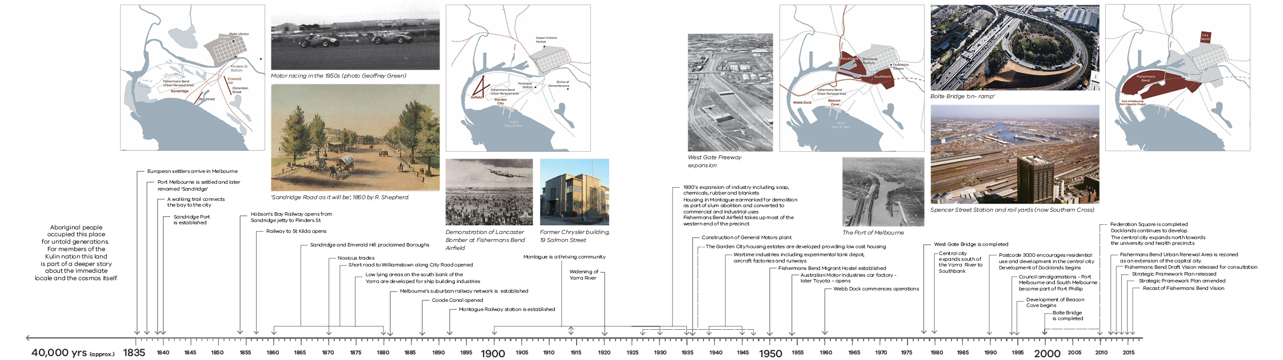

Metropolitan and economic context
Fishermans Bend will play an important role in addressing many of the challenges and opportunities that face metropolitan Melbourne. As identified in Plan Melbourne 2017-2050, it will be a key contributor to protecting and enhancing Melbourne's liveability, while growing and diversifying its economy.
The proximity of Fishermans Bend to the CBD, the Port of Melbourne and the rapidly growing western suburbs means that it will play a pivotal role in the growth and prosperity of the city.

A growing population
With around 800 hectares of land available for urban renewal close to central Melbourne, Plan Melbourne envisages the expanded central city will host almost 900,000 jobs by 2050, double the 435,000 central city jobs in 2011.
As the largest of Melbourne's inner city urban renewal areas, the way that Fishermans Bend is planned and developed will have a significant influence on the future liveability of the city. It is an opportunity to ensure Melbourne remains a great place to live and work by setting new benchmarks for inner city urban renewal and attracting the talent and investment needed to create and sustain economic prosperity. By locating jobs, services and dwellings in proximity to each other, Fishermans Bend will have the social, environmental and economic benefits of a 20-minute neighbourhood. In addition, Fishermans Bend aims to deliver activity centres, community infrastructure and open space within a 10-minute walk.
Over 250 hectares of land has been dedicated to the delivery of medium to high density, mixed use development that will support a range of economic activities and provide housing diversity.
Fishermans Bend will support the growth of Melbourne by accommodating 80,000 residents and 80,000 jobs by 2050.
Figure 2 Melbourne 2050 Plan – Central City (Plan Melbourne 2017)
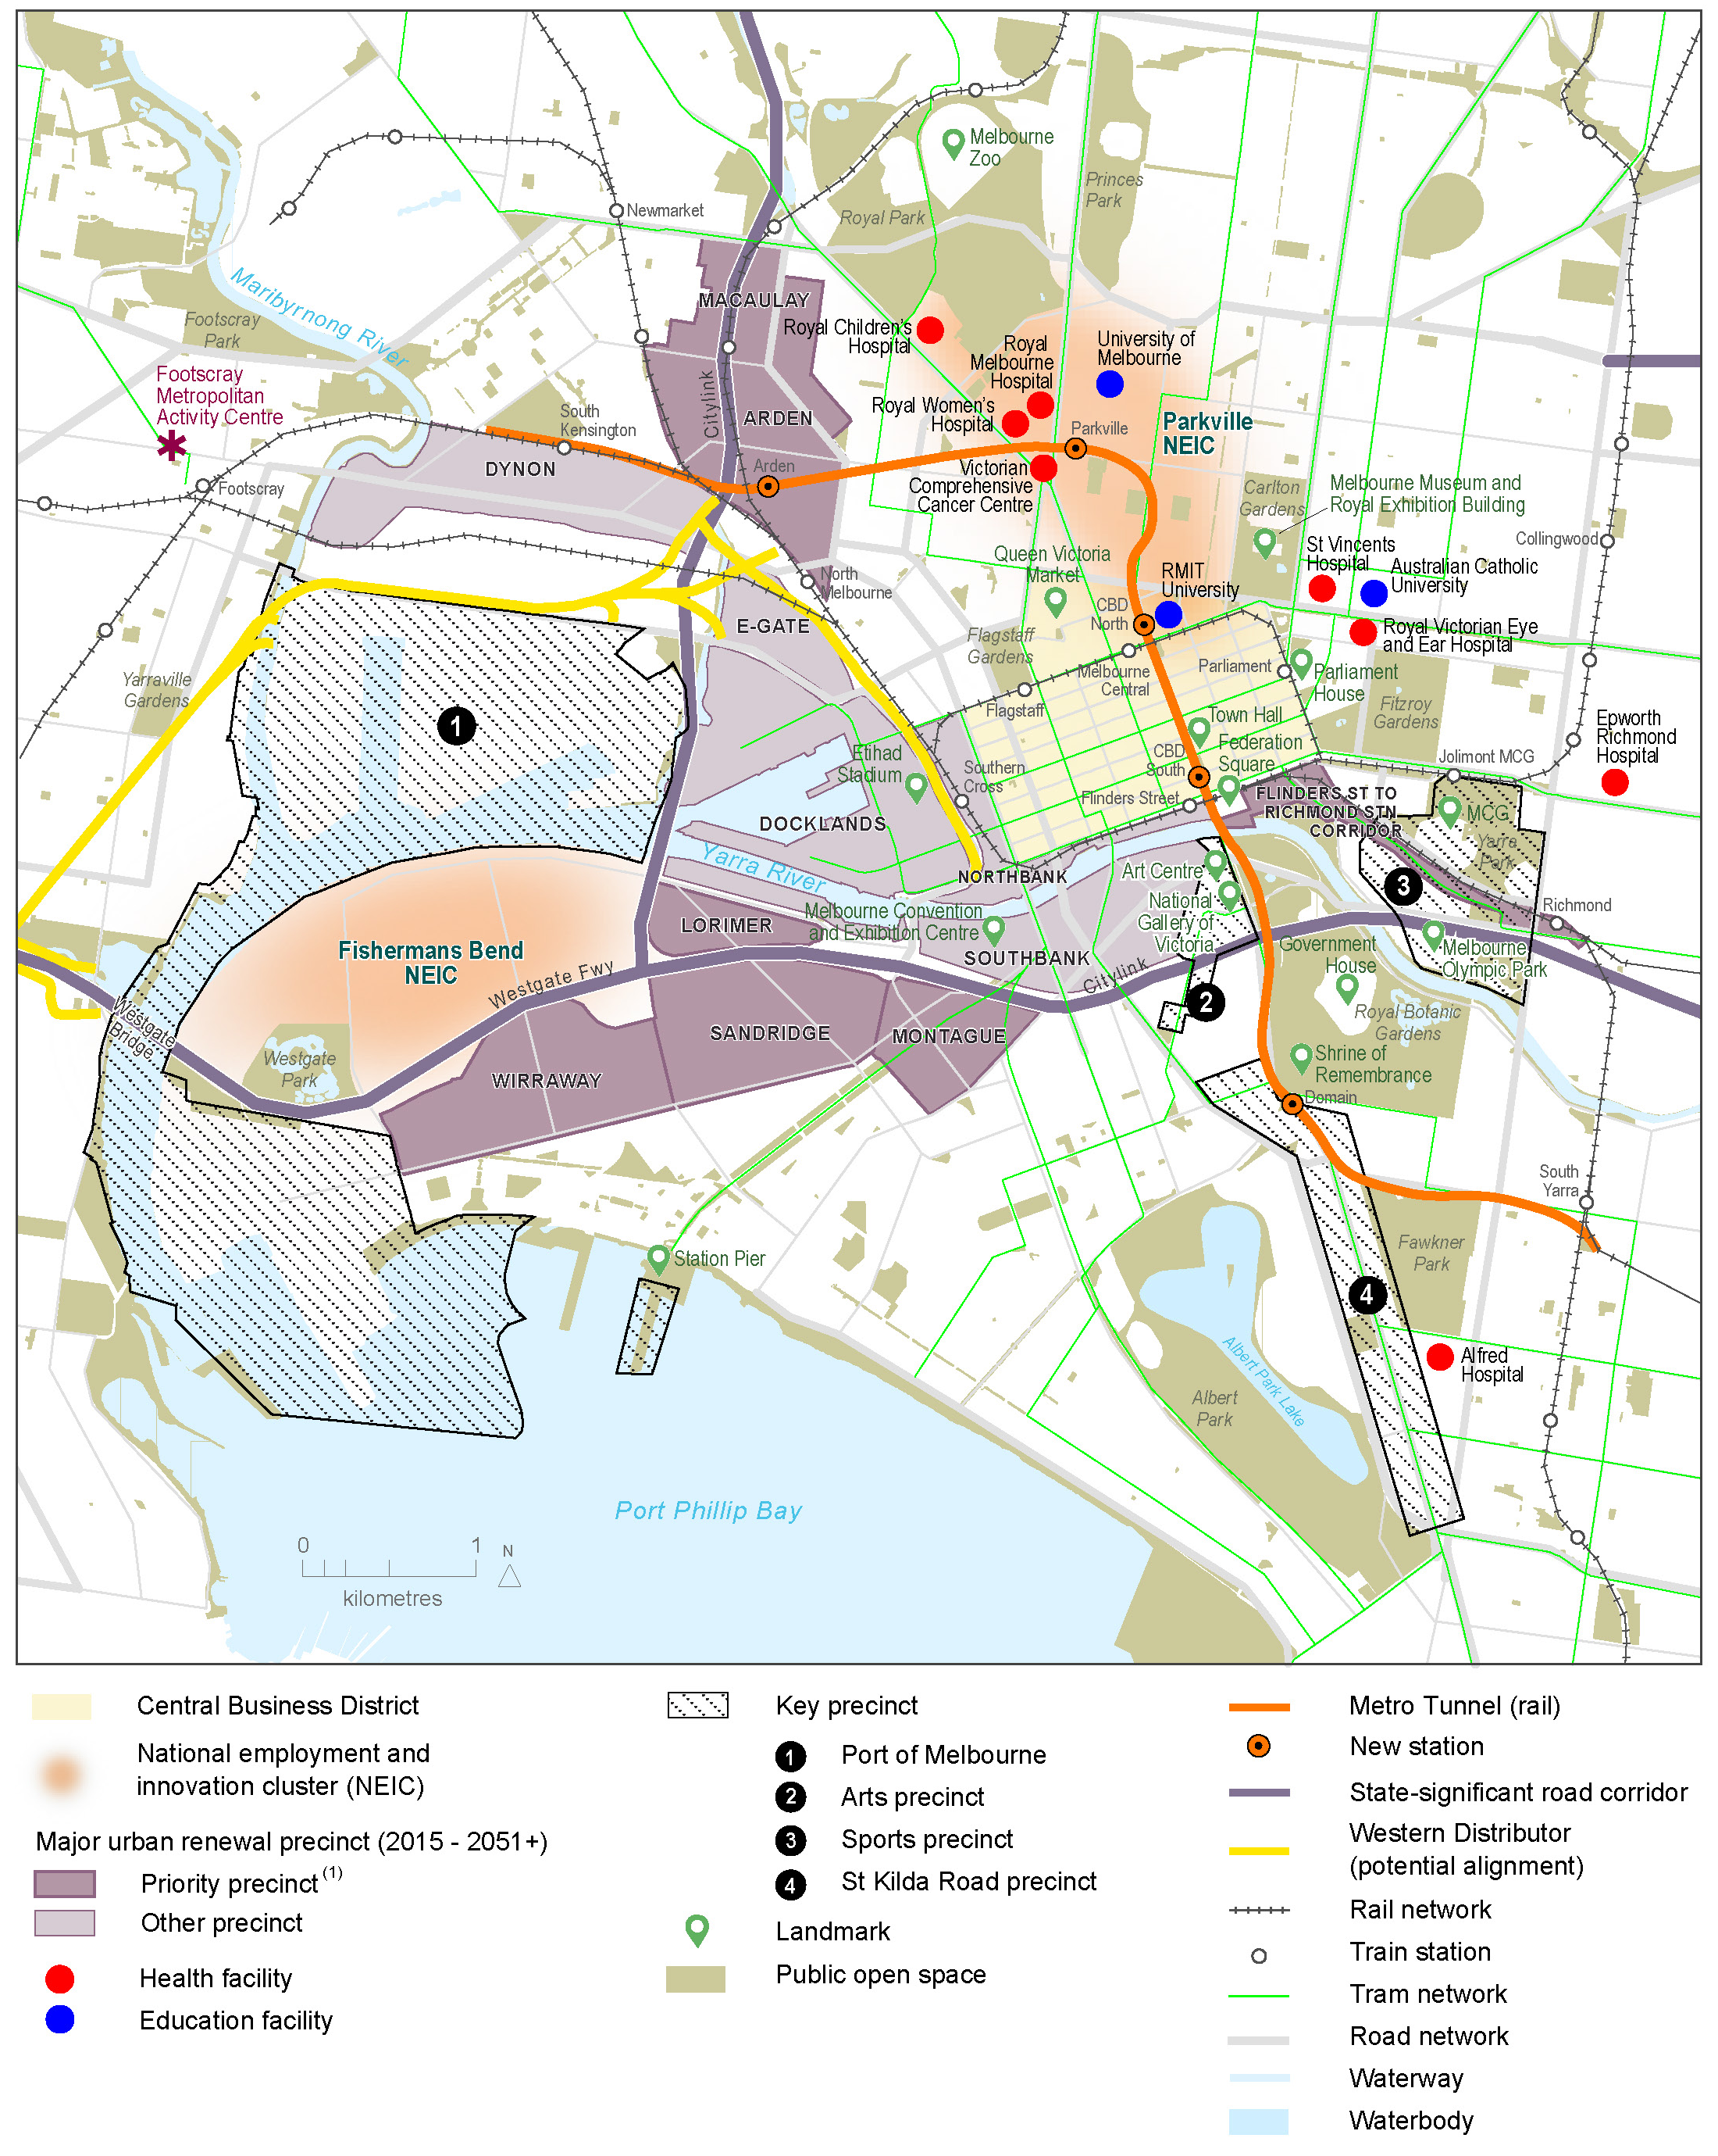

Remaining competitive in a changing economy
Melbourne's economy has undergone substantial change over the last couple of decades. Globalisation and advances in transport and communications technology have resulted in the city transitioning from a powerhouse of traditional manufacturing to a centre for knowledge-intensive industries and advanced manufacturing.
The impacts on the city of this economic restructuring have been profound with a significant increase in employment concentrated in the central city – encompassing the CBD, Docklands and Southbank. The renewal of Fishermans Bend is a substantial opportunity to strengthen the city's economic diversity, resilience and prosperity.
The four capital city zoned precincts (Lorimer, Montague, Sandridge and Wirraway) comprise more than 250 hectares of land well suited for the westward expansion of the CBD and Docklands, supporting mixed use commercial and residential development.
The four precincts offer opportunities for a diverse range of economic activities, including large floor plate campus-style office facilities, creative industries, innovation hubs and more traditional high street retail and hospitality strips. The retention of the precinct's industrial heritage and adaptive re-use of select existing buildings could provide support for this economic transformation.
The 230-hectare Employment Precinct, with its industrial heritage, infrastructure and zoning sets Fishermans Bend apart from Melbourne's other inner city renewal precincts.
Plan Melbourne identifies the Fishermans Bend Employment Precinct as one of Melbourne's seven National Economic and Innovation Clusters (NEIC) along with Monash, Parkville, Dandenong, La Trobe, Sunshine and East Werribee.
The Employment Precinct NEIC has the potential to become Australia's premier design and manufacturing centre, strengthening its focus on physical production and supporting large and small scale manufacturing, be it high-tech, bespoke or artisan. The precinct could also provide a hub for innovation, entrepreneurship and design excellence, drawing on its industrial heritage and building on its proximity to a thriving knowledge sector.
The Victorian Government's purchase of the former General Motors Holden (GMH) site, within the Employment Precinct, provides an opportunity to lead by example in the transformation of the economy in Fishermans Bend.
The development of the 37.7 hectare site provides an opportunity to facilitate a mix of tenant types and sizes to attract 21st century design and manufacturing jobs. Providing spaces for smaller firms, creative businesses and start-ups will be as critical as attracting large anchor tenants. Successful development of this site will be a catalyst for the evolution of the broader precinct.

Housing that is affordable and accessible
Affordable housing is essential to Victoria’s productivity, liveability and social equality. Providing a range of housing options to a diverse cross section of Victorians will be important in Fishermans Bend. The Victorian Government's housing affordability strategy Homes for Victorians provides a coordinated approach across government to address the our nation’s housing affordability challenges, here in Victoria. As a major renewal area in proximity to the jobs and services of central Melbourne, Fishermans Bend is a unique opportunity to leverage the initiatives of Homes for Victorians and improve social and affordable housing supply in a well-located area.

Port of Melbourne
The Port of Melbourne is Australia's largest container and general cargo port, sitting adjacent to Fishermans Bend. It handles more than 7000 containers and 1000 motor vehicles every day, along with other bulk cargo. With a total trade value of more than $90 billion annually, the port supports the prosperity of jobs and businesses across Victoria and south-eastern Australia. Protecting the operations and connections to the port is a key consideration in the development of the Framework.

Climate change – mitigation and adaptation
Climate change is an economic, social, environmental and public health issue. Fishermans Bend will play a key role in benchmarking sustainable and resilient urban transformation. It is planned to be Australia’s largest urban renewal Green Star – Community. This will demonstrate the commitment to reducing greenhouse gas emissions to zero by 2050, making Melbourne a low carbon economy that will generate new jobs, drive innovation and improve the city’s liveability.

Collaborative partnerships
Fishermans Bend is unique; unlike other urban renewal areas, the developable land is predominantly privately owned. A partnership with the private sector must be established to obtain favourable outcomes for Fishermans Bend. The Framework must balance certainty of delivery with ﬂexibility enabling the private sector to innovate and respond to site or market conditions in ways that deliver the agreed Vision.
The City of Melbourne and the City of Port Phillip are crucial partners in the delivery of the Fishermans Bend Vision, providing local expertise and insight into planning, economic development and infrastructure provision.

Environmental challenges
Fishermans Bend is located within the Yarra Delta and consists of several flat geological formations. Originally, the land was low lying and prone to flooding. Ancient formations and modern human interventions, such as land reclamation, sand mining and widespread land filling present environmental problems that need careful consideration as Fishermans Bend is renewed.
Measures to address each of these issues are detailed in the Framework.

Flooding
Fishermans Bend is located near where the Yarra discharges into Port Phillip Bay. Ground levels vary from one to four metres above sea level. Significant parts of the urban renewal area are vulnerable to inundation in tidal events, particularly within the Montague Precinct. The area is known for the regular flooding of streets due to capacity constraints in the underground drainage system.

Land contamination
As typically found in former industrial land in Melbourne, industrial land use has impacted the quality of soils in Fishermans Bend. Preliminary desktop assessments indicate that elements such as heavy metals and solvents may be widespread across Fishermans Bend.
Because of the history of the site and to protect the health of its future communities, detailed site assessments need to be made to catalogue any contamination and implement appropriate remediation or site management plans to meet environmental performance requirements.
Any land contamination will be addressed as part of the planning and development application process and comprehensively managed through Victoria’s environmental regulatory framework.

Groundwater contamination
A regional groundwater study has confirmed elevated levels of nutrients, salts and metals at Fishermans Bend due to past land use activities. Future development will need to cater for remediation and ongoing management of groundwater to satisfy environmental requirements.

Geotechnical conditions
A study has revealed key geotechnical issues and constraints in Fishermans Bend. These issues and constraints vary across Fishermans Bend and include:
• variable strength, quality and thickness of the fill soils
• weak nature of the near-surface soils and the considerable depth to reach suitable founding strata for piles
• variable levels of differential settlement caused by the ongoing secondary consolidation of the Coode Island silt
• potential to trigger consolidation of the Coode Island silt if the groundwater table is lowered during construction

Infrastructure provision

Water
The current water supply system is connected from the east and terminates at Fishermans Bend. The existing water supply infrastructure will require significant upgrades if recycled water is not provided to meet the needs of Fishermans Bend as it grows.

Sewerage
The main sewerage system servicing the CBD and the South Eastern suburbs runs along the southern boundary of Fishermans Bend. The 100 year old Melbourne Main Sewer (servicing the CBD) was replaced in 2012 and has ample capacity to service Fishermans Bend. The sewerage system provides a significant underground river of wastewater adjacent to Fishermans Bend, which could be harvested and treated for recycled water supply.

Energy
A 220 kilovolt overhead transmission line crosses through Fishermans Bend to the terminal station located at 132-140 Turner Street. This station is one of the main supplies to the CBD and inner southern Melbourne, which has adequate capacity to supply the overall area. There is a need to augment lower voltage supplies for the capital city zoned precincts to service predicted growth, however this may be offset by local generation or energy efficiency. Overhead power distribution along streets is proposed to be placed underground as part of redevelopment.

Gas
There are a number of main gas and oil transmission pipelines crossing Fishermans Bend providing an energy supply for Melbourne. These pipelines will need to be maintained and protected from the impacts of development. These pipelines deliver sufficient supply to service future Fishermans Bend requirements.
Developments located in close proximity to these pipelines will need to consider their use, density and mitigation measures. The areas of low pressure gas reticulation are proposed to be upgraded to high pressure to service the proposed high density development.

Transport
The West Gate Freeway provides a significant constraint to movement between the five Fishermans Bend precincts.
The existing public transport, walking and cycling network within Fishermans Bend is limited and this will need to be upgraded over time to meet future population and employment needs. The new Westgate Tunnel will help alleviate this pressure.
Figure 3 Existing utilities infrastructure

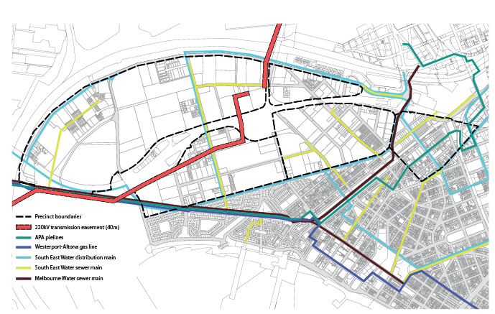

Vision
The Fishermans Bend Vision was released in September 2016, informed by public consultation.
“A thriving place that is a leading example for environmental sustainability, liveability, connectivity, diversity and innovation.”

At a glance
The Vision articulates the following aspirations for Fishermans Bend that will guide the development of the area:
• Fishermans Bend is an unparalleled renewal opportunity at the heart of Melbourne. An area more than twice the size of the current CBD, Fishermans Bend is the next chapter in Melbourne’s growth story.
• A benchmark for sustainable and resilient urban transformation, Fishermans Bend is planned to be Australia’s largest urban renewal Green Star – Community.
• Melbourne is Australia’s fastest growing city and is set to become Australia’s biggest. Fishermans Bend will support this growth – providing 80,000 jobs and a range of well-serviced, medium and high density housing options for 80,000 people.
• Fishermans Bend will play a vital role in securing new high value jobs for Victoria, building on its legacy of world-leading technology and innovation.
• New and improved connections will link Fishermans Bend to the CBD and Melbourne’s transport network, and leverage its strategic location between Port Phillip Bay, the Yarra River and the CBD. It will boast unprecedented levels of walking, cycling and public transport connectivity that will set a new benchmark for Melbourne.
• Heritage and culture will be celebrated and are integral to generating a collection of diverse, mixed use places. Fishermans Bend will provide high quality open space, community services, schools and medical facilities, as well as retail, cultural and entertainment options to build on Melbourne’s acclaimed liveability.

Realising the Employment Precinct's potential
The Employment Precinct is currently home to 13,000 employees, and initial projections for the precinct estimated 20,000 jobs by 2050. With Victorian Government investment in the former General Motors Holden site, the attraction of the University of Melbourne to the site, a proposed tram connection along Turner Street; and, in the long term, a potential underground rail station within the precinct, the jobs projection to 2050 has been upwardly revised to 40,000 jobs. When combined with the 40,000 jobs projected across the balance of the precincts, Fishermans Bend is anticipated to be host to 80,000 jobs in 2050, reflecting its prime location within the metropolitan Melbourne economy.

Distinctive precincts

Creating great places
The Vision articulates clear aspirations for each precinct by 2050. These neighbourhood visions describe the overall outcomes that are sought in each area, including strategic land use priorities. Key public realm projects will help define and shape each neighbourhood. These are summarised here and inform the key strategies within the Framework.

Montague
A diverse and well-connected mixed-use precinct celebrating its significant cultural and built heritage, and network of gritty streets and laneways
The 109 tram line creates two distinct neighbourhoods – Montague North and Montague South. New development in Montague will be centred on the transformation of Normanby Road into an active street that is attractively landscaped, pedestrian friendly and provides a key cycling connection through the precinct.
New parks will provide opportunities for active recreation, including the enhancement of the existing bike path along the tram line into a green linear parkway. All streets will be fronted by well-designed buildings with shops and businesses at ground level and a high quality pedestrian environment.
The southern part of Montague is distinguished by its laneways and heritage buildings, which are highly valued by the local community. In order to maintain these qualities, the adaptive re-use of heritage buildings is strongly encouraged. Buckhurst Street will be established as a green spine, creating the heart of Montague South. The neighbourhood will be established as a diverse and family-friendly community. Co-working spaces, small creative businesses and studios will contribute to the cultural identity of this area. Lower scale buildings along City Road and Boundary Street ensure that the precinct is well-integrated with its neighbours.
The Ferrars Street Education and Community Precinct will support a range of community activities. A second community hub is co-located at the Montague Continuing Education Centre.

Lorimer
A vibrant, mixed-use precinct close to the Yarra River and connected to Melbourne’s CBD, Docklands and emerging renewal areas
Lorimer, together with the Yarra’s Edge Precinct in Docklands, offers the opportunity to strengthen Melbourne’s identity as a river city. River crossings for walking, cycling and public transport continue the legacy of connecting Melbourne to the riverfront – linking Fishermans Bend to Docklands, the CBD, and further afield.
New laneways connect residents and workers directly to Lorimer Street through to the Yarra River. This high-density, mixed-use precinct is centred on the creation of a central parkland and is stitched together with a linear green spine and landscaped pedestrian and cycling links. This will create an important public transport, recreational link and biodiversity corridor linking to the adjacent Employment Precinct.
Ingles Street connects Lorimer directly to the proposed commercial centre in Sandridge and also the future Bolte West Precinct along the Yarra River. Taller buildings are located closer to the freeway forming a well-designed backdrop to the precinct.

Sandridge
One of Melbourne’s premium office and commercial centres, balanced with diverse housing and retail
Sandridge is the largest of the capital city zoned neighbourhoods and will encompass a diverse range of characteristics. It will become one of Melbourne’s premium office and commercial locations, centred around public transport connections providing excellent access to the CBD.
New streets and laneways will transform the existing industrial scale blocks into a walkable neighbourhood. The creation of the Fennell/Plummer Street civic spine will stitch the whole precinct together and provide high quality public transport, pedestrian and cycling connections into Wirraway.
Architecturally diverse towers within the new commercial centre extend Melbourne’s skyline towards Port Phillip Bay. These buildings are designed to provide an attractive street level experience and protect public spaces from overshadowing. The scale of the buildings is lower outside of this centre and transitions to low-scale developments adjacent to Port Melbourne and Garden City.
A variety of new open spaces will provide a wide range of recreational activities. These are connected through a network of green links, laneways and shared paths. North Port Oval, with its historic grandstand, is a key anchor for the local community and supports many civic and recreational uses. A new school located close by provides educational and co-located community services. Other community services for residents and workers in Sandridge are delivered through mixed use developments and community hubs.

Wirraway
A predominantly family-friendly inner city neighbourhood close to the bay and Westgate Park
Wirraway is a family-friendly neighbourhood. Small parks, plazas and playgrounds throughout the neighbourhood are linked by leafy streets lined with shops, businesses and homes. Wirraway provides a choice of diverse housing, including townhouses and small to medium scale apartment buildings. There is also some high-rise development centred on the intersection of proposed public transport routes. Within this precinct a range of retail, cafes and restaurants create an active community space along the Plummer Street boulevard. Building heights step down towards Williamstown Road to respect Garden City’s low-scale built form.
JL Murphy Reserve continues to be a focus for recreation, active through the day and evening, with organised sports and leisure activities. Easy access to Sandridge Beach, Westgate Park and into the Sandridge Precinct is provided by high quality walking and cycling links.
Wirraway is known for its thriving arts scene. Small galleries, art and design centres and cultural facilities are promoted and attract visitors from all over Melbourne. This is part of Wirraway’s success as a place for innovation and creativity and gives it a clear identity.

Employment Precinct
Australia’s leading design, engineering and advanced manufacturing precinct
The inclusion of the 230-hectare Employment Precinct (identified as a National Economic and Innovation Cluster in Plan Melbourne), as part of the Fishermans Bend area presents many unique and exciting opportunities to create and upport, good secure 21st century jobs on the doorstep of the CBD.
The evolution of future businesses and industries provides the opportunity to build a culture in the Employment Precinct that draws on the past while signposting the future. Strengthening its focus on physical production and supporting large and small scale manufacturing, the Victorian Government's investment in the former General Motors Holden site is a catalyst for transforming the Employment Precinct. The transition will encourage the development of high-value, future focused industrial firms, leveraging off new major research institutions.
Westgate Park performs an important role in providing an extensive area of parkland in an urban setting for existing and future residents and workers. A variety of walking and cycling links provide connections to the bay and the city.

Strategic directions
The planning and development of Fishermans Bend has been informed by 10 strategic directions.
These outline the key aspirations and principles that Fishermans Bend must build upon.
The strategic directions were first identified in the Draft Vision 2013 and reaffirmed through consultation on the Fishermans Bend Vision in 2016, with strong community support.
The 10 strategic directions are:
1. the creation of 21st century jobs
2. the timely provision of infrastructure
3. a place that is easy to get around
4. a vibrant mix of uses and activities
5. distinctive and unique neighbourhoods
6. diverse communities
7. a high quality built environment
8. a sustainable and resilient place
9. manage industrial legacy and ground conditions
10. strong partnerships, effective governance and civic leadership.
The ten strategic directions have informed the development of the Vision and the eight sustainability goals. The eight sustainability goals are the focal point of the Framework and replace the strategic directions.
The sustainability goals and associated strategies and objectives provide more information about how the strategic directions will be brought to life in the development of Fishermans Bend.
Over time these commitments will be refreshed and adapted as new residents and businesses call Fishermans Bend home.

The Framework
This Framework is structured around the eight sustainability goals identified in the Vision. It sets out an integrated and holistic plan to deliver best practice sustainability outcomes for Fishermans Bend.
Each sustainability goal includes:
• an overview that outlines why this goal is important in Fishermans Bend
• targets for 2050 that are measurable and articulate what it means to achieve the goal
• objectives that articulate what is needed to achieve the goal
• strategies that outline how each objective could be achieved through key policy and investment directions
The planning controls that give effect to the strategies outlined here are found in the Port Phillip and Melbourne Planning Schemes.
The Fishermans Bend Vision established eight sustainability goals that will drive the overall social, environmental and economic planning for Fishermans Bend.
The eight sustainability goals have informed the development of a series of targets, objectives and strategies.

Sustainability approach

Green Star – Communities
Green Star – Communities has been adopted as a tool to monitor the successful development of Fishermans Bend. It is Australia’s most comprehensive independent rating tool for holistic, triple-bottom line sustainable community and precinct development, providing valuable guidance to communities, governments and the development sector alike.
The tool has five categories: governance, liveability, economic prosperity, environment and innovation. The principles and credits within Green Star – Communities are reflected within the targets, objectives and strategies embedded in the Framework, catalyst projects, planning controls and background technical reports.

Sustainability goals

1 A connected and liveable community
In Fishermans Bend, people will be connected through integrated walking, cycling and public transport links that will make choosing sustainable transport options easy. Digital high-speed data networks will also enhance connectivity. Activity cores will be located near public transport, and include community services and public spaces to ensure that people can access their daily needs close to where they live and work. These reliable and sustainable transport options will mean fewer than one in five trips will be made by private car.

2 A prosperous community
In Fishermans Bend, planning will support diverse employment and education opportunities across all precincts. Local and metropolitan jobs will be supported across a range of sectors and complemented by education and training opportunities. Opportunities for commercial and creative industries will be preserved to ensure that a balanced mix of uses is provided, building on the area’s existing strengths including proximity to the CBD and Port of Melbourne.

3 An inclusive and healthy community
Fishermans Bend will be a community for people of all ages and backgrounds. It will provide a range of dwelling options for all types of households including those with children and affordable housing. Community services, such as schools, health services, community meeting spaces, library services, sporting facilities and high quality public spaces will ensure that people have opportunities to lead healthy lives.

4 A climate resilient community
Fishermans Bend will need to be resilient to extreme weather events – including flooding, drought, heat waves and storm surges associated with sea level rise. A high degree of social cohesion exists, creating an environment that enhances community resilience. In the future in Fishermans Bend, the urban heat island effect will be lower than in other areas of Melbourne.

5 A water sensitive community
Stormwater and recycled water will be utilised as a substitute for potable water to conserve water resources. An integrated water recycling facility will be developed to supply a new third-pipe network. Stormwater detention and retention will be provided within buildings. Landscapes will be designed to incorporate water sensitive urban design principles to improve water. quality and manage flooding.

6 A biodiverse community
Biodiversity will be supported in Fishermans Bend with public spaces and buildings creating habitat opportunities for indigenous flora and fauna. This will be achieved through appropriate landscape design in streets and parks, as well as through the use of green walls and roofs in buildings. Green links will be established to link Fishermans Bend to surrounding areas with biodiverse environments such as Westgate Park and Port Phillip Bay.

7 A low carbon community
Greenhouse gas emissions in Fishermans Bend will be minimised through energy-efficient design, construction and operation of buildings, through renewable energy generation, energy storage and sustainable transport infrastructure. Integrated smart management of energy within precincts and large sites will improve energy efficiency outcomes for Fishermans Bend.

8 A low waste community
Recycling will be maximised and waste to landfill reduced. Waste management systems will divert organic waste from landfills. Construction and demolition waste recycling opportunities will be maximised through reuse and recovery of building materials. Opportunities for advanced resource recovery (such as energy from waste) will be investigated, as will local, place-based waste solutions. Building design guidelines will support increased rates of recycling and diversion from landfill through best practice design and operation.

Sustainability goal 1 – A connected and liveable community

Overview
In order for Fishermans Bend to be a well-connected and liveable place, it must integrate transport and land use planning.

A connected place
To create a reliable transport network that supports people choosing sustainable transport as their preferred way of getting to and around Fishermans Bend, improvements in public transport, cycling and walking infrastructure will be required.
Walking and cycling are affordable, sustainable, healthy ways to get around. The relatively flat topography of Fishermans Bend and proximity to key destinations such as Docklands, the Hoddle Grid, Southbank, South Melbourne, Port Melbourne and Port Phillip Bay, make it generally well-suited to walking and cycling.
The current large block sizes, however, make it difficult to walk to places. By contrast, the Hoddle Grid has a much finer network of streets, which demonstrates how a high level of pedestrian permeability can support walking access through the city and support a vibrant street life. This can be further enhanced by a well-designed public space network of parks, tree lined boulevards and shady streets that connect to a variety of squares, and sports and recreation spaces within Fishermans Bend and beyond.
An efficient, well-connected public transport network will maximise the opportunity to link Fishermans Bend to global markets, improving productivity and attracting jobs (see Sustainability goal 2: A prosperous community).

A liveable place
Liveability is central in the planning for Fishermans Bend. A holistic appreciation of liveability has been adopted, and Fishermans Bend aims to provide workers and residents alike with a sense of community and connection to, and pride in, place.
Mixed use precincts are the foundation of a sustainable city. They create walkable places by locating jobs, homes, shops, entertainment places and essential community services in close proximity to each other.
The design of new buildings contribute to the local sense of place, influence the quality of life for residents and workers, and the environmental footprint of an area. Central to the development of Fishermans Bend will be well-designed buildings that contribute to the creation of distinct neighbourhood character, provide for a high amenity environment and include sophisticated sustainability measures.
Fishermans Bend will provide easy access to schools, and health and community services to support the diverse and growing resident, worker and visitor population.
A range of multi-functional public open spaces, including parks and civic places provide opportunities for recreation, community events, relaxation and a connection to nature (see also Sustainability goal 3: An inclusive and healthy community).
Overall densities need to be carefully managed and monitored to ensure that the area is not over-developed, resulting in loss of amenity, congestion, infrastructure overloading and poor quality streetscapes. The density of Fishermans Bend will be managed through the combination of dwelling densities and height controls.

Targets for 2050
80% of trips are made via sustainable transport
90% of school related trips are made via sustainable transport
A walkability score of 90% is achieved from homes and workplaces
A focus for community interaction is provided within each precinct
Fishermans Bend is widely acknowledged as a place of architectural excellence
A successful activity core is established in each precinct where businesses can thrive and everyday needs are met

Objective 1.1
Deliver public transport services that connect to the existing Melbourne network and are a ten minute walk from all residences and workplaces

Strategies
1.1.1 Extend the tram network to Fishermans Bend, including two new dedicated tram routes connecting north and south of the freeway to Docklands, Southern Cross Station and the Hoddle Grid
1.1.2 Protect future public transport corridors from development that could compromise the future delivery of this critical transport infrastructure
1.1.3 Investigate potential metro station location that may be incorporated into a future underground rail line
1.1.4 Enhance the existing light-rail services in Montague to improve capacity and access
1.1.5 Upgrade existing and introduce new bus services to improve coverage, frequency, connection and user choice
1.1.6 Explore opportunities to support the delivery of privately operated ferries and water taxis

Objective 1.2
Make Fishermans Bend a great place to walk for people with a wide range of abilities and needs

Strategies
1.2.1 Create new, direct pedestrian connections across the Yarra River to Docklands
1.2.2 Introduce a fine grain, permeable street network through the creation of new streets and laneways and ensure intersections are aligned to maximise connectivity (see Figure 6)
1.2.3 Ensure vehicles, cyclists and pedestrians can share the road network safely
1.2.4 Refine and enhance the existing network of fine grain laneways
1.2.5 Design streets to create safe, comfortable pedestrian-friendly environments that enable children, seniors and people with disabilities to get around independently and safely
1.2.6 Improve the pedestrian connectivity across major roads between Fishermans Bend and Port Melbourne, South Melbourne and Docklands including Williamstown Road and Lorimer Street
1.2.7 Improve pedestrian connectivity across the West Gate Freeway
1.2.8 Improve way-finding and signage to make it easier for people to get around

Public transport
Figure 4
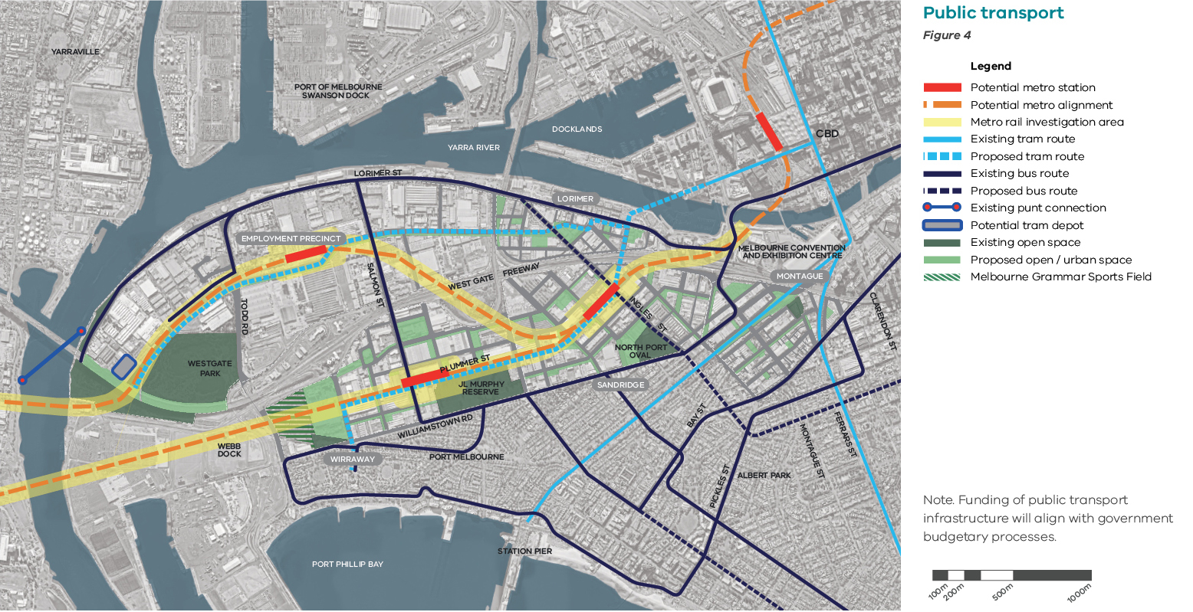

Note. Funding of public transport infrastructure will align with government budgetary processes.

Catalyst projects - Integrated transport planning
Right now, Fishermans Bend is a peninsula with limited transport connectivity and existing on-road congestion at peak periods. The delivery of enhanced transport connections will be required to provide the additional connectivity required to unlock Fishermans Bend and enable it to reach its full potential. The development of transport connections will be staged to meet the travel needs of local communities.

Buses
Upgrades will continue to be made to existing bus services and new routes will be investigated to link Fishermans Bend to key destinations and provide a flexible and quick response to travel demand.

Walking, cycling and light rail
The future development envisioned in Fishermans Bend will require high capacity connections across the precinct and into central Melbourne. In the medium term, new tram routes will be required to extend into the area via a new link across the Yarra River providing fast and direct links between Fishermans Bend and the Melbourne CBD for public transport, walking and cycling.
A new river crossing would deliver safety for walkers and cyclists alongside the tram and existing community services, open spaces, future schools and workplaces would be a short walk away from communities on both sides of the river.
This new connection should be introduced in stages so that its provision can directly influence and respond to how this community grows.
Stage one would deliver the Yarra crossing and the northern corridor that would link the Employment Precinct and the former General Motors Holden site to Southern Cross Station and the CBD. Further stages would include a new bridge across the West Gate Freeway with the southern corridor connecting Sandridge and Wirraway with central Melbourne.
Alongside the development of these links, the redesign of local streets will enhance the provision for walking and cycling, connecting people to the key corridors safely.
A number of further strategic cycling corridors are planned. The first step will be introducing a cycling connection linking the redeveloped Montague Precinct both to the Bay Street activity centre and to the CBD via Buckhurst Street. This link will also connect local and community infrastructure, schools and open spaces along the way.

Underground rail
A future underground rail connection would provide a valuable additional transport resource for Fishermans Bend.
To accommodate a new cross city rail connection for Melbourne, should it be required, the Framework seeks to protect station options so that the area can leverage off any future rail development.
With detailed design and funding decisions on any new rail connection yet to be made, three potential sites have been set aside so that the opportunity for future stations are safeguarded, protecting them from future conflict with other land uses.
The Framework and associated planning controls safeguard two route options that can potentially facilitate two new stations in the area. Final decisions on locations will be made at a later date.

Sustainability goal 1 – A connected and liveable community

Objective 1.3
Make Fishermans Bend an exceptional place to cycle

Strategies
1.3.1 Create new, direct cycling connections across the Yarra River to Docklands
1.3.2 Create new, direct cycling connections to the Moonee Ponds Creek, and extend the Capital City Bike Trail into Fishermans Bend
1.3.3 Create a network of new separated cycling routes that connect to existing and planned cycling networks, including the Westgate Punt and Yarra River Corridor
1.3.4 Install high-quality bicycle parking and facilities at key transport interchanges
1.3.5 Investigate bike sharing schemes
1.3.6 Improve connectivity across the West Gate Freeway for cyclists
1.3.7 Encourage high quality end-of-trip facilities in new developments
1.3.8 Ensure developments provide a minimum of one bicycle space for each dwelling and one space per 10 dwellings for visitors
1.3.9 Provide one bicycle space per 50m² for workers and one space per 1000m² for visitors in non-residential areas

Objective 1.4
Create a street network that encourages walking and cycling while still facilitating vehicle access

Strategies
1.4.1 Introduce an expanded street network through the creation of new streets and laneways that provide vehicular access to all properties (see Figure 6)
1.4.2 Design street networks to reduce conflicts between modes of transport
1.4.3 Ensure properties on streets in activity cores, dedicated public transport routes and strategic cycling corridors are accessed from streets and laneways off this core network to prioritise safety and movement flow
1.4.4 Provide rear access to properties on streets in activity cores, dedicated public transport routes and strategic cycling corridors to prioritise safety and movement flow

Objective 1.5
Enable residents and workers to access public spaces and community facilities within an easy walk

Strategies
1.5.1 Connect key community facilities to new and existing open spaces in a network utilising linear parks
1.5.2 Create safe, high amenity walking and cycling connections to open spaces that provide a diversity of recreational uses from every home and workplace
1.5.3 Locate schools to maximise access by walking, cycling and public transport
1.5.4 Design streets to encourage growth of large connected tree canopies that provide shade

Cycling infrastructure
Figure 5
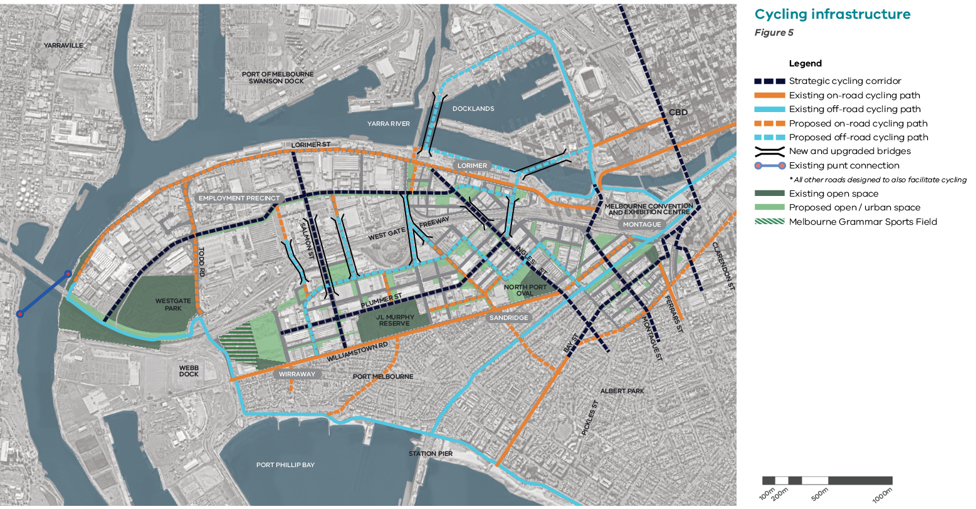

Road network
Figure 6
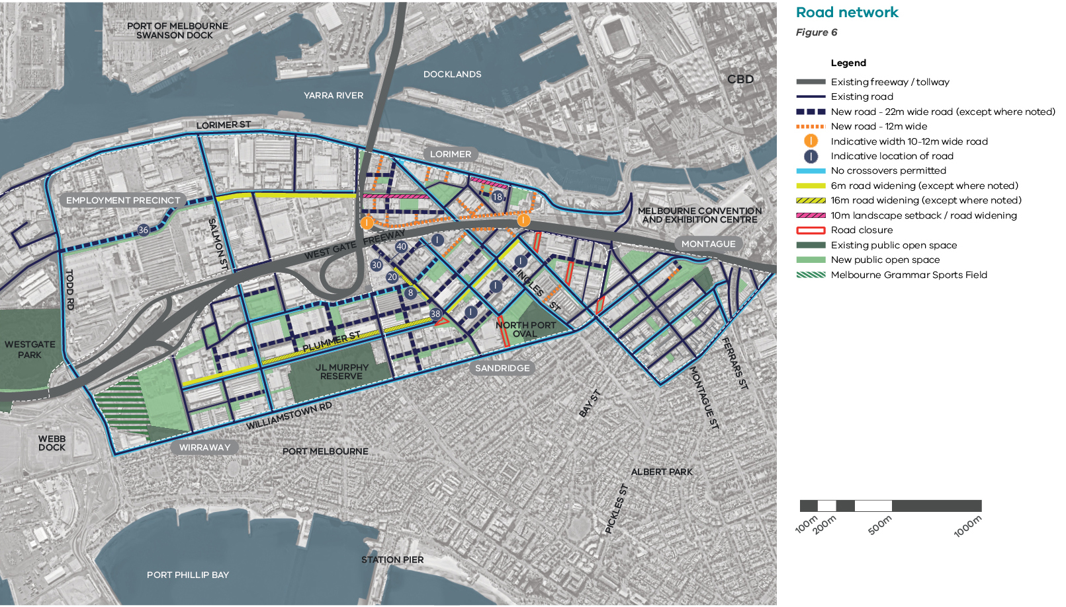

Objective 1.6
Support long-term sustainable transport patterns

Strategies
1.6.1 Reflecting the popularity and availability of sustainable transport alternatives, less car parking will be required. Private car parking in new developments is required to comply with the following ratios: 0.5 cars per one and two bedroom dwelling, 1 car per three bedroom dwelling and 1 car per 100m2 for employment uses
1.6.2 Design car parks to allow for future conversion to alternative uses and subdivided as common property (not individually titled) to be managed by the owners corporation and leased to property owners
1.6.3 Support the off-site delivery of precinct car parking stations to provide dedicated car parking in the short term
1.6.4 Encourage new development to incorporate green travel plans to support resident and worker use of alternative transport modes
1.6.5 Locate car share spaces within new developments

Objective 1.7
Support low-impact methods of delivering last-kilometre-freight and waste removal

Strategies
1.7.1 Require buildings to be designed to ensure their deliveries, servicing and waste management are managed on-site
1.7.2 Prioritise freight delivery and supply chain solutions to reduce the number of trucks accessing the area

Objective 1.8
Plan and design new development to respond to existing and future infrastructure and land uses

Strategies
1.8.1 Require sensitive uses to include appropriate mitigation measures to protect against off-site amenity impacts
(see Figure 7)
1.8.2 Require development to mitigate negative amenity impacts such as noise, vibration, odours and light pollution associated with adjoining and nearby infrastructure and land uses
1.8.3 Investigate opportunities to underground overhead transmission lines in the long term

Figure 7. Buffer and amenity consideration
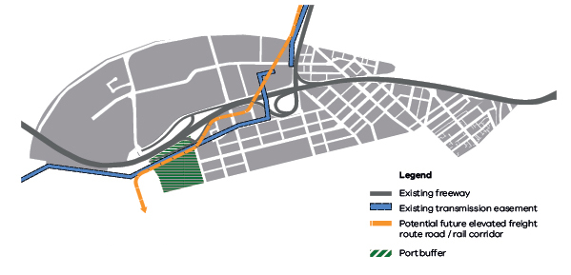

Objective 1.9
Create thriving, lively mixed-use neighbourhoods that have a distinct identity and character, to foster social cohesion

Strategies
1.9.1 Introduce density and built form controls that support the creation of a clear centre in each precinct and support increased economic activity
1.9.2 Encourage a diversity of architectural styles, particularly on large sites to create engaging and varied built form
1.9.3 Create a varied built form in response to place and preferred character
1.9.4 Create a diversity of high-quality publicly accessible spaces within new development on large sites, including new squares, gardens and laneways
1.9.5 Encourage architectural design excellence in new buildings
1.9.6 Encourage new developments to be designed by qualified architects and design professionals

Objective 1.10
Ensure housing options are suitable for families with children across Fishermans Bend, with the highest provision in Wirraway

Strategies
1.10.1 Require all developments to provide minimum communal open space that is 30 per cent of the net developable site area in Wirraway and Sandridge (outside of core areas only) to encourage provision of private open space and a range of building types
1.10.2 Require the inclusion of private green open space in all developments, including private gardens, communal gardens, balconies and rooftop spaces
1.10.3 Encourage the delivery of three bedroom dwellings in developments of more than 100 dwellings with the following targets per precinct:
– Wirraway – 30 per cent
– Sandridge – 20 per cent
– Montague – 25 per cent
– Lorimer – 20 per cent
1.10.4 Encourage living room sizes that exceed minimum requirements
1.10.5 Encourage diversity and choice in housing and affordable housing

Guiding new development
The developable land within Fishermans Bend is primarily held in private ownership. It is important that as this land is developed to contribute to the overarching vision and sustainability goals for Fishermans Bend. For this to be achieved, appropriate tools and planning mechanisms have been designed to link population growth to the desired neighbourhood character, high levels of amenity and to infrastructure provision.

Managing residential densities
The vision for Fishermans Bend is to create liveable and vibrant neighbourhoods that are world-leading examples of urban renewal. To achieve this, new developments need to provide high levels of private and public amenity, creating places where people want to live, work and visit.
The residential target of 80,000 people will lead to an average residential density of 323 people per hectare, which is comparable to the projected population densities of other inner city neighbourhoods such as the Hoddle grid (297 people per hectare) and Southbank (308 people per hectare) Average residential densities reflect the diverse built form across suburbs from low to high-rise, as well as the varying mix of residential and commercial uses.
Managing residential densities is most directly achieved through a control that guides the number of dwellings that can be developed on a site.
The development of Fishermans Bend will be monitored and reviewed every five years.

Supporting job growth and business investment
Current development trends are for predominantly residential uses with very few proposals for commercial uses that would support the creation of new business and jobs in Fishermans Bend.
The provision of commercial uses is also critical to the creation of successful mixed-use precincts and the establishment of 20-minute, walkable neighbourhoods.
Planning controls that encourage a minimum provision of commercial uses in the core areas can deliver this aim.
Distinct neighbourhoods
The Vision for Fishermans Bend outlines the desire for each neighbourhood to have a distinct feel and a range of housing choices. Built form controls are critical to achieving this outcome as they establish the preferred scale and form of development in any given area and support the range of desired building typologies (see Figure 8).
The population targets need to be varied for each neighbourhood to establish overall dwelling densities that support the delivery of the desired neighbourhood character and range of building typologies in each precinct.
Benefits of introducing Dwelling Density Ratios together with built form controls
A tailored Dwelling Density Ratio applies to Fishermans Bend to help deliver on the aspirations for the area. It provides for:
• certainty of future overall population growth and densities
• alignment between population growth and distribution and infrastructure provision
• land use mix, including employment opportunities
• diversity of housing types, including mid-rise apartment developments
• design flexibility, with a range of design options possible on each site

Social Housing Uplift
Additional opportunities to support the realisation of the Fishermans Bend Vision and sustainability goals will be provided through the introduction of a Social Housing Uplift. This enables the developer to exceed the defined Dwelling Density Ratios in exchange for the provision of a defined public benefit.
All development is required to meet all built form controls that apply to a site to ensure that the preferred neighbourhood character is achieved and amenity outcomes are met.

Sub-precincts and building typologies
Figure 8
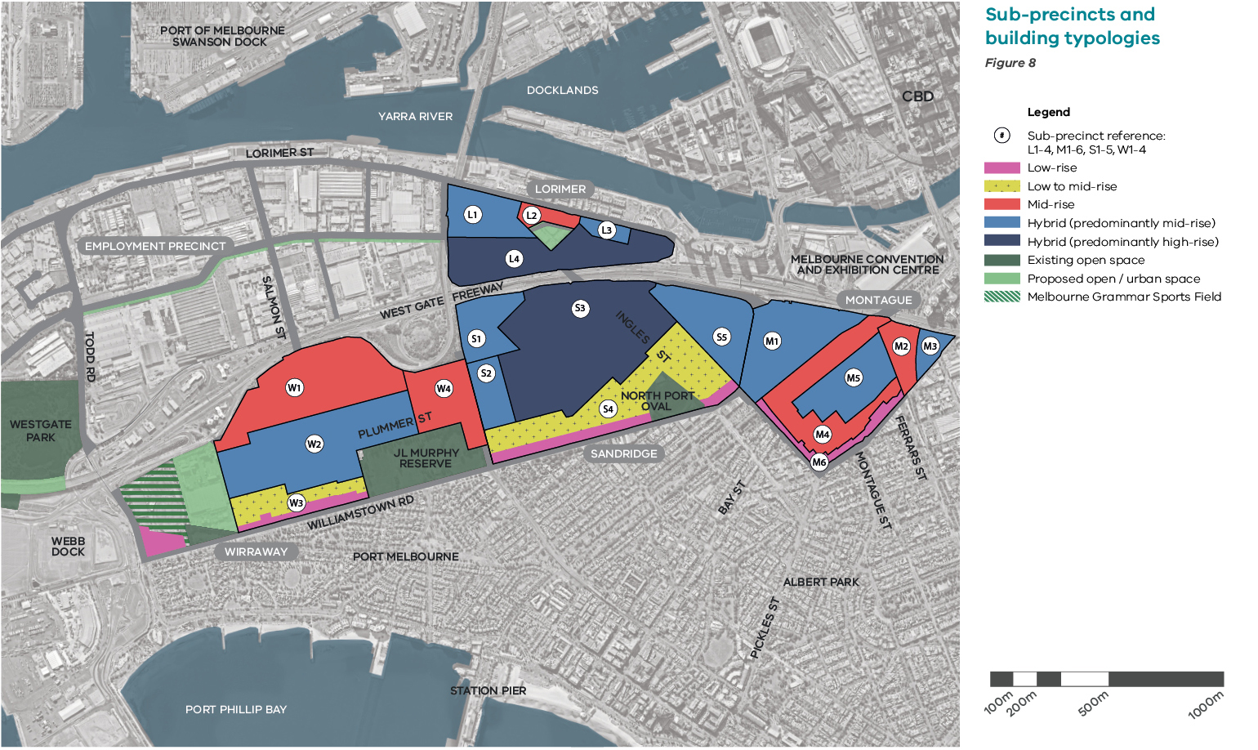

Sustainability goal 1 – A connected and liveable community

Objective 1.11
Align population, job growth and residential densities with the provision of infrastructure and amenities

Strategies
1.11.1 Introduce Dwelling Density Ratios that are aligned with the overall population targets within each precinct. The Dwelling Density Ratios apply to residential land uses
1.11.2 Encourage the provision of a minimum employment floor area in activity cores to ensure that job targets are met
1.11.3 Introduce a Social Housing Uplift control to deliver social housing. Developers can seek to apply a Social Housing Uplift on their site, which enables them to construct an additional eight dwellings for private sale for every social housing unit delivered and transferred to a registered housing association. The Uplift is required to meet all planning controls (including height and overshadowing provisions)
1.11.4 Maximise employment opportunities by allowing additional commercial floor area above the maximum dwelling density without the need for provision of a Social Housing Uplift

Objective 1.12
Deliver a diverse range of housing choices, including apartment towers, mid-rise and low-rise buildings, that suit a wide range of people and can be adapted to changing housing needs over time

Strategies
1.12.1 Introduce a range of height limits, that, together with the Dwelling Density Ratios, can deliver a range of housing choices and types, including hybrid developments
1.12.2 Establish built form provisions that facilitate the following housing types for each precinct which align with the vision as follows:
– Lorimer – a mix of mid-rise and hybrid development that incorporate courtyard apartments, and perimeter block developments as well as towers
– Sandridge – a mix of low to mid-rise housing south of the core area that includes infill developments, shop-top housing and courtyard apartments; elsewhere hybrid developments that include mid-rise, perimeter block developments as well as towers
– Montague (South) – predominantly a mix of low to mid-rise housing that includes infill and terrace developments, and hybrid developments that include towers along Buckhurst spine and east of the 96 tramline
– Montague (North) – hybrid developments that are predominantly mid-rise with some towers
– Wirraway – a mix of low and mid-rise housing, including townhouses, infill developments, shop-top housing, courtyard and perimeter block development; hybrid developments that are predominantly mid-rise with slender towers included along Plummer Street
Within each precinct, the following definitions apply to building scales, low-rise is developments up to and including six storeys, mid-rise is developments of seven to 10 storeys and high-rise is development of 11 storeys and taller
1.12.3 Establish design standards that address the need for all external spaces within new developments to contribute to the creation of safe, and enjoyable pedestrian-friendly environments

Dwelling Density Ratios
Figure 9
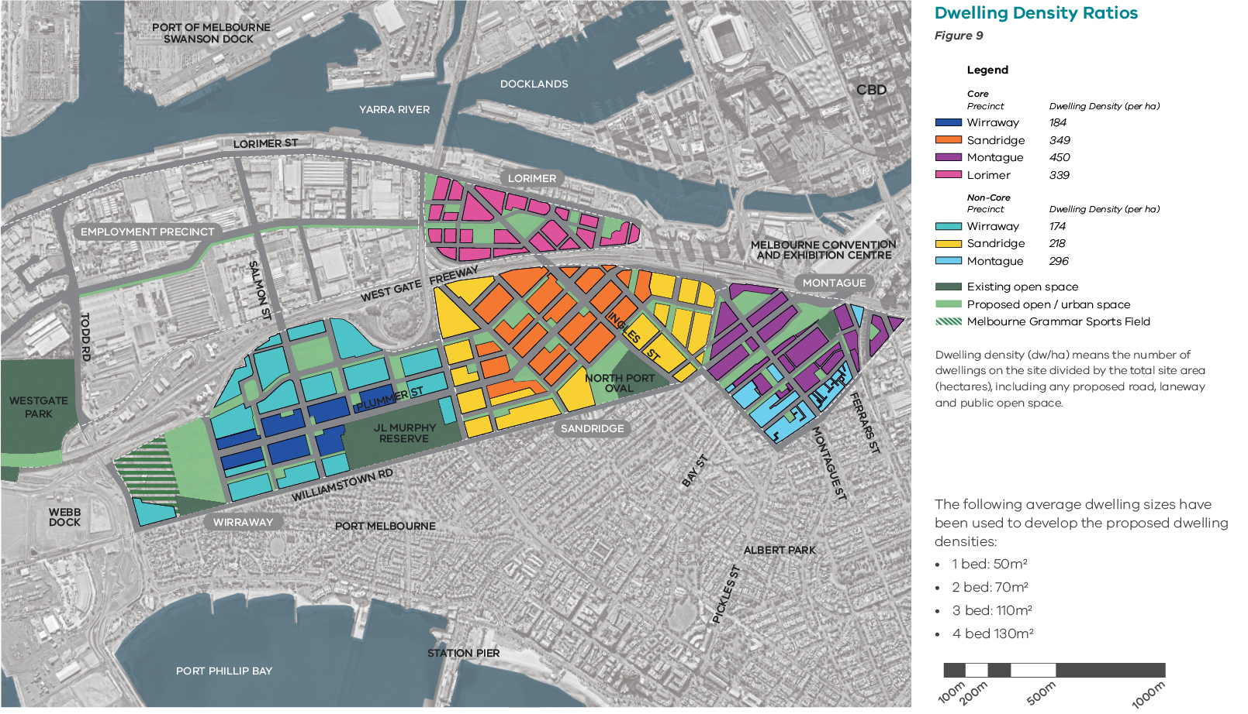

Dwelling density (dw/ha) means the number of dwellings on the site divided by the total site area (hectares), including any proposed road, laneway and public open space.
The following average dwelling sizes have been used to develop the proposed dwelling densities:
• 1 bed: 50m2
• 2 bed: 70m2
• 3 bed: 110m2
• 4 bed 130m2

Objective 1.13
Design buildings to protect internal amenity and deliver a high quality public realm

Strategies
1.13.1 Maintain a mandatory four-storey street wall height in areas designated as four and six-storey height limits along the boundaries of Fishermans Bend that respond to the existing low-scale development patterns in South Melbourne and Port Melbourne
1.13.2 Establish development standards that ensure the scale, height, setbacks and interfaces of new development create a high quality public realm
1.13.3 Design all buildings to provide sufficient access to daylight, sunlight and an outlook from habitable spaces and address development equity by:
– Below the street wall, establishing preferred and mandatory minimum separation and setback provisions that respond to the preferred building typology, amenity and character outcomes within each precinct
– Above the street wall, for buildings up to 20 storeys, establishing preferred and mandatory minimum separation and setback provisions that respond to the preferred building typology, amenity and character outcomes within each precinct
– Above the street wall, for developments that are 20 storeys and higher, establish a mandatory tower separation control of 20 metres and setback controls of 10 metres from all boundaries
1.13.4 Design developments with no building separation or setback on side and rear boundaries up to the street wall height where building types incorporate blank party walls
1.13.6 Establish street wall height controls that respond to the street width and the preferred building typology and character outcome in each precinct
1.13.7 Establish a preferred and mandatory minimum requirement for setbacks above the street wall that relate to building height:
– Buildings eight storeys or less: 5 metres (preferred), 3 metres (minimum)
– Buildings greater than eight storeys and up to 20 storeys: 10 metres (preferred), 5 metres (minimum)
– Buildings greater than 20 storeys: 10 metres (mandatory minimum)
Enable setbacks to be reduced in limited circumstances, such as the interface with the West Gate Freeway and with existing tram corridors
1.13.8 Incorporate a ‘tooth and gap’ approach to development fronting Plummer Street spine in Wirraway and Buckhurst Street spine in Montague

Building heights
Figure 10
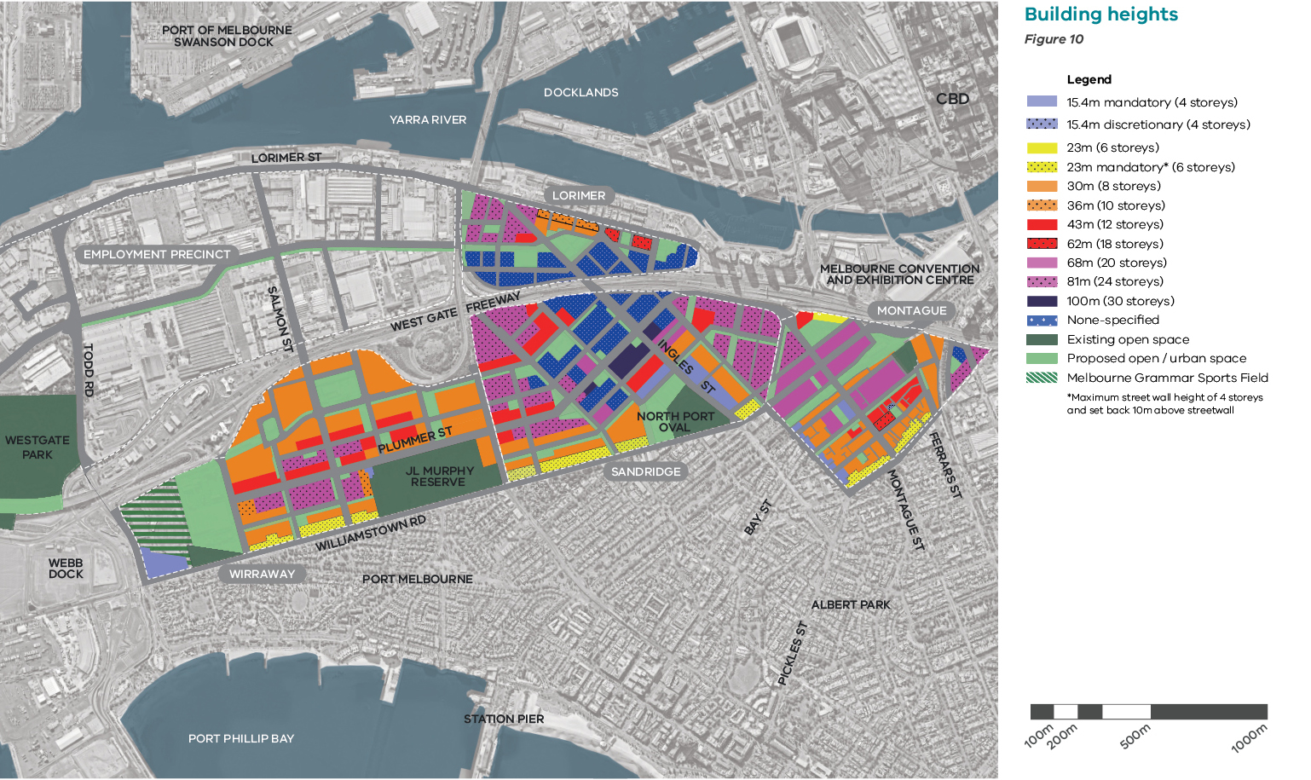

Sustainability goal 2 - A prosperous community

Overview
The Lorimer, Montague, Sandridge and Wirraway precincts were rezoned to Capital City Zone in 2012. This rezoning did not facilitate the development of a range of uses and densities necessary to create a prosperous community, leading instead to a dominance of high density residential development with minimal commercial offering.
The new objectives and strategies outlined in the Framework, coupled with the suite of planning controls encourage these four precincts to develop a range of economic activities, including large floor plate campus-style office facilities, creative industries and innovation hubs, as well as more traditional high street retail and hospitality strips, alongside residential uses. The retention of industrial heritage and adaptive reuse of select existing buildings in each precinct could provide the built form transition for this economic transformation.

A smart city
To be a prosperous community in the 21st century, high speed data connections are essential. Fishermans Bend will be an exemplar smart precinct for Melbourne, with the capacity to connect the community and businesses to and from anywhere in the world. Smart technologies will also enable the real time control of infrastructure – improving services, boosting efficiency, maximising capacity and minimising faults.

Integrated transport planning
Fishermans Bend will be a mix of residential, commercial, retail, community, leisure and entertainment activity. For this to occur successfully an alignment between higher intensities of use and public transport provision is required (see Goal 1).
Economic development will need to be supported over time by additional public transport infrastructure that connects Fishermans Bend to the rest of Melbourne.

Employment Precinct
The inclusion of the 230-hectare Employment Precinct as part of the Fishermans Bend renewal area presents a unique opportunity to create 21st century jobs centred on innovation, entrepreneurship and excellence in manufacturing and design.
The Victorian Government's purchase of the former General Motors Holden (GMH) site, located centrally within the Employment Precinct, creates a catalyst opportunity for the precinct. Its transformation into Australia's leading design, engineering and technology district provides an opportunity to set the agenda for the broader redevelopment to follow.
While a range of sectors and business models will be promoted in the Employment Precinct, it will retain a strong focus on physical production and the transformation of ideas into commercially viable products. This will differentiate it from inner Melbourne’s other National Employment and Innovation Clusters (NEIC), and create a distinctive brand for Fishermans Bend. Smaller scale tenants, urban manufacturers, creative industries and start-ups will be important contributors to the success of the Fishermans Bend NEIC, complementing and supporting larger tenants and research institutions.
Promoting innovative design and manufacturing employment will require modification to the existing urban structure, with some areas of the precinct requiring a finer grain urban form, aided by the inclusion of smaller scale users. It will be important for the precinct to have higher levels of amenity than would ordinarily be associated with traditional industrial precincts, with several active and vibrant streets. Adaptive reuse of buildings should be encouraged whenever possible to both utilise spaces that are in transition and provide reference points to the precinct's past.
Fishermans Bend is a neighbour to the Port of Melbourne. As Australia's largest container port in the country, Port of Melbourne is a significant generator of jobs and economic prosperity for Victoria and Australia. Protecting the viability of its operations is also a critical factor in the planning and future development of the area.

Targets for 2050
Fishermans Bend is host to 80,000 jobs
Fishermans Bend has strong economic resilience and diversity
High capacity wireless or internet is provided across all of Fishermans Bend
Port of Melbourne remains Australia's primary container port
Several universities have established campuses in Fishermans Bend
The Employment Precinct is internationally renowned as a centre of innovation in design and manufacturing

Objective 2.1
Facilitate job growth across Fishermans Bend to host 80,000jobs by 2050

Strategies
2.1.1 Prioritise the delivery of new public transport connections to Fishermans Bend
2.1.2 Locate the majority of employment opportunities close to public transport to ensure easy access to these jobs from within and outside Fishermans Bend
2.1.3 Establish Sandridge as a major activity core accommodating the highest jobs density in Fishermans Bend
2.1.4 Establish activity cores within Wirraway, Montague and Lorimer that are supported by public transport
2.1.5 Introduce a requirement for active frontages within the activity cores and fronting key pedestrian routes and public spaces
2.1.6 Encourage provision of a minimum amount of employment floor area within each core area that is aligned with job targets to ensure a rich mix of employment across Lorimer, Montague, Sandridge and Wirraway
2.1.7 Introduce built form controls that support commercial development floor plates in core areas
2.1.8 Develop a distinctive brand for Fishermans Bend that reflects its history and promotes its future
2.1.9 Attract world class tertiary institutions that will enable research and development, education, services and productive engagement with the market
2.1.10 Develop a strategic and integrated plan for employment and investment in Fishermans Bend
2.1.11 Increase opportunities to connect and collaborate with future and established employment-rich areas

Objective 2.2
Strengthen Melbourne’s economic diversity and resilience

Strategies
2.2.1 Investigate the new desired mix of industry and business
2.2.2 Encourage job opportunities for all Victorians including the long-term unemployed, migrant and Aboriginal Victorians
2.2.3 Create high quality liveable places that are conducive to innovators and entrepreneurs and that attract talented and skilled workers from a range of educational backgrounds
2.2.4 Promote the economic and cultural value of creative industries and embed them into the renewal process
2.2.5 Monitor and analyse the economic development outcomes to inform future policy
2.2.6 Promote a range of commercial and industrial building typologies, adaptable built form and mix of scale to enable flexibility and a diverse range of uses
2.2.7 Design car parking to enable conversion to future commercial uses as required

Objective 2.3
Establish the Employment Precinct as a unique economic precinct of global significance

Strategies
2.3.1 Devise and map a development program for the Employment Precinct that provides leadership and opportunities for collaboration that will:
– attract 40,000 jobs to the precinct
– create a finer grain and higher amenity urban environment conducive to innovation
– achieve economic convergence by co-locating and clustering compatible industries across various sectors
– attract high-value adding sectors and businesses of various sizes
– be Australia's premium location for innovators
2.3.2 Utilise government investment in the GMH site to promote the evolution of manufacturing and create a hub for innovation, entrepreneurship and design excellence

Activity cores
Figure 11
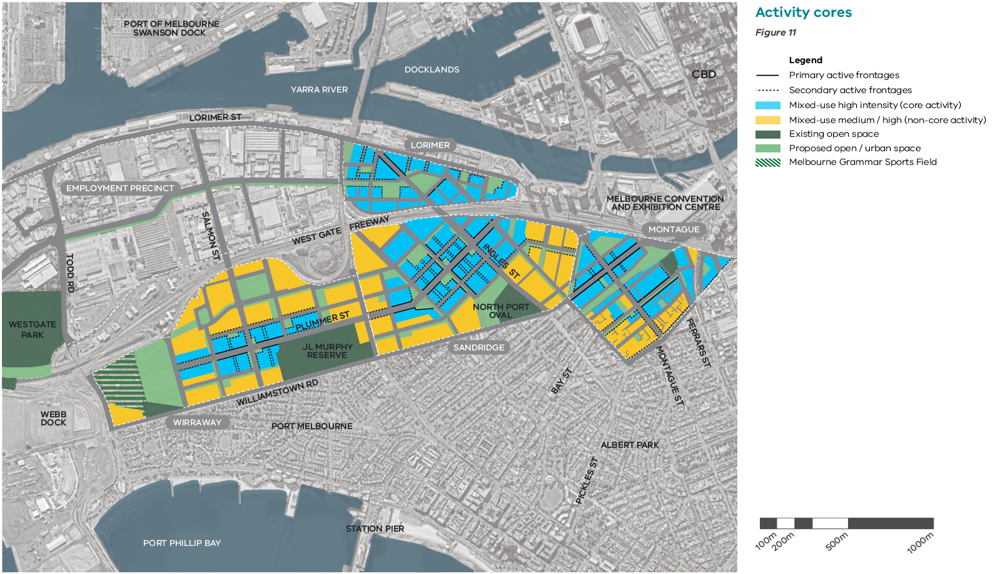

Catalyst project - General Motors Holden site redevelopment
The General Motors Holden (GMH) site is a key catalyst project for Fishermans Bend and Melbourne, providing a lever for the Victorian Government to lead by example in attracting the innovators and entrepreneurs that will be critical to the economy of the 21st century.
Located in the heart of the Employment Precinct, the site is substantial at 37.7 hectares. It has played an influential role in driving the economic success of Fishermans Bend for many decades and that critical role will continue.
In 2016, the Victorian Government purchased this unique landholding to rejuvenate industrial production and to stimulate a new chapter in Melbourne’s position as a globally creative, innovative and inclusive city.
In late 2017 the University of Melbourne committed to move its engineering campus to Fishermans Bend.
With careful and targeted government planning, investment and curation, the site will become Australia’s new home for design, engineering and technology, providing a showcase for coordinated world class urban renewal and economic development. It will:
• attract private sector investment that builds and enriches the skills that will form the jobs of the future
• secure local employment while expanding the city’s global reach
• be home to students and specialised businesses of different scales and types, presenting opportunities for industry to intersect with research, fostering innovation and the process of turning ideas into commercially viable products
• create a range of jobs that require a range of skill sets and educational backgrounds
• promote the reuse of existing buildings making use of under-utilised spaces in the short-term and retaining reference points to the site’s industrial heritage in the longer-term
• create a fine grain, high amenity urban form conducive to vibrant street activity that sets the tone for redevelopment of the broader Employment Precinct.

Sustainability goal 2 – A prosperous community

Objective 2.4
Provide smart city technology to support economic activity in Fishermans Bend

Strategies
2.4.1 Plan for the delivery of high-bandwidth fibre and wireless networks across Fishermans Bend
2.4.2 Encourage next generation technologies, such as smart devices, smart networks and big data, to maximise the efficiency of new and existing infrastructure while minimising the environmental impacts of growth
2.4.3 Integrate smart sensors to monitor environmental conditions, such as air quality, thermal comfort, wind and flood levels

Objective 2.5
Protect Port of Melbourne activities to expand and enhance the long-term economic viability of Melbourne and access to global markets

Strategies
2.5.1 Safeguard 24/7 access to the port by preserving a direct rail and road freight corridor between Webb Dock and Swanson/Appleton Docks and the freight terminal at Dynon
2.5.2 Introduce planning controls required to protect the rail and road corridor, including land use, air quality and noise attenuation controls
2.5.3 Maintain land use buffers around the Port of Melbourne
2.5.4 Maintain Todd Road/Lorimer Street/Wurundjeri Way as a freight route in the short to medium term for vehicles that cannot use the West Gate or Bolte Bridges and require access to Swanson/Appleton Docks and Dynon Precinct
2.5.5 Maintain the current over-dimensional routes along Lorimer Street and Williamstown/Normanby Roads
2.5.6 Promote the use of preferred freight corridors to minimise the impacts on residential and commercial activities in Fishermans Bend
2.5.7 Explore the upgrade of the West Gate and Bolte Bridges to accommodate larger freight vehicles

Figure 12 Freight activity
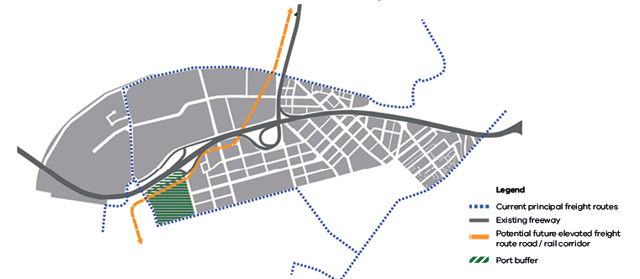

Sustainability goal 3 - An inclusive and healthy community

Overview
The rich history of Fishermans Bend provides inspiration for an invigorated contemporary identity that embraces diversity, innovation and a sense of place. The cultural, social and architectural heritage of the area provides a link to the past and inspiration for its future.
Preserving historical elements within Fishermans Bend is critical in both developing a sense of place and respecting the past. This can be achieved by responding to the existing landscape and built form that has been shaped by the natural and historical attributes of the area.
Fishermans Bend will deliver infrastructure in a coordinated and timely manner to support it's growing community. In order to support this, an Infrastructure Contributions Plan will be developed.
An inclusive and healthy community can be fostered through increased participation, a sense of belonging and individual health and wellbeing.
Essential community services will need to be delivered from the early stages of redevelopment. This includes schools, children, youth and family services, health and wellbeing services and community gathering spaces. Community facilities play an important role in supporting creativity, collaboration, social cohesion and community learning.
The Ferrars Street Education and Community Precinct is the first step in delivering this essential infrastructure and an example of how community facilities and services will be delivered in the future.
Partnerships between government, private sector and not-for profits will be the primary model for the delivery of community infrastructure in Fishermans Bend. Key design requirements and specifications will be developed for different types of community facilities to ensure they are fit for purpose and adaptable spaces.
The public open spaces of Fishermans Bend will foster a sense of belonging and encourage social connections between neighbours and workers.
Active and healthy lifestyles will also be promoted through the provision of open space.
Fishermans Bend is an opportunity to increase the supply of a diverse range of, affordable housing, including social housing. The aim is for at least six per cent of housing across Fishermans Bend to be affordable. This includes a range of affordable housing models, typologies, and occupancies, from short-term crisis accommodation through to long-term secure housing for people with special needs, the aged and key workers employed in essential services.
Government at all levels, private industry and the not-for-profit sectors will need to work in partnership to provide more affordable housing. The Social Housing Uplift scheme will provide an opportunity to deliver social housing within each precinct of Fishermans Bend.

Targets for 2050
Fishermans Bend is a diverse community, including a mix of income, age, education levels and backgrounds
People have an opportunity to participate in local organisations and activities
People can access public open space within 200 metres of their home and work
One in three households are families with children
At least six per cent of all housing in Fishermans Bend is affordable

Objective 3.1
Provide community facilities and services to meet the needs of people of all ages, cultures and backgrounds, which create a focal point for social connections

Strategies
3.1.1 Plan for and support the delivery of the following community hubs (see Figure 13)
Sandridge:
– 1 Education and community hub
– 1 Arts and cultural hub
– 1 Sport and recreation hub
Lorimer:
– 1 Education and community hub
– 1 Arts and cultural hub
– 1 Health and wellbeing hub
– 1 Sport and recreation hub
Wirraway:
– 2 Education and community hubs
– 1 Arts and cultural hub
– 1 Health and wellbeing hub
– 1 Sport and recreation hub
Montague:
– 1 Education and community hub (constructed)
– 1 Arts and cultural hub
– 1 Sport and recreation hub
3.1.2 Incorporate a range of flexible and adaptable spaces in each hub to provide for changing community needs over time
3.1.3 Consider the needs of workers and residents in the planning of service provision in library services, long daycare, sports facilities (e.g. gyms) and health services to meet their needs
3.1.4 Harness new technologies that can support the provision or reach of community facilities and services
3.1.5 Encourage community gardens as gathering spaces for residents
3.1.6 Design sports grounds and community facilities as multi-purpose and integrated facilities
3.1.7 Explore opportunities to utilise non-traditional spaces for sport and recreational purposes, e.g. rooftops and bridge undercrofts

Objective 3.2
Embed community infrastructure in mixed use developments in order to maximise access and delivery opportunities

Strategies
3.2.1 Provide clear guidance on how community infrastructure would be delivered through partnerships between government and the private sector
3.2.2 Encourage early delivery of community infrastructure hubs
3.2.3 Establish design guidelines and specifications for each type of hub to ensure the community facilities are fit for purpose and align with the Universal Design principles
3.2.4 Consider ways to use school facilities as community assets during weekend and evening hours

Objective 3.3
Involve the community in the evolution of public open spaces and community facilities

Strategies
3.3.1 Establish partnerships between government, existing and future community groups, residents, sporting clubs and local businesses to promote collaboration in the delivery, management and activation of new facilities
3.3.2 Utilise innovative ways to improve community engagement in the transition of Fishermans Bend

Community facilities and services
Figure 13
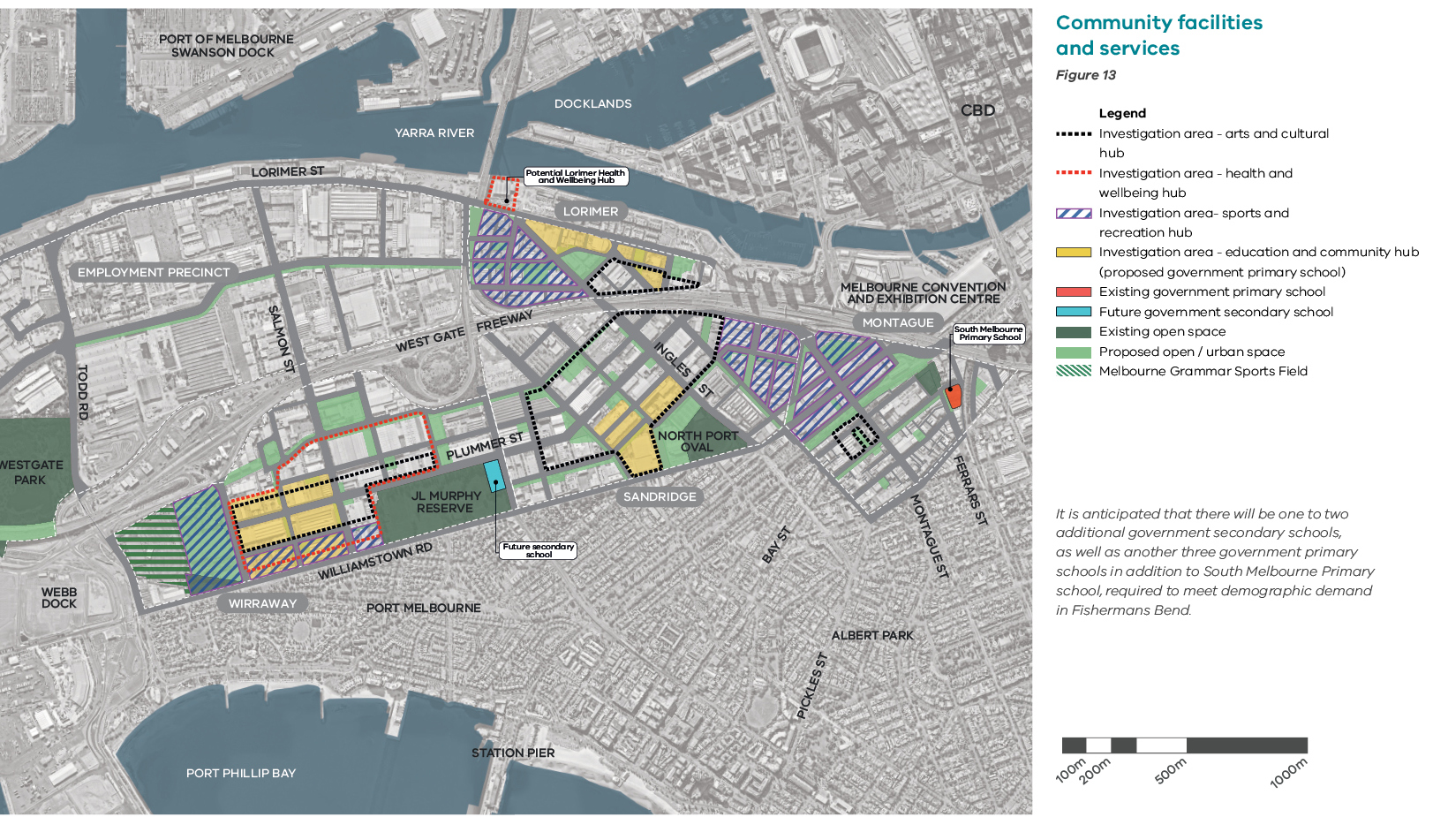

It is anticipated that there will be one to two additional government secondary schools, as well as another three government primary schools in addition to South Melbourne Primary school, required to meet demographic demand in Fishermans Bend.

Catalyst projects - Ferrars Street Education and Community Precinct
The Ferrars Street Education and Community Precinct has been identified as a catalyst project to deliver education and community services for the growing Montague Precinct community.

First government vertical school
The precinct includes a new integrated vertical primary school catering for 525 students from prep to year six. The development is co-located with community facilities including multi-purpose rooms, a kindergarten, an early learning centre and indoor/outdoor sports courts to support a healthy and engaged community within an urban school model. The integrated community facilities are managed by the City of Port Phillip. The vertical primary school opened for term 1 in 2018.

Kirrip Park
Through joint investment and partnership between the City of Port Phillip and the Victorian Government, the site diagonally opposite the school site at 2-4 Buckhurst Street was purchased to provide a key open space for the Montague Precinct. Kirrip Park features a paved entrance and forecourt area facing Buckhurst Street, four lawn areas, outdoor LED lighting, multiple seating areas and paths, and native garden beds.

Tram stop upgrades
Tram stop 125A (Route 109) and tram stop 126 (Route 96) have been upgraded to provide safe, DDA-compliant pedestrian access and support the development of the primary school and wider Montague Precinct.

Intersection upgrades
To improve accessibility and connectivity across the Montague Precinct and the wider South Melbourne and Port Melbourne communities, the intersection at Ferrars Street and City Road has been upgraded, to provide two-way access from Ferrars Street (north of City Road) with enhanced pedestrian crossings for school children.

Streetscape works
Changes to Railway Place, Douglas, Ferrars, Meaden, Buckhurst and Kerr Streets are also being made to encourage pedestrians, sustainable transport and safe access to the new school and precinct.

Sustainability goal 3 - An inclusive and healthy community

Objective 3.4
Create an inclusive community that enables people to age in place

Strategies
3.4.1 Undertake a holistic approach across government, private sector and not- for-profit organisations to provide services for an ageing population
3.4.2 Encourage dwellings that are adaptable to meet the needs of older people
3.4.3 Design public spaces to suit a range of ages and abilities
3.4.4 Encourage development to consider the needs of an ageing population within the design of buildings and dwellings

Objective 3.5
Deliver affordable housing outcomes through well-established partnership models between government and industry

Strategies
3.5.1 Support a partnership approach between government, private industry and the community housing sector to deliver a range of affordable housing options
3.5.2 Encourage six per cent affordable housing for all new development delivered within the maximum allowed Dwelling Density Ratios
3.5.3 Introduce planning incentives for the delivery of social housing via a Social Housing Uplift. Social housing will be required to be transferred at no cost to registered housing providers to secure this housing in perpetuity
3.5.4 Identify potential current and future government sites that would be suitable for affordable housing
3.5.5 Explore the option to collect ‘cash-in-lieu’ contributions instead of the provision of affordable housing on-site. Explore the establishment of a ‘Fishermans Bend Affordable Housing Trust’ (or similar) which may be required if these contributions are introduced in the future

Objective 3.6
Reconsider existing public open spaces within Fishermans Bend in the context of a changing urban environment

Strategies
3.6.1 Redesign and/or expand Westgate Park, JL Murphy Reserve and North Port Oval to incorporate more active uses, multi-functional spaces and improved interface design
3.6.2 Consider ways to use open spaces associated with schools as public assets during weekend and evening hours
3.6.3 Increase access for public use to areas of privately owned and leased open space
3.6.4 Increase utilisation of encumbered public land for active uses and recreational links, such as under the West Gate Freeway and Bolte Bridge
3.6.5 Increase the degree of use and range of activities held to provide public access to existing sports fields
3.6.6 Use innovative design, temporary and permanent installations to protect, enhance and activate vacant and unused spaces

Objective 3.7
Ensure a distribution of diverse, well designed and accessible public open spaces

Strategies
3.7.1 Design and activate public open spaces that provide informal meeting places for the community across Fishermans Bend
3.7.2 Create a recreational walking and cycling trail along linear parks and streets (see Figures 5, 14 and 15) through Fishermans Bend that connects to the Yarra River and Port Phillip Bay and the Capital City Trail
3.7.3 Provide 'dog off-leash' areas
3.7.4 Locate playgrounds across Fishermans Bend to ensure that they are accessible within 400 metres of each residence where possible
3.7.5 Locate new public open spaces to maximise solar access and amenity
3.7.6 Establish new mandatory overshadowing controls to protect one park in each precinct from overshadowing in winter for three hours of the day, and key neighbourhood parks from overshadowing on the equinox for three hours of the day, excluding linear parks
3.7.7 Retain controls that protect pedestrians from negative wind effects created by new buildings
3.7.8 Provide a distributed network of public open spaces of varying sizes (from metropolitan level spaces to pocket parks) that cater for different demands and uses, both day and night
3.7.9 Create a robust and flexible public open space network that is capable of adapting to changing conditions, community demographics, diversity, ability and needs over time
3.7.10 Design and manage public open space to ensure passive surveillance
3.7.11 Investigate longer-term opportunities to construct decking over transport infrastructure
3.7.12 Design public open space based on the Principles of universal design

Objective 3.8
Recognise the original topography of the area, especially the profile of the Yarra River and Hobson’s Bay, as a significant historic landscape feature

Strategies
3.8.1 Identify and consider views to the Yarra River from the surrounding street network
3.8.2 Identify Aboriginal cultural associations with the original topography of the area, recognising the strong cultural, spiritual and historic connections of Traditional Owners to the Yarra (Birrarung) and the bay (Nairm)

Figure 14 Green Links
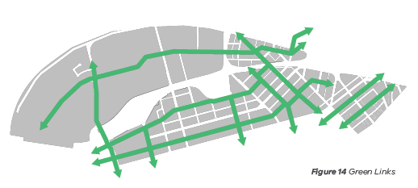

Public space
Figure 15
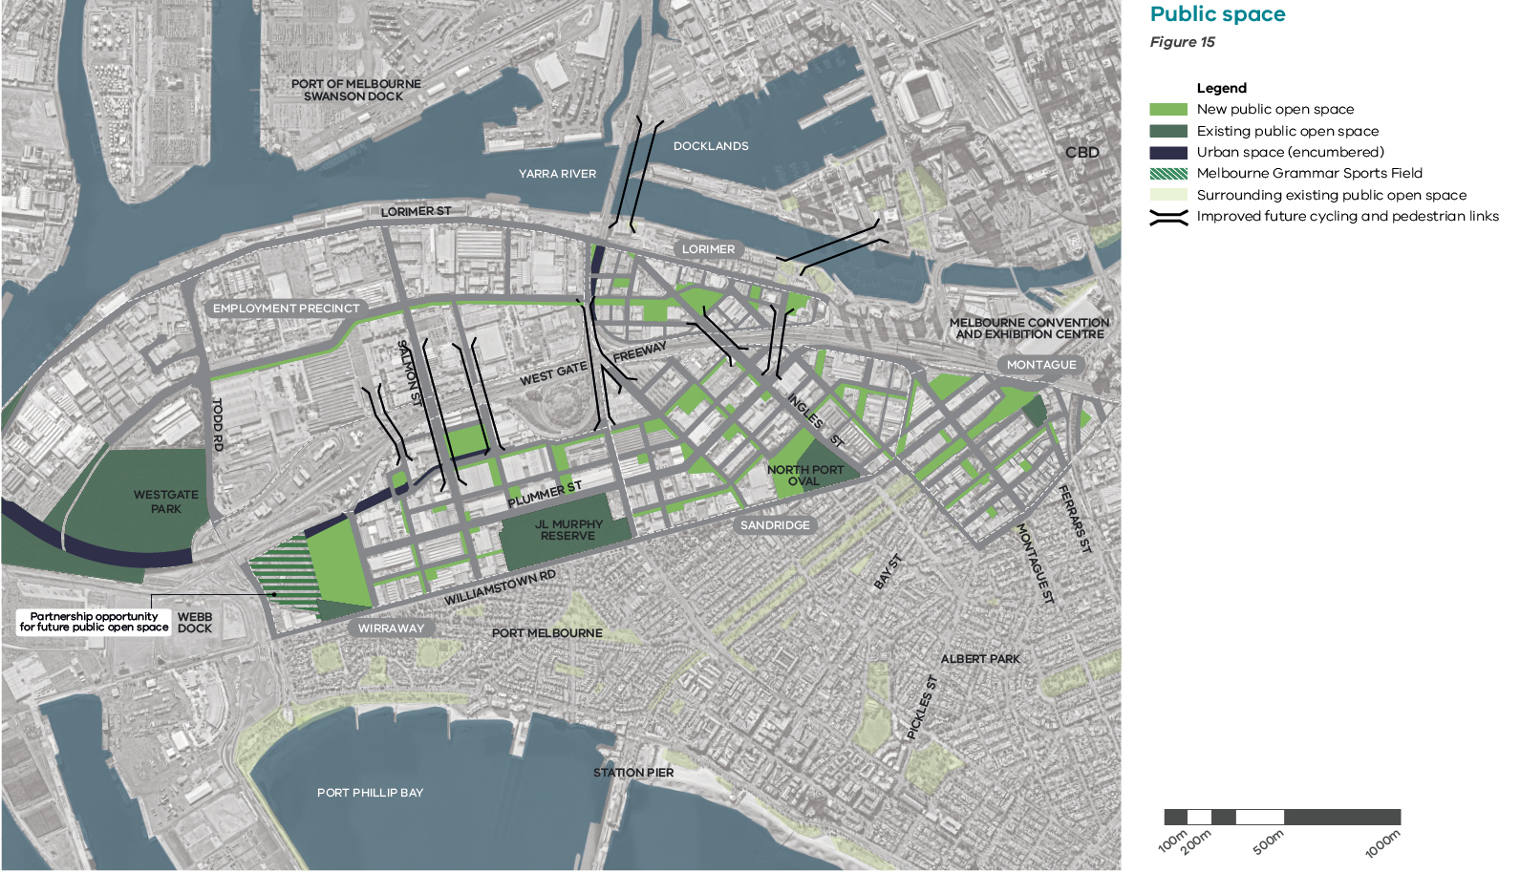

Objective 3.9
Protect architectural and cultural heritage to strengthen the sense of place and identity

Strategies
3.9.1 Continue to evaluate locations, sites and buildings for their potential heritage value
3.9.2 Protect and enhance the existing heritage fabric
3.9.3 Retain and re-purpose existing heritage buildings through adaptive re-use
3.9.4 Investigate and promote the area’s social history and its many stories to enhance the character and identity of buildings, sites and locations
3.9.5 Enhance guidelines pertaining to the conservation of cultural heritage
3.9.6 Encourage art and creative practices as an integral component of place making and innovation
3.9.7 Increase the accessibility and profile of historic information

Objective 3.10
Recognise and protect Aboriginal cultural heritage

Strategies
3.10.1 Actively involve Aboriginal people in cultural heritage management
3.10.2 Actively celebrate and promote Aboriginal people’s intangible cultural heritage in consultation and collaboration with Traditional Owners, recognising cultural custodianship
3.10.3 Reflect Aboriginal cultural heritage and Caring for Country principles in the design and management of public spaces
3.10.4 Embed Aboriginal languages in the design and naming of streets, parks and public buildings
3.10.5 Establish how Caring for Country can best be applied in an urban context

Objective 3.11
Ensure the appropriate management of contaminated land to maximise user safety

Strategies
3.11.1 Work with the Environment Protection Authority (EPA) to introduce a general duty of care to protect human health and the environment
3.11.2 Develop with the EPA a public and comprehensive database of potentially contaminated sites
3.11.3 Develop appropriate land use standards and controls for Fishermans Bend in conjunction with the EPA and ensure that these can be readily understood and applied through the planning system
3.11.4 Promote the sharing of data and learnings from remediation efforts to enable best practice
3.11.5 Understand the precinct baseline groundwater quality to inform the remediation for changing land use and safe, appropriate use of groundwater

Celebrating heritage
Figure 16
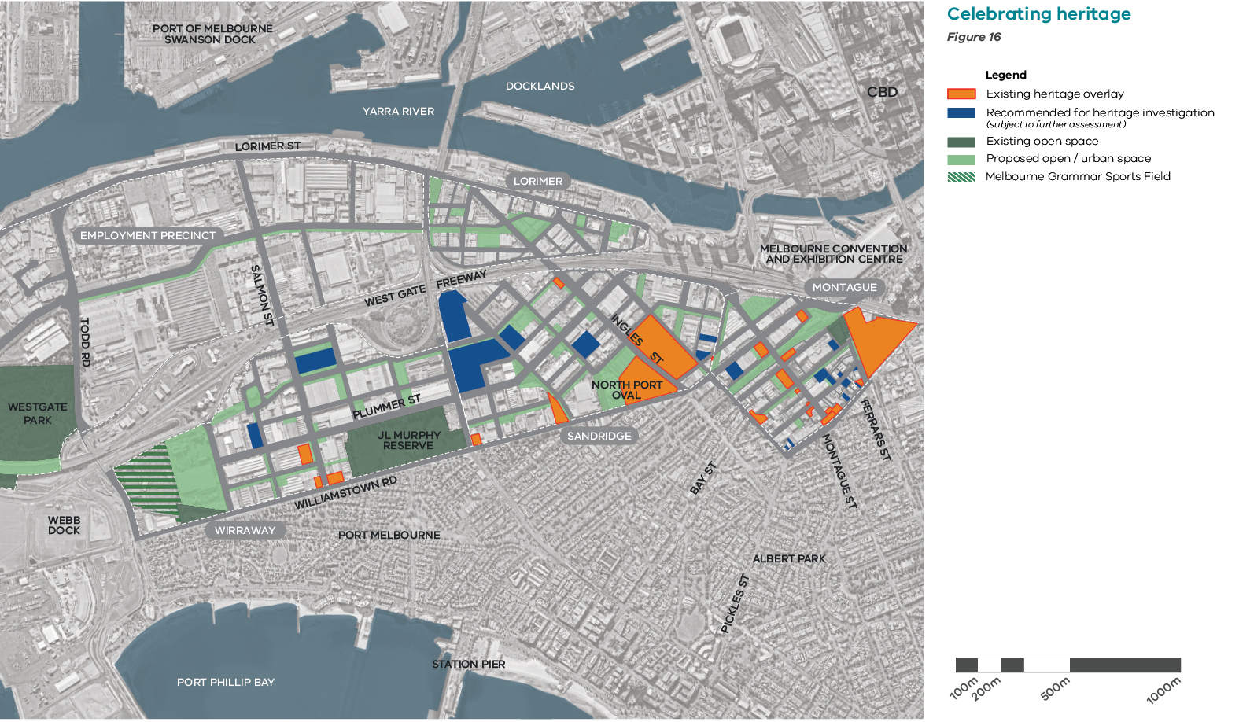

Sustainability goal 4 - A climate resilient community

Overview
Climate change is an issue that is global and local. Government and communities have a role to play in building resilience and decreasing the vulnerability of people and places to the adverse effects of climate change.
Melbourne is expected to experience more heatwaves and less rainfall, as well as more extreme storm events and flooding. These changing weather patterns will impact human health, the water supply, property, infrastructure and the natural environment. They will also have an economic impact. It is more cost effective to plan for climate change risks before they occur, rather than repair damage following extreme weather events. This is why a climate readiness framework has been developed for Fishermans Bend.
A key strategy for becoming climate-adept is increasing the number of trees and amount of vegetation, and ensuring this is irrigated, in order to encourage cooling through evapotranspiration and the provision of shade. A climate resilient water source such as provision of recycled water, as outlined in Sustainability goal 5 ‘A water sensitive community’, is a key part of implementing this strategy.

Targets for 2050
The urban heat island effect is reduced so that Fishermans Bend will be no hotter than inner Melbourne
The community is resilient to the shocks and stresses of climate change

Objective 4.1
Reduce the urban heat island effect in Fishermans Bend

Strategies
4.1.1 Introduce design standards to deliver initiatives in private developments such as shading, cool or green roofs and facade albedo treatments
4.1.2 Incorporate measures such as shading and vegetation to reduce temperatures in public spaces

Objective 4.2
Embed green infrastructure into the design of public spaces and buildings

Strategies
4.2.1 Encourage the inclusion of well-designed and managed green roofs and green walls in new development
4.2.2 Incorporate requirements for deep soil planting within new developments and public spaces
4.2.3 Ensure development will not impact growth of healthy trees in public spaces

Objective 4.3
Tree planting to deliver 50% urban forest canopy coverage in public spaces by 2050

Strategies
4.3.1 Ensure tree and plant selection will consider future climates. A diversity of indigenous, native, and exotic species will be planted to create a resilient urban forest
4.3.2 Design and construct new streets to support the growth of existing and new large healthy trees including irrigation with recycled water

Objective 4.4
Develop better community understanding of climate risks

Strategies
4.4.1 Work with stakeholders to increase awareness on climate risks and management in the community

Sustainability goal 5 - A water sensitive community

Overview
Consistent with the Water for Victoria water plan, Fishermans Bend will use all elements of the water cycle to deliver a more resilient and liveable community. Households account for most of Melbourne’s water consumption with the average person in Melbourne using 166 litres a day in 2015-2016.
Recycled water infrastructure in Fishermans Bend will significantly reduce consumption, as well as enable the irrigation of trees and vegetation to increase amenity and reduce the urban heat island effect as outlined in Goal 4 'A climate adept community'. Climate change will bring more extreme storm events, including flooding. Given its proximity to the Yarra River and Port Phillip Bay, Fishermans Bend will need to be resilient to sea level rise.

Targets for 2050
Nutrient discharges from stormwater and treated effluent to Port Phillip Bay are reduced
Net sewage discharge reduced by 50%
Potable water demand of less than 100 litres per person per day
Reduced impact of storm and flood events, including sea level rise

Objective 5.1
Design the urban form to accommodate sea-level rise and storm events

Strategies
5.1.1 Harvest, treat and reuse stormwater to minimise flooding and other environmental impacts
5.1.2 Utilise smart grid technology to maximise the capture of rainwater in buildings, while maintaining enhanced flood mitigation
5.1.3 Ensure that stormwater is treated to reduce nutrient discharge and minimise environmental impacts
5.1.4 Prepare a strategy to holistically manage drainage and mitigate the impacts of storms and sea-level rise
5.1.5 Design the public realm to make water visible and part of the Fishermans Bend identity through water sensitive urban design
5.1.6 Retain design controls to raise habitable floor levels to avoid flooding where other mitigation measures are not possible

Objective 5.2
Establish an integrated water system across Fishermans Bend to provide access to high quality potable and recycled water

Strategies
5.2.1 Support the delivery of a water recycling plant and associated third-pipe infrastructure to provide recycled water as a substitute for potable water for toilet flushing, laundry and irrigation across all public and private development in Fishermans Bend. This will supplement stormwater harvested via rainwater tanks in all buildings
5.2.2 Minimise the potable water use by using recycled water and rainwater for toilet flushing, laundry and irrigation
5.2.3 Provide recycled water to maintain sports fields and other planting in streets and parks

Catalyst project - Water recycling plant
The proposed water recycling plant by South East Water in Fishermans Bend will supply Class A recycled water via a third pipe. This would provide class A recycled water at a significantly lower cost than smaller building-scale systems.
Reticulated recycled water supplied throughout the precincts could supplement rainwater and create a drought-free, green landscape. This could eliminate the need to upgrade the trunk potable water infrastructure, saving the need to link into the Punt Road main, and supply a pumping station, transfer main and additional water storage.
It is proposed a reduction in potable water consumption will be achieved through a combination of building-scale rainwater capture and reuse, supplemented by a precinct wide supply of recycled water. The water recycling plant could also provide recycled water for community uses beyond Fishermans Bend.
Buildings will incorporate best-practice water-efficient fixtures and rainwater tanks for flood mitigation. Through the inclusion of a third pipe and smart grid technology in the building, captured rainwater and recycled water will be beneficially used as non-drinking water, for toilet flushing, laundry and garden watering.

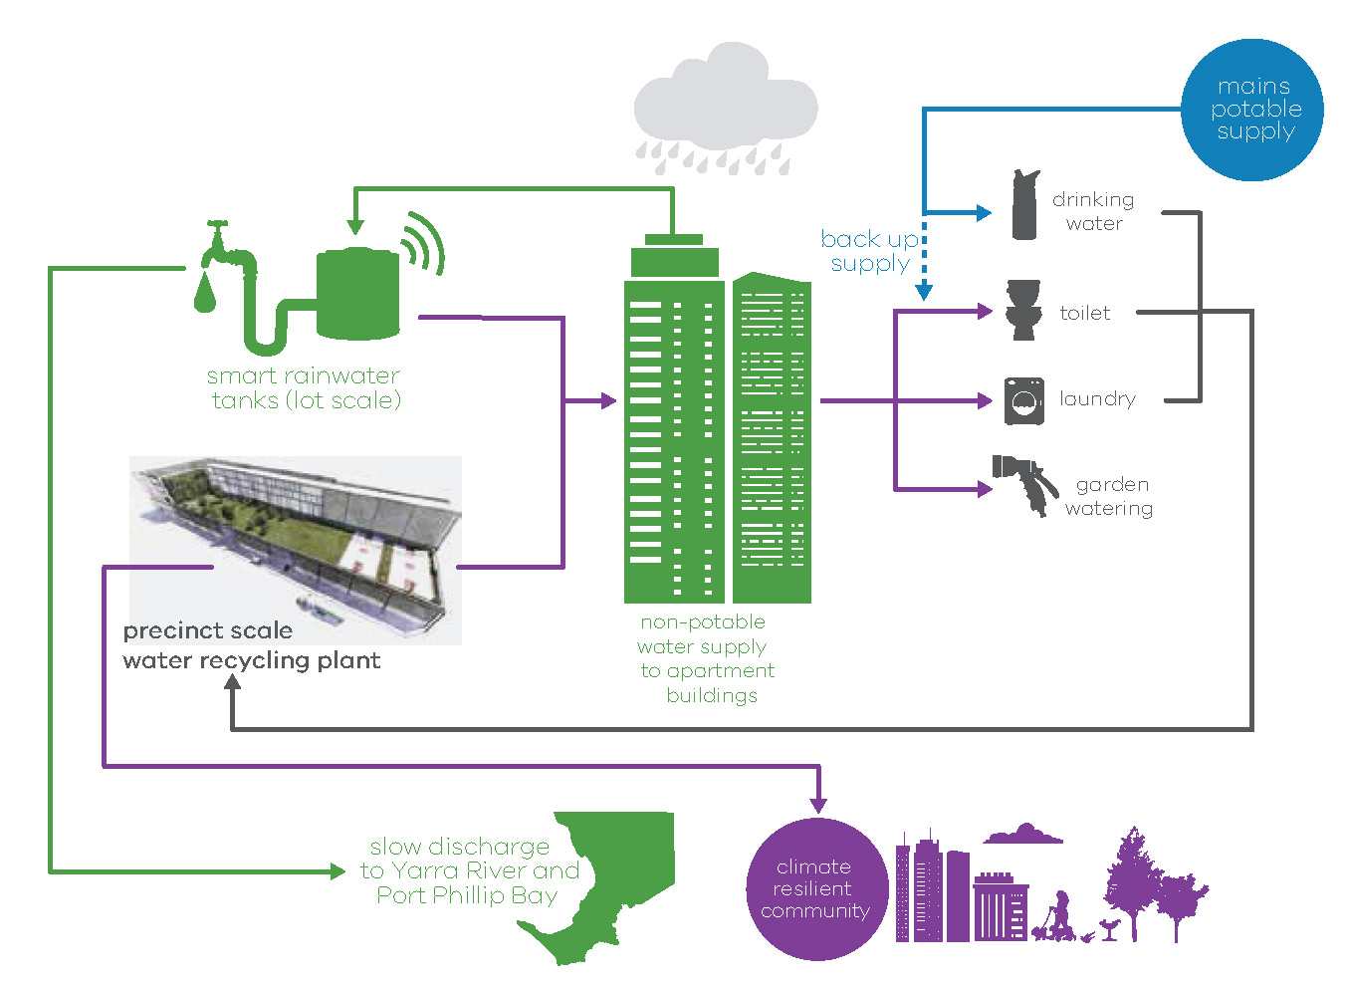
Source: South East Water

Sustainability goal 6 - A biodiverse community

Overview
Improving biodiversity contributes to the health and wellbeing of the community, by providing pleasant spaces to play in and enjoy. Biodiversity will be enhanced in Fishermans Bend – benefitting local flora and fauna as well as residents and visitors.
Green spaces and water bodies help reduce impacts of heatwaves and reduce air pollution. Biodiversity also increases the resilience of the area to shocks such as flooding and climate change. More broadly, green spaces enhance character and liveability, making Fishermans Bend a great place to live, work and visit.

Targets for 2050
More than 90% of the trees will be in good health by 2050
Greater diversity of plant species and fauna recorded compared to 2017 levels

Objective 6.1
Create an open space network that enhances connection to nature along with biodiversity and supports local wildlife

Strategies
6.1.1 Identify, utilise, protect and enhance existing biodiversity and habitats in the design of public open spaces
6.1.2 Design the open space network and streets to provide a mosaic of habitats that enhance ecologic connectivity
6.1.3 Encourage the inclusion of green infrastructure such as green roofs and walls, blue laneways and green streets into new development to increase biodiversity. New private open space should be designed with multi-layered vegetation volume to support a rich ecosystem
6.1.4 Plant trees early and select tree species and support other planting to support biodiversity using the following hierarchy:
– Plant native or indigenous trees where conditions are favourable for large canopy growth
– Where exotic trees are planted, select species that provide resources for biodiversity, such as flowers, pollen, nectar and rough bark

Objective 6.2
Establish greater habitat diversity, including over, mid and ground-storey vegetation

Strategies
6.2.1 Seek opportunities to create designated areas of complex vegetation that incorporate a wide variety of plant species and scales, including layers of ground covers, shrubs and trees
6.2.2 Design all public spaces to enhance human interaction with biodiversity, including the provision of diverse native and indigenous species
6.2.3 Engage the community in biodiversity conservation and mapping, including residents, businesses, and Aboriginal and community groups
6.2.4 Improve soil and water health in parks and streets
6.2.5 Maximise resources for biodiversity in open spaces, such as habitat logs, artificial habitat, mulch and water features

Sustainability goal 7 - A low carbon community

Overview
In order to keep global temperature increases within two degrees celsius, Victoria has committed to reduce its greenhouse gas emissions to net zero by 2050, as well as setting renewable energy targets of 25 per cent by 2020 and 40 per cent by 2025.
Fishermans Bend has a key role to play in contributing to this target, and demonstrating how urban renewal precincts can lead the way in Melbourne and across Australia in achieving significantly better performance. Sustainability objectives and strategies are aligned with the directions and obligations set by the Victorian Government Climate Change Act 2017, and set out in Plan Melbourne.
Switching from private cars to public and active transport is a key component – see Sustainability goal 1.

Targets for 2050
Fishermans Bend will achieve zero net greenhouse gas emissions by 2050

Objective 7.1
Develop Fishermans Bend as a zero net emissions precinct

Strategies
7.1.1 Provide clear direction on zero net emission actions needed now and in the future for the development sector, authorities, government and the community
7.1.2 Set interim emissions targets, as well as targets for each sector within Fishermans Bend to enable performance to be tracked
7.1.3 Consider how the opportunities outlined within the Fishermans Bend Net zero emissions strategy can best be delivered and implemented
7.1.4 Explore opportunities to facilitate large scale purchase of renewable energy generated outside the Fishermans Bend boundaries

Objective 7.2
Design, construct and operate to best practice green building standards

Strategies
7.2.1 Require new developments to meet 4-Star Green Star Design and As-built (or equivalent) ratings and 5-Star Green Star Design and As-built (or equivalent) for all buildings over 5000 square metres, and clearly indicate future increases to performance requirements
7.2.2 Encourage highly energy-efficient buildings that are also adapted to a warming climate
7.2.3 Develop a transition plan to help improve the energy and emissions performance of existing buildings within Fishermans Bend, either prior to long-term redevelopment or where buildings will be retained

Objective 7.3
Maximise renewable energy generation, storage and distribution

Strategies
7.3.1 Maximise renewable energy generation such as solar panels on appropriate rooftops and sharing or storing of this energy
7.3.2 Explore opportunities for precinct-wide sustainable energy generation and distribution

Sustainability goal 8 - A low waste community

Overview
Fishermans Bend is a unique opportunity to reduce waste to landfill and improve recycling through a range of new, pioneering initiatives. Fishermans Bend aims to have one of the highest diversion rates in Victoria. Increasing recycling has a range of benefits – it reduces greenhouse gas emissions, minimises odour and pollution, creates jobs and improves the enjoyment of public spaces. Improving the efficiency of waste services will reduce local noise, improve traffic flow and may be more cost efficient.
Increasing food waste recycling is crucial. Only three per cent of food waste is recycled and it makes up about 22 per cent of waste to landfill and about 35 per cent of household garbage.
Research into the best methods of optimising waste outcomes is underway and includes:
• research on collection and storage systems for multi-unit developments
• projections for commercial and residential waste
• feasibility study on advanced resource recovery technology facilities.

Targets for 2050
80% of household waste is diverted from landfill
50% of all food waste is diverted from landfill
Improved waste and recycling knowledge in the local community

Objective 8.1
Leading-practice waste and resource recovery management within buildings

Strategies
8.2.1 Provide shared collection services to reduce truck movement
8.2.2 Require high standards for waste management plans and building design guidelines to ensure all waste is managed within buildings
8.2.3 Utilise new smart city technologies, such as sensor technologies, to monitor bin volumes and optimise collection routes

Objective 8.2
Reduce amenity impacts from waste collection

Strategies
8.1.1 Require high standards for building construction, design and operation to increase resource recovery rates. These standards will be harmonised across Fishermans Bend
8.1.2 Encourage food waste recovery systems in all new commercial and residential buildings
8.1.3 Investigate methods to prioritise using recycled materials in infrastructure construction, including buildings
8.1.4 Introduce innovative education and engagement programs for residents, businesses and construction sectors

Objective 8.3
Maximum value is extracted from waste

Strategies
8.3.1 Encourage new advanced resource recovery technology facilities to manage waste
8.3.2 Develop a new transfer station and resource recovery centre to improve the range and effectiveness of resource recovery options for businesses and residents
8.3.3 Investigate a sustainability hub that includes the water recycling plant, advanced resource recovery facilities, an education centre, a resource recovery centre and community facilities (such as community gardens, food recovery organisations and men’s sheds)

Next steps
There are a number of initiatives already underway in Fishermans Bend that are working to deliver the Vision for the five precincts.
These actions are detailed in the following section, along with the plan that will guide the development of the precinct plans.

Completing the planning
Over the next year the Fishermans Bend Taskforce will deliver the following priority actions required to finalise the planning of Fishermans Bend and work towards the implementation of key initiatives.
The development of Fishermans Bend benefits from continued input from the community, businesses and industry. As we progress precinct planning and implementation there will be a number of opportunities to get involved.

Precinct planning
The Framework will be complemented by precinct plans for the four capital city zoned precincts. All precincts will have their own plan that will reflect the fine grain detail of what has been outlined in the Framework. The Employment Precinct, will follow a separate planning process.
Precinct plans aim to:
• elaborate the unique and distinct character and vision of each precinct
• undertake a place-making approach that spatially integrates the objectives and strategies in the Framework through a set of detailed design responses
• identify a range of detailed priority actions and initiatives to guide the delivery of key projects identified in the Framework
Further detail on key elements of the urban structure will be developed to identify each precinct's design response:
Transport and movement including street cross-sections, street network and hierarchy and key movement networks including pedestrian and cycling paths.
Public spaces including type, size and characteristics of public spaces, tree canopies, planting, overshadowing and wind mitigation
Community facilities including the priority sites for delivering each type of hub in each precinct within the preferred areas identified in the Framework.
Activity cores including identification of the hierarchy across all precincts, and the role and function of each activity core in delivering a diverse range of economic activities.
Environmental sustainability including possible precinct approaches, water-sensitive urban design and rain gardens, blue laneways, green streets and cloudburst technology.
Precinct plans will be developed in collaboration with the City of Melbourne, the City of Port Phillip and Victorian Government departments and agencies. The community, businesses, landowners and stakeholders will be engaged during development of the five precinct plans.
The Framework and planning controls may be updated, if required to align with the final precinct plans.

Employment precinct planning
In order to realise the long term potential of the Employment Precinct, state and local government will collaborate with industry and key stakeholders to plan the future of the Employment Precinct. This process will explore and test the potential of the precinct and strive to balance the certainty and flexibility required to grow and support the manufacturing sector, creating a hub for innovation, entrepreneurship and design excellence.
The Employment Precinct will strengthen Melbourne’s sustainable economic growth and will be integrated into the broader renewal area.

Establish funding models
A comprehensive Funding and finance strategy is being developed to deliver Fishermans Bend and realise the vision by 2050. This plan will consider a mix of funding sources, including an Infrastructure Contributions Plan.

Infrastructure contributions plan
Essential infrastructure will be delivered through an Infrastructure Contributions Plan, which is being prepared for the four capital city zoned precincts and is expected to be finalised by early-mid 2019.

Review and evaluation
Fishermans Bend is a long-term project. Over its life, market conditions, community expectations and attitudes will change. This will necessitate review and monitoring of the Framework.
An evaluation methodology will be developed to measure the progression of achieving the Fishermans Bend targets. The evaluation will establish baseline information and regular monitoring intervals to track progress.

Governance
The Victorian Government, along with Melbourne City Council and the Port Phillip City Council, has an important statutory role to play in the renewal of Fishermans Bend. A governance framework has been established to prioritise and co-ordinate the renewal of Fishermans Bend. A development board will oversee the implementation of the Framework, future work on precinct planning, and funding and finance.

Collaborative partnerships
As the land is predominantly privately owned, the successful implementation of the Framework will involve ongoing conversations and collaboration with the community, industry, land-owners, businesses, all levels of government and the not-for-proﬁt sector.
The Framework is only the beginning of this process. Continued project momentum will require ongoing collaboration, as outlined in this section.

Current activities

Committed next steps
To commence implementation, the Victorian Government, the City of Port Phillip and the City of Melbourne are currently undertaking a series of actions. These will be completed during the finalisation of the Framework and precinct plans

No. | Action | Framework objective
1. | Develop and finalise the precinct plans, a funding and finance strategy and an infrastructure contributions plan | multiple
2. | Finalise the planning and design of the tram corridors | 1.1
3. | Identify future major road network upgrades | 1.2–1.5
4. | Develop an attraction strategy for world leading higher education institutions and future employment and investment opportunities | 2.1-2.3
5. | Determine high speed internet delivery stages | 1.8
6. | Develop utilities servicing guidelines including placing electricity supplies underground | 2.4
7. | Finalise preferred school sites | 3.1
8. | Develop design specifications to integrate community infrastructure into mixed use developments | 3.1-3.2
9. | Complete the next stages of the Westgate Park master plan | 3.6
10. | Review buildings of heritage significance and heritage overlays | 3.9
11. | Develop Caring for Country guidelines in consultation with Aboriginal groups | 3.10
12. | Develop a zero net emissions and climate readiness strategy | 4.1-4.3 and 7.1

Precinct actions
Fishermans Bend will deliver a number of new infrastructure items that achieve outcomes in the objectives and strategies. This section locates the infrastructure actions that will be delivered to meet the future community needs in each precinct, where practicable.
A number of these actions may be delivered in more than one stage.
Sites that have already been chosen, have been identified in the precincts. However, a number of sites will need to be delivered in partnership with the private sector as part of mixed-use developments. For each of these sites, an investigation area has been identified in the precinct, indicating the preferred location for a facility. Negotiation on these sites will need to occur through the planning process.
Indicative timings have been proposed for the infrastructure items. These will be staged to align with population growth and the funding and financing strategy.
Also outlined in this section are the population and job projections for each precinct and key details on attributes relating to the overall size, developable area and open space.
Further detail on the actions will be provided in the precinct plans.

Delivering Montague
“A diverse and well-connected mixed use precinct celebrating its significant cultural and built heritage, and network of gritty streets and laneways.”

Planning for Montague 2050
 | 2018 | 2025 | 2050
Population projections | 280 | 4450 | 23,200
Projected number of households | 155 | 2450 | 10,311
Job projections | 3240 | 3400 | 4000
Open space (hectares) | 0.86 ha | 1.89 ha | 6.91 ha
Total precinct size 43 hectares

Infrastructure delivery – key projects
Sustainability goal reference | Timeframe
 | Short term
Objective 1.2 | 1 | City Road/Ferrars Street intersection upgrade
Objective 3.1 | 2 | South Melbourne primary school and community hub
Objective 3.7 | 3 | Kirrup Park
Objective 1.1 | 4 | Route 96 (Stop 126) and 109 (Stop 125A) tram stop upgrades
Objective 1.2, 1.5 | 5 | Railway Place/Ferrars Street streetscape upgrade
 | Medium term
Objective 1.3 | 6 | Bay Street to City bike connection
Objective 3.7 | 7 | Buckhurst linear park
Objective 3.7 | 8 | Johnston Street road closure
Objective 1.2, 1.3, 1.5 | 9 | Buckhurst/Montague Streets intersection upgrade
Objective 3.1 | 10 | Montague sports and recreation hub
Objective 3.1 | 11 | Montague arts and cultural hub
 | Long term
Objective 3.7 | 12 | Montague North open space
Objective 3.7 | 13 | Buckhurst Street open space
Objective 1.1 | 14 | Montague Street route 109 (Stop 126) tram stop upgrade

Delivery timeframes
Short term Medium term Long term
2018–2020 2020–2025 2025+
Based on the financial calendar (1 July–30 June)

Figure 17 Infrastructure delivery in Montague
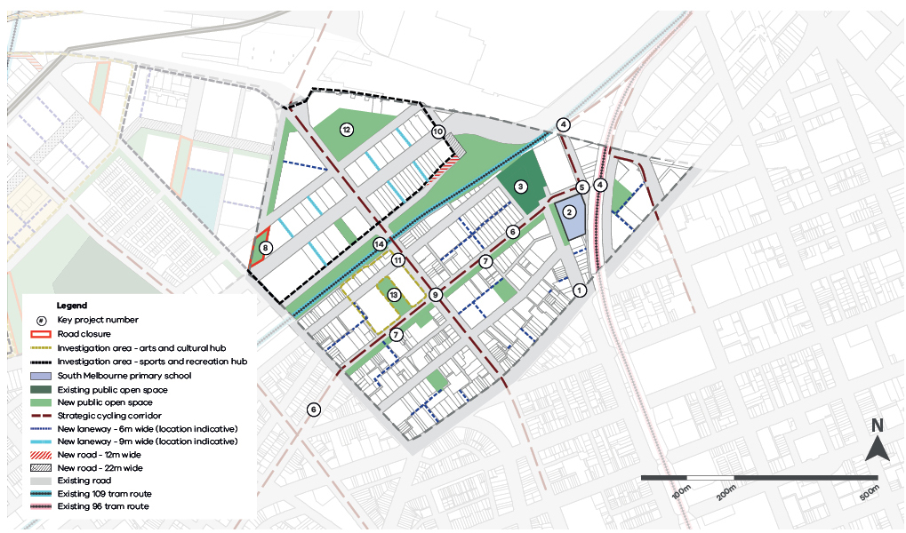

Delivering Lorimer
“A vibrant, mixed use precinct close to the Yarra River and connected to Melbourne’s CBD, Docklands and emerging renewal areas.”

Planning for Lorimer 2050
 | 2018 | 2025 | 2050
Population projections | 280 | 3440 | 12,000
Projected number of households | 0 | 1900 | 5882
Job projections | 1820 | 2290 | 6000
Open space (hectares) | 0 ha | 0.98 ha | 4.91 ha
Total precinct size 25 hectares

Infrastructure delivery – key projects
Sustainability goal reference | Timeframe
 | Medium term
Objective 3.1 | 1 | Pop up community hub in Bolte West precinct
Objective 3.1 | 2 | Lorimer health and wellbeing hub
Objective 3.1 | 3 | Lorimer education and community hub
Objective 1.1 | 4 | Northern tram corridor
Objective 3.7 | 5 | Lorimer Central open space
 | Long term
Objective 3.1 | 6 | Lorimer sports and recreation hub
Objective 3.1 | 7 | Lorimer arts and cultural hub
Objective 3.7 | 8 | Lorimer West open space
Objective 1.2, 1.3-1.5 | 9 | Graham/Bridge Street pedestrian bridge

Delivery timeframes
Short term Medium term Long term
2018–2020 2020–2025 2025+
Based on the financial calendar (1 July–30 June)

Figure 18 Infrastructure delivery in Lorimer
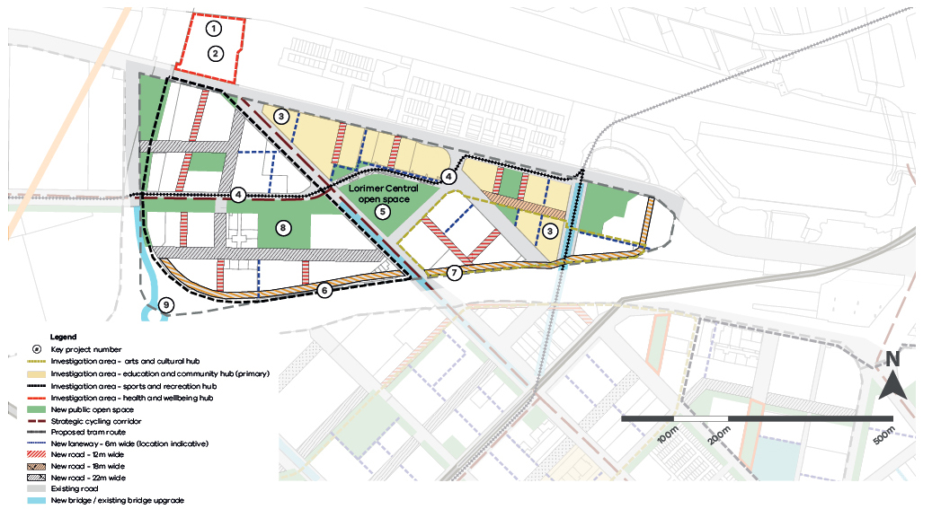

Delivering Sandridge
"One of Melbourne’s premium office and commercial centres, balanced with diverse housing and retail."

Planning for Sandridge 2050
 | 2018 | 2025 | 2050
Population projections | 520 | 880 | 27,200
Projected number of households | 287 | 487 | 13,737
Job projections | 5200 | 11,080 | 26,000
Open space (hectares) | 3.45 ha | 4.99 ha | 13.02 ha
Total precinct size 86 hectares

Infrastructure delivery – key projects
Sustainability goal reference | Timeframe
 | Medium term
Objective 3.7 | 1 | North Port Oval parkland expansion
Objective 1.1, 1.2 ,1.3 | 2 | New tram, pedestrian and cycle bridge over freeway
Objective 1.1, 1.2 ,1.3, 1.5 | 3 | Southern tram Corridor/boulevard
Objective 1.1, 1.2, 1.3 | 4 | Redevelopment of Fennell/Plummer/Bridge Street intersection
Objective 3.6 | 5 | Opening of pop-up outdoor public space on future potential Sandridge Rail Station site
Objective 3.7 | 6 | White Street road closure and temporary pop-up
 | Long term
Objective 3.7 | 7 | White Street open space
Objective Multiple | 8 | Catalyst site redevelopment opportunity
Objective 3.1 | 9 | Sandridge sports and recreation hub
Objective 3.1 | 10 | Sandridge arts and cultural hub
Objective 1.3, 1.5, 3.1 | 11 | Sandridge education and community hub
Objective 1.2 | 12 | Ingles Street bridge widening
Objective 1.2, 1.3, 1.5 | 13 | Graham/Bridge Street pedestrian bridge
Objective 1.1 | 14 | Potential rail (including station and associated infrastructure such as transport interchange and public square)

Delivery timeframes
Short term Medium term Long term
2018–2020 2020–2025 2025+
Based on the financial calendar (1 July–30 June)

Figure 19 Infrastructure delivery in Sandridge
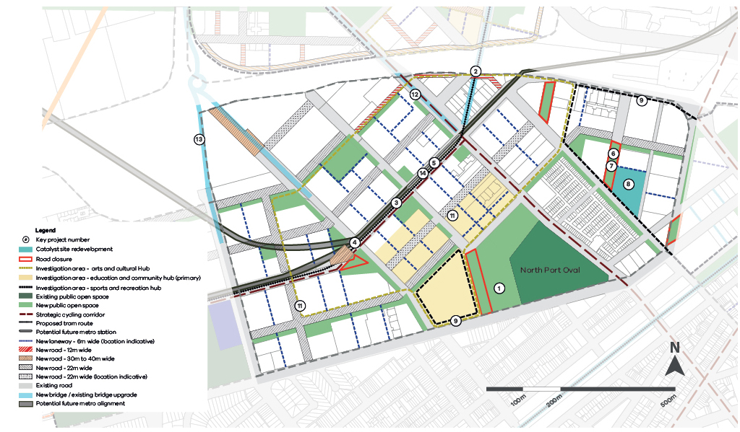

Delivering Wirraway
“A family friendly inner city neighbourhood close to the Bay and Westgate park”

Planning for Wirraway 2050
 | 2018 | 2025 | 2050
Population projections | 200 | 360 | 17,600
Projected number of households | 155 | 200 | 6,822
Job projections | 2410 | 2740 | 4000
Open space (hectares) | 12.49 ha | 12.49 ha | 27.43 ha
Total precinct size 94 hectares

Infrastructure delivery – key projects
Sustainability goal reference | Timeframe
 | Medium term
Objective 3.6 | 1 | Deliver JL Murphy Reserve upgrades
Objective 3.1 | 2 | Fishermans Bend education and community hub (secondary school)
 | Long term
Objective 3.1 | 3 | Wirraway health and wellbeing hub
Objective 3.1 | 4 | Wirraway arts and cultural hub
Objective 3.1 | 5 | Wirraway education and community hub
Objective 3.1 | 6 | Wirraway sports and recreation hub
Objective 1.1, 1.2, 1.3, 1.5 | 7 | Southern Tram corridor
Objective 3.7 | 8 | Prohasky North open space
Objective 3.7 | 9 | Wirraway East open space
Objective 3.7 | 10 | Prohasky South open space
Objective 3.7 | 11 | Wirraway North open space
Objective 1.1, 1.2, 1.3, 1.5 | 12 | Salmon Street bridge widening
Objective 1.2, 1.3, 1.5 | 13 | Rocklea Drive walk and cycle bridge
Objective 1.2, 1.3, 1.5 | 14 | Thackray Street walk and cycle bridge
Objective 1.1 | 15 | Potential underground rail

Delivery timeframes
Short term Medium term Long term
2018–2020 2020–2025 2025+
Based on the financial calendar (1 July–30 June)

Figure 20 Infrastructure delivery in Wirraway
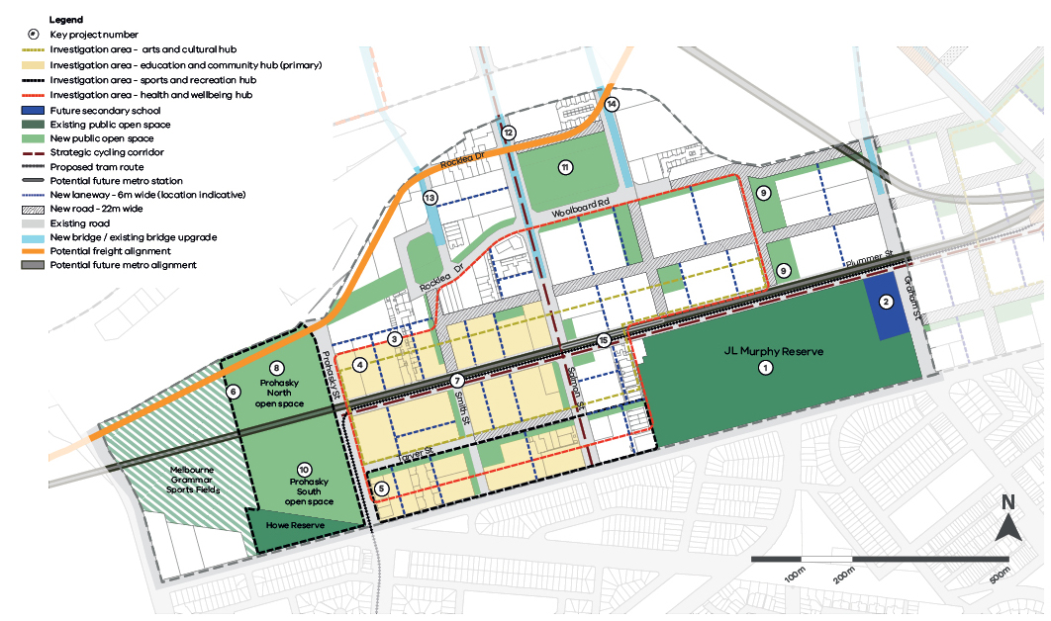

Delivering the Employment Precinct

Planning for Fishermans Bend Employment Precinct 2050
The inclusion of the 230-hectare Employment Precinct as part of the Fishermans Bend renewal area presents many unique opportunities to provide 21st century jobs centered on innovation, entrepreneurship and design excellence in manufacturing.
Over the next 12 months, state and local government will collaborate with industry and key stakeholders to plan the Fishermans Bend National Employment and Innovation Cluster (NEIC). This will follow a separate timeframe from the other four precincts.
This process will investigate how this precinct can be successfully developed as an NEIC. Until the planning is completed, the interim list below provides a starting point.
Initial constraints and opportunities have been identified to assist with the further detailed planning for this precinct.

Constraints
• Lack of public transport, pedestrian and cycling access and connections to neighbouring precincts
• Limited access to the Yarra River, with land abutting the river utilised by the Port of Melbourne
• Large block industrial subdivision pattern that makes achieving finer grain urban form, street activation, and improved permeability challenging
• Medium to high soil contamination in some locations
• The need to consider existing industrial uses, including concrete batching plants
• Limited provision of community infrastructure and services
• Existing utility infrastructure and easements required to be maintained, including high-voltage power lines and existing sub-stations Salmon/Turner Streets and Graham Street
• Existing freight rail alignment along Lorimer Street, Todd and Wharf Roads required to be maintained until an alternative is established
• Truck movements associated with Webb Dock upgrade

Opportunities
• Government ownership of former General Motors Holden (GMH) site to act as catalyst project and set the tone for broader evolution of precinct
• Rich industrial history and supporting infrastructure, with several world-renowned companies in operation
• Industrial zoning and a strong commitment to a precinct focused on employment and the physical production of goods
• Proximity to Melbourne’s CBD and its thriving knowledge economy
• Accessibility to key road infrastructure connecting the precinct to the port, airport and broader Melbourne
• Key transport infrastructure providing a substantial buffer to surrounding areas slated for mixed use development
• Large sites and an abundance of under-utilised space, providing numerous opportunities for intensification of employment and supporting institutional developments
• Ability to adaptively reuse large industrial buildings to accommodate a variety of uses, including small scale urban manufacturers, start-ups, creative industries, and pop-ups
• Potential to relocate industries from other Fishermans Bend precincts and sites
• Potential location for other catalyst projects including the water recycling plant
• Ability to increase and equitably distribute regional open space and improve the Westgate Park connection to the Yarra River
• Connect the precinct with the river to improve vistas and view-lines

Infrastructure delivery – key projects
Sustainability goal reference | Timeframe
 | Medium term
Objective 1.1 | 1 | Northern tram corridor
Objective 2.1. 2.2, 2.3 | 2 | GMH site redevelopment
Objective 1.1, 1.2, 1.3 | 3 | Upgrade of the Westgate Punt
 | Long term
Objective 5.2 | 4 | Water recycling plant (location to be determined)
Objective 1.1 | 5 | Potential underground rail

Figure 21 Infrastructure delivery in the Employment Precinct
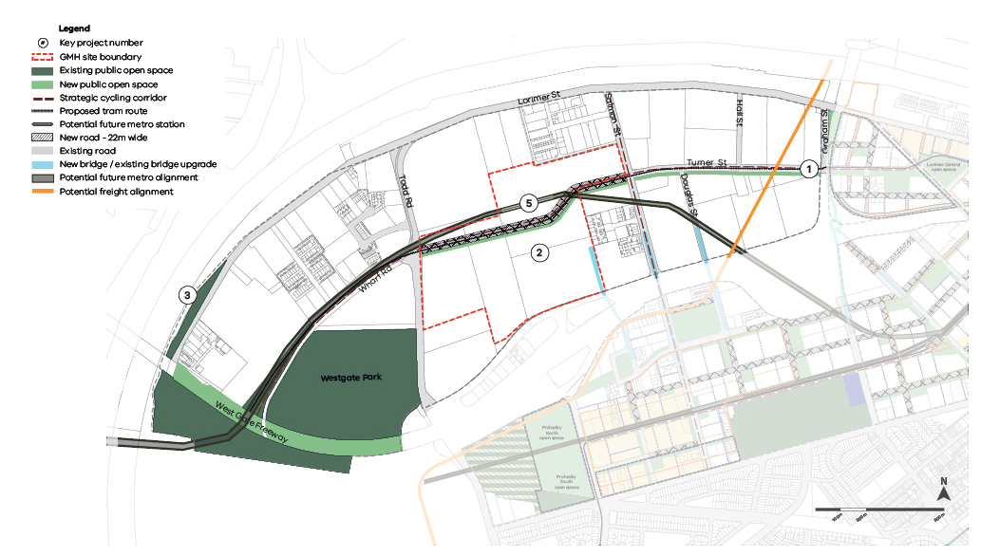

Appendix

Background reports overview
To inform the preparation of the Framework, extensive detailed studies were completed. These build on previous reports produced during 2012–2018. All of the background reports are available at our website www.fishermansbend.vic.gov.au

Fishermans Bend Baseline Groundwater Quality Assessment 2016
Prepared by: AECOM Australia

Fishermans Bend Baseline Utility Assessment 2016
Prepared by: GHD

Fishermans Bend Buffer Assessment 2016
Prepared by: GHD

Fishermans Bend Economic and Employment Study 2016
Prepared by: SGS Economics and Planning

Fishermans Bend Heritage Study 2016
Prepared by: Biosis

Fishermans Bend Preliminary Land Contamination Study Employment Precinct 2016
Prepared by: Golder Associates

Fishermans Bend SMART City Framework 2016
Prepared by: WSP Parsons Brinckerhoff

Fishermans Bend Aboriginal Cultural Values Interpretation Strategy 2017
Prepared by: Extent

Fishermans Bend Community Infrastructure Plan 2017
Prepared by: Fishermans Bend Taskforce

Base Line Drainage Plan Options 2017
Prepared by: GHD

Fishermans Bend Integrated Transport Plan 2017
Prepared by: Transport for Victoria

Fishermans Bend Population and Demographics 2017
Prepared by: Fishermans Bend Taskforce in association with Department of Environment, Land, Water and Planning

Fishermans Bend Social History Study 2017
Prepared by: Context

Fishermans Bend Sustainability Strategy 2017
Prepared by: Fishermans Bend Taskforce

Fishermans Bend Taskforce Public Space Strategy 2017
Prepared by: Planisphere

Fishermans Bend Urban Design Strategy 2017
Prepared by: Hodyl + Co

Draft Fishermans Bend Waste and Resource Recovery Strategy 2017
Prepared by: Metropolitan Waste and Resource Recovery Group

Fishermans Bend Climate Readiness Strategy - Organising Framework 2018
Prepared by: AECOM/Ramboll

Fishermans Bend Net Zero Emissions Strategy Baseline Assessment 2018
Prepared by: Point Advisory/Aurecon

Fishermans Bend Review of Sustainability Standards 2018
Prepared by: ARUP

Fishermans Bend Urban Renewal Area Retail Assessment 2018
Prepared by: Essential Economics Pty Ltd.

Glossary
Aboriginal
Aboriginal is used to refer to both Aboriginal and Torres Strait Islander people.
Accessibility
The ease of reaching destinations. The capacity regardless of age, ability or income to reach an activity or destination. The accessibility of an area can be a measure of local liveability as it relates to the functionality and performance of the area.
Active recreation
Activities that are engaged in for the purpose of relaxation, health and wellbeing or enjoyment with the primary activity requiring physical exertion, and the primary focus on human activity.
Activity core
An area that provides a focus for enterprises, services, shopping, employment, housing, transport and social interaction. They range in size, intensity and composition.
Advanced manufacturing
Any manufacturing process that takes advantage of high technology or knowledge-intensive input as an integral part of its manufacturing process.
Adaptability
The capacity of a building or space to respond to changing community needs and to accommodate new land uses and users.
Affordable housing
Affordable housing is housing, including social housing, that is appropriate for the housing needs of any of the following – very low income households, low income households and moderate income households, as defined in the Planning and Environment Act 1987, see the Act for further details and definitions.
Amenity
A collection of qualities that make spaces attractive for human occupation. The features of an area, street or building, that provide facilities and services that contribute to physical or material comfort and benefit, and are valued by users.
Built form
The height, volume and overall shape of a building as well as its surface appearance.
Caring for Country
A term used to describe the different sustainable land management practices and initiatives that Aboriginal people undertake, and the key role these practices play in continuing culture.
Creative industries
An evolving mix of sectors spanning arts, culture, screen, design, publishing and advertising encompassing diverse disciplines.
Small organisations, micro-businesses and sole practitioners comprise the vast majority of the sector.
Dwelling Density Ratios
The number of dwellings in an urban area divided by the area of the residential land they occupy, often expressed as dwellings per hectare.
Fine grained
An urban environment with small-scale spaces, street blocks and a mix of uses to foster diverse activities and walkability.
Green infrastructure
A range of elements including vegetation walls, green tram tracks, roof gardens and tree planting, which work together to improve the environmental health of an area and mitigate the effects of climate change.
Gross Developable Area
Gross Developable Area is the proposed total site area, including any roads, laneways and public open space.
High-quality
The perceived value and associated positive experience of an environment, feature or space.
Human-scale
The proportional relationship of the physical environment (such as buildings, roads, vegetation) to human dimensions. Maintaining and favouring a human scale means that the urban structure and especially its built form are not perceived as overwhelming at ground level.
Knowledge economies
Production and services based on knowledge-intensive activities that contribute to an accelerated pace of technical and scientific advancement.
Land use
The primary purpose for which the land is used or may be developed.

Liveability
A measure of city users' quality of life, used to benchmark cities around the world. It includes socioeconomic, environmental, transport and recreational measures.
Mixed use
The composition of land use mix. The arrangement – quantity and distribution – and type of uses within a geographic area or development site.
National Employment and Innovation Clusters (NEIC)
Designated concentrations of employment distinguished by a strong core of nationally significant knowledge sector businesses and institutions that make a major contribution to the national economy and Melbourne's positioning in the global economy.
Open space
Space open to the sky regardless of its ownership and management arrangements.
Passive surveillance
Informal observation by people of streets and public spaces, which increases perceptions of safety.
Public realm
All public open space, along with other publicly owned land between buildings including streetscapes.
Public space
Publicly owned open as well as encumbered space that is easily accessible to all 24/7 as well as privately owned space that is available for public use at some times with or without fee.
Passive recreation
Casual use of open space such as sitting, walking, reading a book, meeting people enjoying the ambience and relaxing.
Population density
The number of people residing in a particular area or catchment. Density is calculated by dividing the total number of people living in an area by the overall size of the area.
Social housing Public housing and housing owned, controlled or managed by a participating registered agency, as defined in the Planning Environment Act 1987
Universal design
The designing of environments for people of all ages and abilities.
Urban heat island effect
A localised heating effect in urban areas caused by a concentration of hard surfaces such as non-porous pavements, walls and roofs that retain heat and radiate it back into the environment.
Urban renewal
The process of redeveloping an existing area to changing conditions such as environmental, economic and/or political circumstances.
Urban structure
The spatial arrangement of a city's primary organising components: the blocks, open space, movement network, land parcels and natural physical features such as topography, waterways and floodplains. Land use and built form contribute to and influence the city's urban structure.
Walkability
The extent to which the built environment supports walking for transport and recreation, where the walking environment is safe, connected, accessible and pleasant.
Walkability score
A measure to describe the walkability of an area from an address (home or work) based on the distance to essential services in conjunction with its pedestrian friendliness.

Contact us
www.fishermansbend.vic.gov.au
fishermansbend@delwp.vic.gov.au
@fishermans_bend
Victorian Government Contact Centre – 1300 366 356
Translation Service – 03 9280 0787

